Unit 2 Mid-Unit Test Study Guide Name_____________________________

Consider the following expression:

6x + 4y – 3x – 7

1. What are the terms?
2. What are the like terms?
3. What are the coefficients?
4. What is the constant?

Translate the following verbal phrases to algebraic expressions

1. The sum of twice a number and three
2. Twice the sum of a number and three
3. Four less than three fourths of a number

Translate the verbal phrase and then simplify

1. Four times the difference of a number and six

Use the diagram at the right for questions 9 and 10.

5*a* + 6

3*a* + 4

5

8

1. Determine the length of fence needed to enclose the backyard.
2. Determine the area of the backyard.

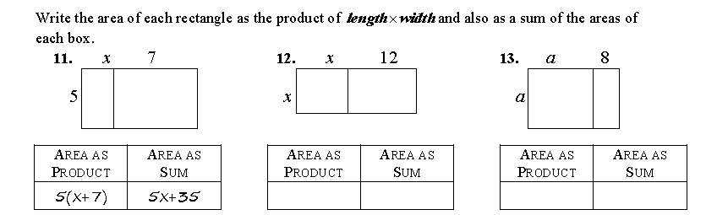

Simplify

14. 

15. 

16. Stephen owns a bicycle rental stand at the beach. He uses the equation c = 3.50h + 5 to determine c, how much he will charge to rent a bicycle for h hours. Which of the following is a correct amount someone would pay to rent a bicycle during the day?

A. $3.50 B. $5.50 C. $15.50 D. $30.00