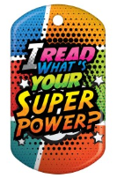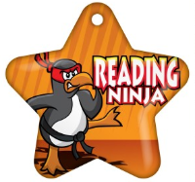

**2nd Grade Reading Challenge**

This year we are starting a school-wide reading challenge. The challenge itself will look a little different for each grade level. The goal of the challenge is for students to read and find books and genres throughout the challenge that they enjoy. For each challenge, the students will be able to earn Reading Brag Tags that they can collect all year. There will even be surprise Reading Brag Tag giveaways throughout the year.

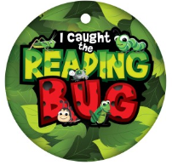

|  |  |
| --- | --- |
| **Challenge 1: (Due October 11th)**   * Read 4 books with your parent * Two books must be non-fiction * Complete book form for each book   **Prizes (Awarded on October 16th)**   * Pencil * Bookmark * Brag Tag | **Challenge 2: (Due December 13th)**   * Read 5 books **to** your parent * Two of the books must be non-fiction * Complete book form for each book   **Prizes (Awarded on December 18th)**   * Pencil * Bookmark * Brag Tag * HW Pass |
| **Challenge 3: (Due March 3rd)**   * Read 5 books **to** your parent * Two of the books must be non-fiction * One of the books must be a chapter book * Complete book form for each book   **Prizes (Awarded on March 6th)**   * Pencil * Bookmark * Brag Tag * Makerspace Pass | **Challenge 4: (Due May 6th)**   * Read 5 books **to** your parent * One of the books must be a chapter book * Complete book form for each book   **Prizes (Awarded on May 11th)**   * Pencil * Bookmark * Brag Tag * An Extra Brag Tag * Popsicle |