**Germany Physical Map (Document #1)**

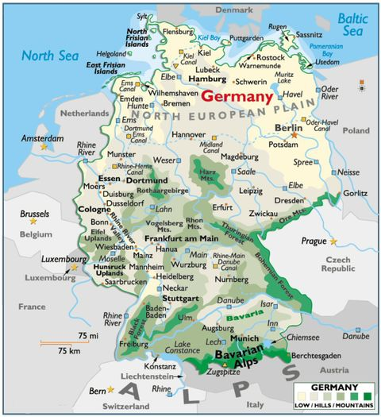

1. **Find Mannheim, Mainz, and Cologne on this map. What geographic feature connects them?**
2. **Find Munich on the map, What geographic feature is likely a source of natural resources for this Munich?**

**Climate Map of Germany Document #2**

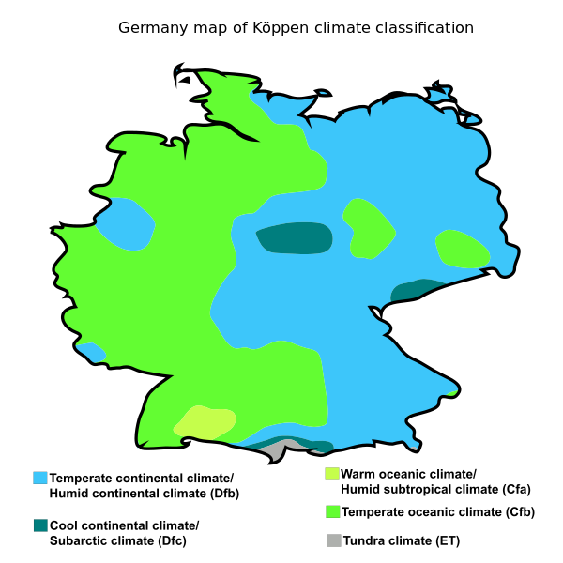

1. **Find the three coldest regions of Germany, What causes them to be cooler than their surrounding areas (hint: match them up with the physical map / document #1)**

**German Land Use & Industry (Document #3)**

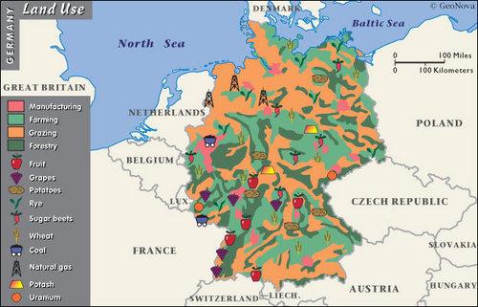

Question #4: What physical feature explains the large areas of farming and grazing land in the northern parts of Germany?

Question #5: In which physical feature is the uranium (a mineral) on the Czech Republic / German border most likely found?

**Germany Population Density Map (Document #4)**

