Document #1

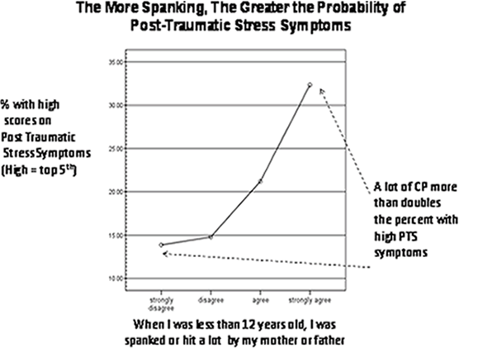

1. Do you trust this source? Why or why not?
2. What does the chart seem to tell you about the use of spanking?
3. Notice the caption at the bottom of the chart. Could this have been worded better?

Document #2

Press Release by the American Psychological Association

WASHINGTON — Corporal punishment remains a widely used discipline technique in most American families, but it has also been a subject of controversy within the child development and psychological communities. In a large-scale study of 88 different scientific studies, psychologist Elizabeth Thompson Gershoff, PhD, of the National Center for Children in Poverty at Columbia University, looked at both positive and negative behaviors in children that were associated with corporal punishment. Her research and commentaries on her work are published in the July issue of Psychological Bulletin, published by the American Psychological Association.

While conducting the meta-analysis, which included 62 years of collected data, Gershoff looked for associations between parental use of corporal punishment and 11 child behaviors and experiences, including several in childhood (immediate compliance, moral internalization, quality of relationship with parent, and physical abuse from that parent), three in both childhood and adulthood (mental health, aggression, and criminal or antisocial behavior) and one in adulthood alone (abuse of own children or spouse).

Gershoff found "strong associations" between corporal punishment and all eleven child behaviors and experiences. Ten of the associations were negative such as with increased child aggression and antisocial behavior. The single good association was that corporal punishment increased immediate compliance with the rules on the part of the child.

1. Do you trust this source? Why or why not?
2. What does this article seem to suggest about the use of corporal punishment?
3. What specific dangers does this article associate with corporal punishment?

Document #3

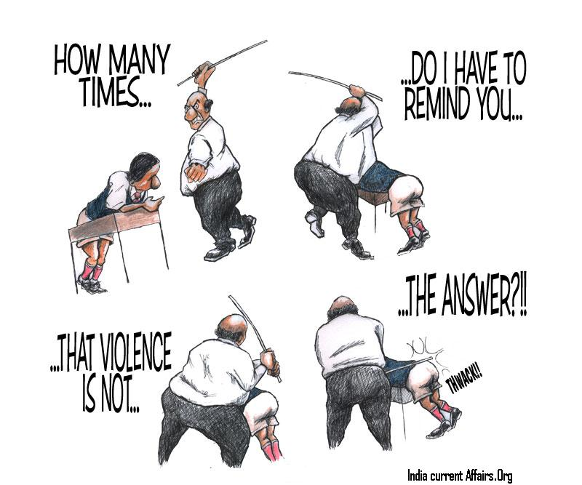

1. Do you trust this source? Why or why not?
2. This cartoon uses situational irony. Is it effective? Why or why not?
3. Could a cartoon such as this be used to help make your case? Why or why not?

Document #4

Excerpt from:

*Briefing prepared by the Global Initiative to End All Corporal Punishment of Children*

[*www.endcorporalpunishment.org*](http://www.endcorporalpunishment.org)*;* [*info@endcorporalpunishment.org*](mailto:info@endcorporalpunishment.org)

*April 2013*

Increased aggression in children

There is abundant evidence that corporal punishment is associated with increased aggression in children. All 27 studies on the topic included in the major study found an association,[1] and this has been confirmed by numerous other studies. Children who have experienced corporal punishment are more likely to be aggressive towards o,[2] to approve of the use of violence in peer relationships, to bully and to experience violence from their peers, [3] to use violent methods to resolve conflict[4] and to be aggressive towards their parents. [5]

The reasons may include that aggression is a reflexive response to experiencing pain, that children learn that violence is an appropriate method of getting what you want and that children copy their parents’ behaviour. Children describe feeling aggressive after being physically punished.[6]

1. Do you trust this source? Why or why not?
2. What harm can spanking do, according to this brief?

1. See note 3
2. Ani, C.C., & Grantham-McGregor, S. (1998) “Family and personal characteristics of aggressive Nigerian boys: Differences from and similarities with Western findings”, *Journal of Adolescent Health,* 23(5): 311-317
3. Ohene, S. et al (2006) “Parental Expectations, Physical Punishment, and Violence Among Adolescents Who Score Positive on a Psychosocial Screening Test in Primary Care”, *Pediatrics* 117(2): 441-447
4. Hart, C.H. et al (1990) “Children’s expectations of the outcomes of social strategies: Relations with sociometric status and maternal disciplinary styles”, *Child Development,* 61(1): 127-137
5. Ulman, A. & Straus, M. A. (2003) “Violence by children against mothers in relation to violence

   between parents and corporal punishment by parents”, *Journal of Comparative Family Studies* 34: 41-60
6. Dobbs, T. (2005) *Insights: children & young people speak out about family discipline,* Save the Children New Zealand