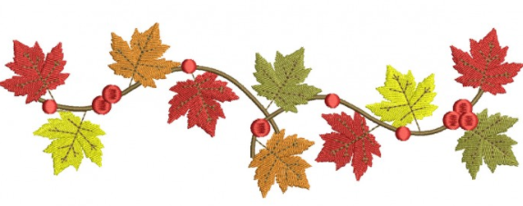**2nd Grade Wildcat Times**

**September 28 to October 2**

Reminders

* Frozen Friday has begun. If you did not prepay for the semester or year, you can still purchase ice cream. Send $1 in on each Friday with your child.
* Your child can purchase ice cream from their lunch accounts Monday-Thursday.
* Your child can purchase additional items from the lunch accounts each day.
* Until December 31, 2020, all breakfast and lunch are free to all students.
* Please place all money in a Ziploc bag with your child’s name on it and what it is for.
* Please pack a snack for your child daily. We have a working snack, so it needs to be quick and simple (eaten one-handed).

We hope everyone had a safe and relaxing Fall Break last week.

Look What We Are Learning

**Reading-** We are readingTale of a Tadpole together with discussions and activities.

**Writing-** We are exploring descriptive texts. Beginning research on the life cycle of a chosen organism.

**ELA-** We are working on simple and compound sentences, nouns, verbs, adjectives, and adverbs.

**Math-** We are comparing three-digit numbers by looking at the value of each place.

**Science/Social Studies-** We are readingWhat Is It Made Of? together with discussions and activities.

**Spelling (practice nightly for Friday’s test):**

Pattern: short a: snag span

Pattern: aCe (long a sneaky e): scrape shape paste strange graceful* shaping*

Pattern: ay (long a): may play clay gray replay* payment*

Important Dates

September 30 – Happy Birthday Mrs. Mills

October 1-18 – Gifted Referrals Accepted

October 13 – Picture Retakes

October 12-16 – Virtual Parent-Teacher Conferences-

Report Cards Issued

Two Hour Early Dismissal

October 26-30 – PTA Virtual Pumpkin Carving

Contest

**Math online resource:**

Freckle (also has Reading)

Students have code information in their folder

Log in - their name (not nickname)

Code - hrv48g

Specials

|  |  |  |  |  |  |
| --- | --- | --- | --- | --- | --- |
|  | **M** | **T** | **W** | **Th** | **F** |
| **Bowling** | PE | A | M | L | M |
| **Davis** | M | PE | A | M | L |
| **Mills** | A | L | PE | A | A |
| **Quinn** | STEM | M | L | PE | PE |

Please wear sneakers for PE.