**Physical Map of Italy (document #1)**

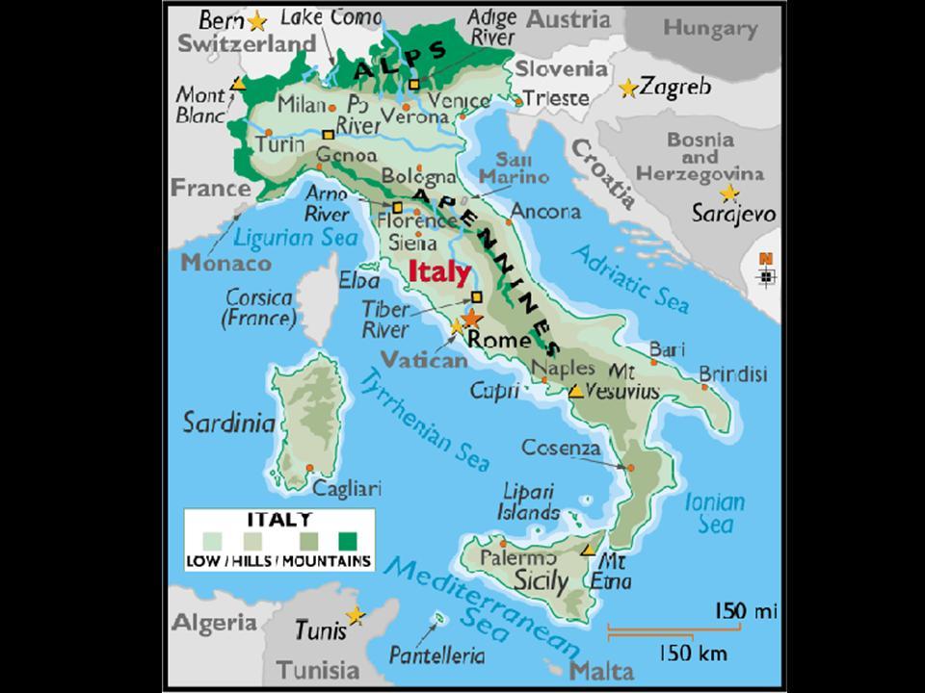

**Locate the following physical features and cities (Po River, Tiber River, Apennine Mountains, Alps) (Turin, Milan, Rome, Naples)**

**Question #1: For each city, how was its growth helped (or hurt) by the physical features near it?**

**(ex. Brindisi has access to the Adriatic Sea so that fishing and trade are easy, but it has with no major river and the Apennine Mountains cut it off from most of the other cities in Italy. Therefore it might be hard for it to attract businesses)**

**Italy’s Industry and Jobs (document #2)**

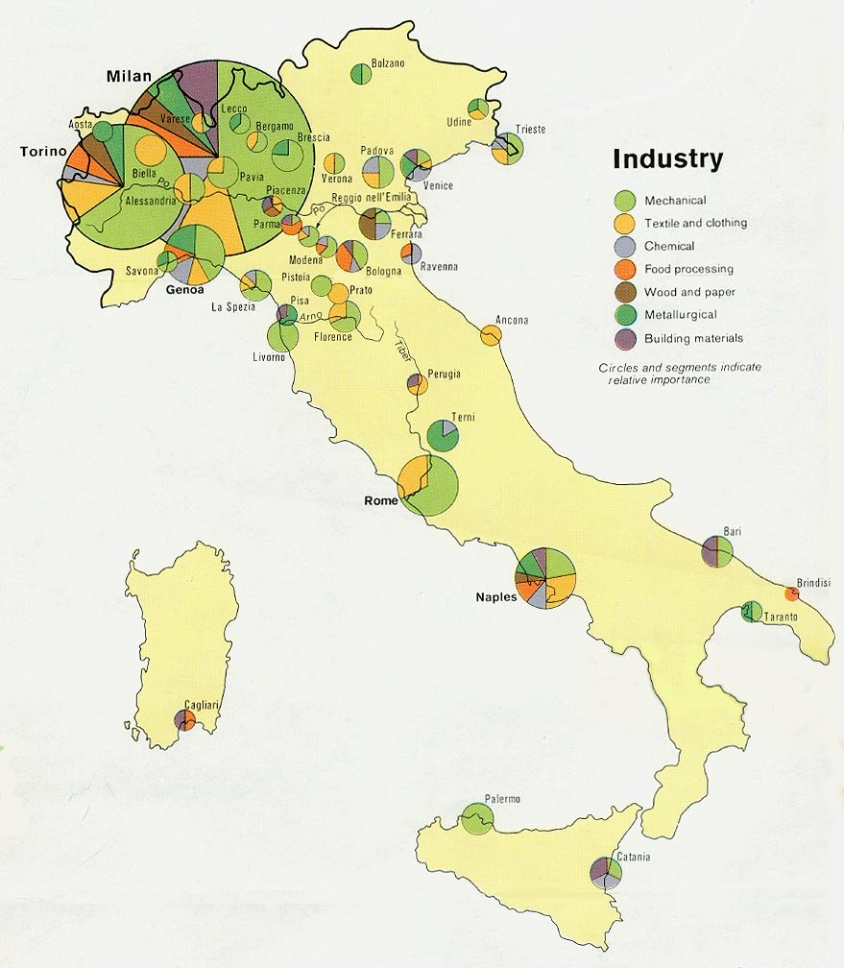

**Hint: The bigger the circle the more important the city is as a center for employment. The color of the pie wedges show the kinds of industry in the city. (Example: Rome is a moderately important center for jobs if you want to produce machinery or make clothing)**

**Question #2: Compare the industry in Brindisi with that of Turino. Why does Turino have more industry of many different kinds?**

**Italy Climate Map (document #3)**

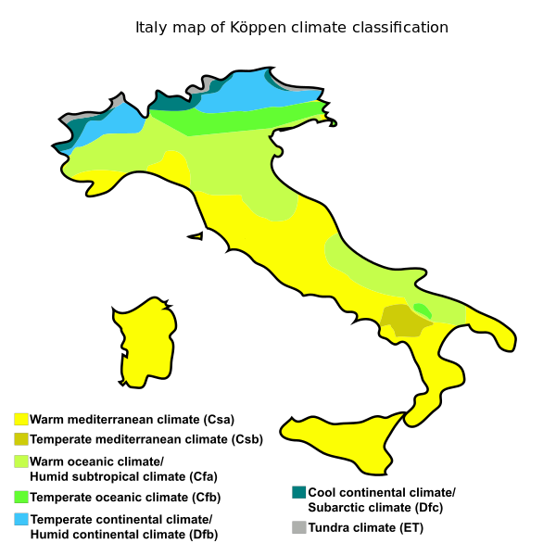

**Question #3: Italy is a world leader in producing grapes, wine, olives, and olive oil. Using the above map, what areas are the best (and worst) suited for producing these products?**

**Italy Population Density (document #1)**

