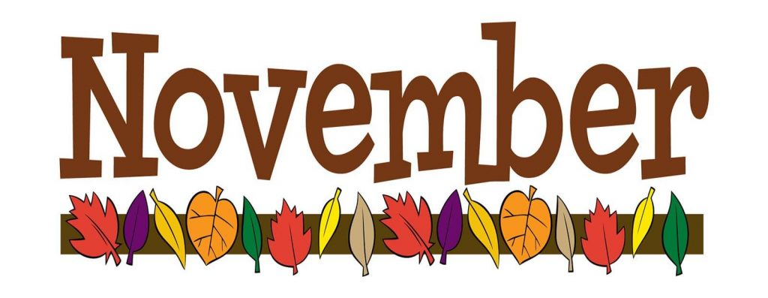  - November  This Week 11/9– 11/13  We are working on a Turkey writing for the next 2 weeks. We will be writing a story using the 5 essential elements of a story. These elements are character, resolution, plot, setting, and conflict. In math we are working on coordinate planes. We are working on pure substances and mixtures in Science. In social studies we are working on government as it relates to the judicial system.  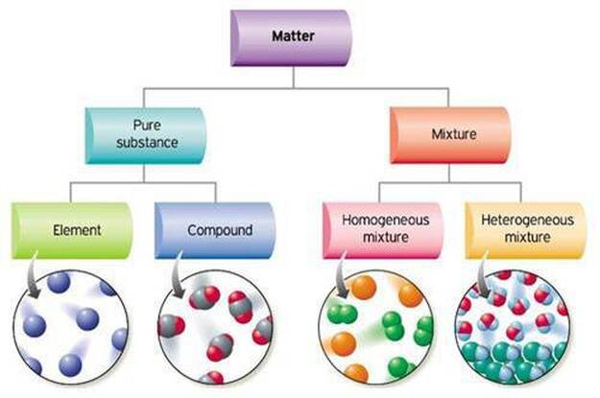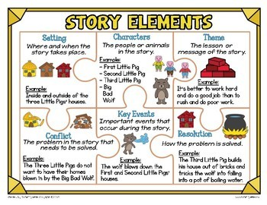  Email: knunn@paulding.k12.ga.us  Phone: 770-443-1449 |  |   Mrs. Nunn’s Class  Upcoming events  11/20  STEM showcase  11/23 – 11/27  Thanksgiving Break  Questions to ask your child…  What is the name of your turkey?  What are characters in a story and why are they important?  Which quadrant has a negative X and a negative Y?  What is a pure substance?  What is the judicial system?

