AP Human Geography

Reading Guide & AP Exam

Student Review Book

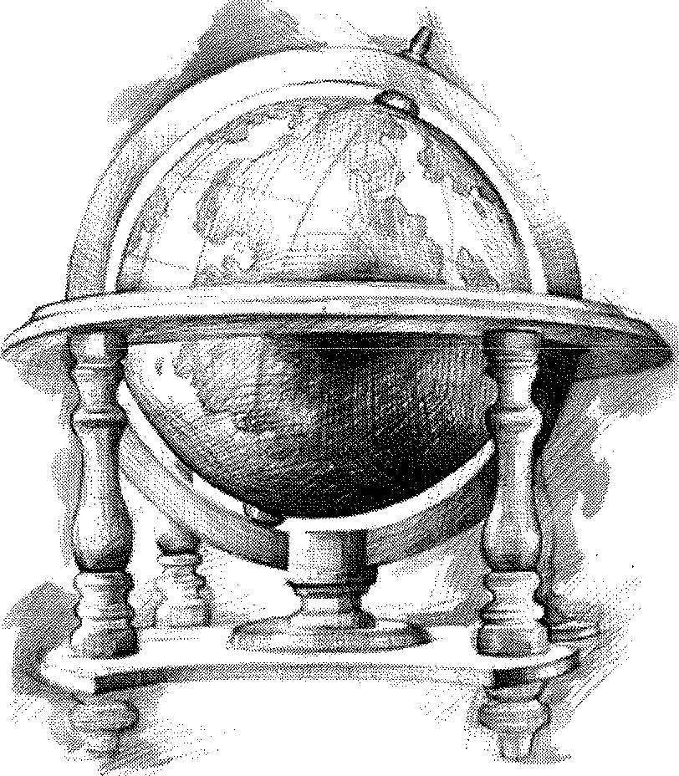

Name: ------

**AP Human Geography Review Project**

Directions: On one side of the note card write the key term. On the other side define or summarize the key term. All key terms listed below, but you are welcome to include additional terms/ concepts as you feel you need them.

Purpose: Review for units, review for the midterm in December, and AP Exam review in May. With this in mind, it would be in your best interest to develop these notecards while you are reading or studying for each unit. Do not procrastinate. Knowledge of these terms and concepts will help you immensely in this course and on the AP exam.

Due Dates:

• Unit 1-3 Due: Friday, November 21, 2014.

• Unit 4-7 Due: Friday, April 3, 2015.

Notecards may be turned in early, but note cards WILL NOT BE ACCEPTED AFTER THE DEADLINE. Assessment Value: 1 summative grade[= test grade)

Format: Your 3x5 or 4x6 notecards need to be rubberbanded together in the following format. These MUST be

handwritten and in a notecard format. Each card MUST be numbered. You may even want to number them on both sides. This project will NOT be accepted in any other format.

First Card:

George P. Student

May5, 2014

APHG Review Cards

Unit 1: Geography: Its Nature & Perspectives

(Rubenstein Ch. 1]

1. agricultural density

2. arithmetic density

3. base line

4. cartography

5. concentration

6. connections

7. contagious diffusion

8. cultural ecology

9. culturallandscape

1D. culture

11. density

12. diffusion

13. distance decay

14. distribution

15. environmental determinism

16. expansion diffusion

17. formal region

18. functional region

19. Geographic Information

System (GIS]

20. Global Positioning System

(GPS]

21. Globalization

22. Greenwich Mean Time

23. hearth

24. hierarchical diffusion

25. International Date Line

26. Land Ordinance of 1785

27. latitude

28. location

29. longitude

Second Card Front:

1.

Scarcity

30. map

31. mental map

32. meridian

33. parallel

34. pattern

35. physiological density

36. place

37. polder

38. possibilism

39. prime meridian

*4Q* prin p merid n

41. projection

42. region

43. regional studies

44. relocation diffusion

45. remote sensing

46. resource

47. scale

48. section

49. site

50. situation

51. space

52. space-time compression

53. stimulus diffusion

54. toponym

55. township

56. transnational corporation

57. uneven development

58. vernacular region

(Kuby Ch. 1]

59. aggregation

60. choropleth map

61. dot map

62. human-environment interaction

Second Card Back:

when unlimited wants exceed limited resources

63. human geography

64. isoline map

65. legend

66. location

67. map projection

68. map scale

69. movement

70. place

71. primary data

72. proportional symbol map

73. reference map

74. region

75. secondary data

76. simplification

77. spatial data

78. thematic map

(Kuby Ch.2]

79. core

80. cultural landscape

81. culture

82. culture region

83. culture trait

84. domain

85. ecological trilogy

86. perceptual region

87. regional identity

88. sphere

89. symbol

90. syncretism

(Kuby Ch. 3]

91. barriers to diffusion

92. biased innovation

93. hierarchical effects

94. spatial diffusion

*APHG Vocab Notecard Project*

95. urban hierarchy

Unit 2: Population & Migration

(Rubenstein Ch. 2):

96. agricultural density

97. agricultural revolution

98. arithmetic density

99. census

100. crude birth rate (C8R]

101. crude death rate (CDR]

102. demographic transition

103. demography

104. dependency ratio

105. doubling time

106. epidemiologic transition

107. epidemiology

108. ecumene

109. Industrial Revolution

110. infant mortality rate (IMR)

111. life expectancy

112. medical revolution

113. natural increase rate (NIR)

114. overpopulation

115. pandemic

116. physiological density

117. population pyramid

118. sex ration

119. total fertility rate (TFR)

120. zero population growth (ZPG)

(Kuby Ch. 5)

121. age-specific birth rate

122. cohort

123. demographic momentum

124. Demographic Transition Model

(DTM)

125. diaspore

126. equilibrium

127. hidden momentum

128. replacement fertility

(Rubenstein Ch. 3)

129. brain drain

130. chain migration

131. circulation

132. counterurbanization

133. emigration

134. floodplain

135. forced migration

136. guest workers

137. immigration

138. internal migration

139. international migration

140. interregional migration

141. intervening obstacles

142. intraregional migration

143. migration

144. migration transition

145. mobility

146. net migration

147. pull factor

148. push factor

149. quotas

150. refugees

151. undocumented immigrants

[KubyCh 4)

152. distance decay

153. extreme value

154. gravity model

155. migration counterstream

156. migration selectivity

157. migration

158. stream

159. net migration rate

160. outlier

161. remittances

162. residuals

163. scatter diagram

164. spatial interaction

Unit 3: Cultural Patterns & Processes

[Rubenstein Ch. 4)

165. custom

166. folk culture

167. habit

168. popular culture

169. taboo

(Rubenstein Ch. 5)

170. British Received Pronunciation

171. Creole or creolized language

172. Dialect

173. Ebonies

174. extinct language

175. Franglais

176. ideograms

177. isolated language

178. language

179. language branch

180. language family

181. language group

182. lingua franca

183. literary tradition

184. official language

185. pidgin language

186. Spanglish

187. standard language

188. Vulgar Latin

(Rubenstein Ch. 6)

189. animism

190. autonomous religion

191. branch

192. caste

193. cosmogony

194. denomination

195. diocese

196. ethnic religion

197. fundamentalism

198. ghetto

199. hierarchical religion

200. missionary

201. monotheism

202. pagan

203. pilgrimage

204. polytheism

205. sect

206. solstice

207. universalizing religion

[Rubenstein Ch. 7]

208. apartheid

209. balkanization

210. balkanized

211. blockbusting

212. centripetal force

213. ethnic cleansing

214. ethnicity

215. ethnocentrism

216. multi-ethnic state

217. multinational state

218. nationalism

219. nationality

220. nation-state

221. race

222. racism

223. racist

224. self-determination

225. sharecropper

226. triangular slave trade

(Kuby Ch. 12)

227. enclave

228. ghetto

229. integration

230. plantation system

231. residential segregation

232. segregation index

233. social distance

234. spatial convergence

235. spatial divergence

236. tenant farmer

Unit 4: Political Geography

(Rubenstein Ch. 8)

237. balance of power

238. boundary

239. city-state

240. colonialism

241. colony

242. compact state

243. elongated state

244. federal state

245. fragmented state

246. frontier

247. gerrymandering

248. imperialism

249. landlocked state

250. perforated state

251. prorupted state

252. sovereignty

253. state

254. unitary state

[Kuby Ch. 13)

255. colony

256. ethnonationalism

257. homeland

258. irredentism

259. nation

260. nationalism

261. nation-state

262. patriotism

263. province

264. raison d'etre

265. refugee

***APHG Vocab Notecard Project***

266. regional autonomy

267. secession

26B. separation

268. shatterbelt

Unit 5: Agriculture & Rural Land Use

[Rubenstein Ch. 1OJ

270. agribusiness

271. agriculture

272. cereal grain

273. chaff

274. combine

275. commercial agriculture

276. crop

277. crop rotation

27B. desertification

278. double cropping

2BO. grain

2B1. Green Revolution

2B2. horticulture

2B3. hull

2B4. intensive subsistence agriculture

2B5. milkshed

2B6. paddy

2B7. pastoral nomadism

2BB. pasture

2B8. plantation

280. prime agricultural land

281. ranching

282. reaper

283. ridge tillage

284. sawah

285. seed agriculture

286. slash-and-burn agriculture

287. shifting cultivation

28B. spring wheat

288. subsistence agriculture

300. sustainable agriculture

301. swidden

302. thresh

303. transhumance

304. truck farming

305. vegetative planting

306. wet rice

307. winnow

30B. winter wheat

(KubyCh. B)

308. capital

310. capital-intensive agriculture

311. commercial agriculture

312. comparative advantage

313. extensive agriculture

314. 1" Agricultural Revolution

315. free trade

316. friction of distance

317. globalization

31B. global-local continuum

318. hunting & gathering

320. intensive agriculture

321. irrigation

322. labor-intensive agriculture

323. land cover

324. land use

325. livestock

326. mixed farming

327. monoculture

32B. nomadism

328. remote sensing

330. 2"' Agricultural Revolution

331. sedentary agriculture

332. 3'' Agricultural Revolution

333. time-space convergence

334. yield

Unit 6: Industrialization & Economic

Development

(Rubenstein Ch. 8)

335. development

336. Gender Empowerment Index

(GEM)

337. Gender-Related Development

Index [GDI]

33B. Human Development Index

(HOI)

338. Gross Domestic Product (GOP)

340. Less Developed Country (LDC)

341. literacy rate

342. More Developed Country

(MDC)

343. primary sector

344. productivity

345. secondary sector

346. structural adjustment program

347. tertiary sector

34B. value added

(Kuby Ch. 7]

348. appropriate technology

350. circular & cumulative causation

351. core periphery

352. dependency school

353. economic indicators

354. Gross National Product (GNP)

355. Human Welfare Indicators

356. import substitution

357. modernization

35B. neocolonialism

358. neoliberal counterrevolution

360. polarization effects

361. spread effects

362. structural change

363. subsistence economy

364. substitution of capital for labor

365. sustainable development

366. technology transfer

367. transition economies

(Rubenstein Ch. 11)

36B. break-of-bulk point

368. bulk-gaining industry

370. bulk-reducing industry

371. cottage industry

372. fordist

373. Industrial Revolution

374. labor-intensive

375. *maquiladora*

376. new international division of labor

377. post-fordist

37B. right-to-work state

378. site factors

3BO. situation factors

3B1. textile

3B2. trading bloc

(Kuby Ch. 6)

3B3. agglomeration

3B4. basic industry

3B5. capital goods

3B6. cost minimization

3B7. division of labor

3BB. economic base model

3B8. economies of scale

380. externalities

381. industrial economy

382. labor productivity

383. localization economies

384. market oriented

385. nonbasic industry

386. outsourcing

387. postindustrial economy

38B. primary activity

388. producer services

400. quaternary activity

401. raw material oriented

402. regional multiplier

403. secondary activity

404. services

405. spatial division of labor

406. technological spillovers

407. tertiary activity

40B. transaction costs

408. ubiquitous

410. urbanization economies

Unit 7: Cities & Urban Land Use

(Rubenstein Ch. 12)

411. basic industries

412. business services

413. Central Business District (CBD)

414. central place

415. Central Place Theory

416. city-state

417. clustered rural settlement

41B. consumer services

418. dispersed rural settlement

420. economic base

421. enclosure movement

422. gravity model

423. market area (or hinterland)

424. nonbasic industries

425. personal services

426. primate city

427. primate city rule

42B. prorducer services

428. public services

430. range (of a service)

431. rank-size rule

432. retail services

433. service

434. settlement

***APHG Vocab Notecard Project***

435. threshold

436. transportation and information services

(KubyCh. 9)

437. Central Place Function

438. order

439. urban hierarchy

(Rubenstein Ch. 13)

440. annexation

441. census tract

442. concentric zone model

443. council of government

444. density gradient

445. edge city

446. filtering

447. gentrification

448. Greenbelt

449. Metropolitan Statistical Area

(MSA)

450. micropolitan statistical area

451. multiple nuclei model

452. peripheral model

453. public housing

454. redlining

455. rush (or peak] hour

456. sector model

457. smart growth

458. sprawl

459. squatter settlement

460. underclass

461. urbanization

462. urbanized area

463. urban renewal

464. zoning ordinance

(Kuby Ch. 1OJ

465. concentric ring model

466. creative class

467. invasion and succession

468. modernism

469. postmodernism

470. slums

471. suburbanization

472. urban realm

473. urban underclass

(Kuby Ch. 11)

474. congestion

475. ecologically sensitive space

476. growth boundary

477. infill development

478. leapfrog development

479. mass transit

480. metropolitan government

481. mixed-use development

482. new urbanism

483. scenario

484. stakeholder

485. trade-off

486. urban fringe

487. urban sprawl

488. urban village

489. win-win solution

490. zoning

(Rubenstein Ch. 14)

491. acid deposition

492. acid precipitation

493. active solar energy systems

494. air pollution

495. animate power biochemical oxygen demand [BOO)

496. biodiversity

497. biomass fuel

498. breeder reactor

499. chlorofluorocarbon (CFC)

500. conservation

501. ferrous

502. fission

503. fossil fuel

504. fusion

505. geothermal energy

506. greenhouse effect

507. hydroelectric power

508. inanimate power

509. nonferrous

510. nonrenewable energy

511. ozone

512. passive solar energy systems

Additional terms you want to add for your own enrichment (not required]:

513.

514.

515.

516.

517.

518.

519.

520.

521.

522.

523.

524.

525.

526.

527.

528.

529.

530.

531.

532.

533.

534.

535.

536.

537.

538.

539.

540.

541.

542.

543.

544.

545.

546.

547.

548.

549.

550.

551.

552.

553.

554.

555.

556.

557.

558.

559.

560.

561.

562.

563.

564.

565.

566.

567.

568.

569.

570.

571.

572.

573.

574.

575.

576.

577.

578.

579.

580.

581.

***APHG Vocab Notecard Project***

Nature and Perspectives on Geography: Topics and Concepts Essential to Unit 1

Key Terms: These are the vocab notecards that you have created for Unit 1 that are part of your vocabulary notecard project. Know these terms and the concepts surrounding them. It will be helpful if you can provide examples or case studies for these concepts as well.

• agricultural density • location • vernacular region

• arithmetic density • longitude • aggregation

• base line • map • choropleth map

• cartography • mental map • dot map

• concentration • meridian • human-environment

• connections • parallel interaction

• contagious diffusion • pattern • human geography

• cultural ecology • physiological density • isoline map

• cultural landscape • place • legend

• culture • polder • location

• density • possibilism • map projection

• diffusion • prime meridian • map scale

• distance decay • principal meridian • Mercator projection

• distribution • projection • movement

• environmental determinism • region • place

• expansion diffusion • regional studies • primary data

• formal region • relocation diffusion • proportional symbol map

• functional region • remote sensing • reference map

• frequency • resource • region

• Geographic Information • scale • Robinson projection

System [GIS] • section • secondary data

• Global Positioning System • site • simplification

[GPS] • situation • spatial data

• Globalization • space • thematic map

• Greenwich Mean Time • space-time compression • time zones

• hearth • stimulus diffusion • non-standard time zone

• hierarchical diffusion • toponym •

• International Date Line • township

• Land Ordinance of 1785 • transnational corporation

• latitude • uneven development

Points to Ponder:

1. How do the studies of human geography differ from those of physical geography?

2. What makes one region more developed than another? More importantly, why has such a difference occurred?

3. Why do modern geographers reject the theory of environmental determinism?

4. How do physical processes such as climate, soil and landforms impact the study of human geography?

5. What impact has globalization have on the world network? Do what degree has this impact been a positive change and to what impact has the change been negative?

6. How has globalization led to an increased call for local diversity?

7. Why has the global economy produced a greater disparity between the core and periphery? Online Review:

[1] [http://bcs.wiley.com/hebcs/Books?action=mininav&bcsld=3206&itemld=0471701211&assetld=97828&](http://bcs.wiley.com/hebcs/Books?action=mininav&amp;bcsld=3206&amp;itemld=0471701211&amp;assetld=97828)

resourceld=8619&newwindow=true [Chapter 1 from the Kuby text...you can find links for ch 1-2, too.]

[2] <http://quizlet.com/1072080/ch-1-thinkinq-qeoqraphically-flash-cards/>[Chapter 1 from the Rubenstein text]

Chapter 1: Thinking Geographically

Key Issue **1:** How Do Geographers Address Where Things Are?

Rubenstein, pp. 6-15

1. Define map:

2. Define cartography:

**MAPS**

3. Give two examples of early mapmaking and its (unusual?) materials for the maps.

(a)

(b)

4. Who first demonstrated that the earth was round? How? Sa. Who was the first to use the term "geography."

5b. List three of his contributions in geography at that time.

(a) (b) (c)

6. Provide an example of developments in geography for each of the following: (Pg. 8,9)

Chinese

Muslims

Age of Discovery

(16th Century)

7. Define scale: Shown in 3 ways:

8. What is the advantage of a map which shows only a small portion of the earth's surface - like a neighborhood- that is, a large-scale map?

8b. What advantage does a map which shows the entire globe, a small-scale map, have?

9. When geographers convert the round earth to a flat map, they use a projection. All projections have some distortion (only a globe has none). List the four things that typically become distorted in various projections. (Pg. 9)

a. c.

b. d.

10. Two important projections are the Mercator and the Robinson. Complete the table below to compare their advantages and disadvantages. (Pg. 10)

|  |  |  |
| --- | --- | --- |
|  | ROBINSON | MERCATOR |
| IaJJ;  0.0  til  §  :>  "d  <t:: |  |  |
| IaJJ;  0.0  J:l  §  .6  ..t.i.l.  IJJ  Cl |  |  |

11. With regard to the Land Ordinance of 1785, which became the official survey system for the United States, define the following: (Pg. 10-12)

a) township-

b) sections-

**CONTEMPORARY TOOLS**

12. Geographers use a GIS (Geographic Information System) to store "layers" of data. Give three examples of types of data stored in a single layer.

13a. Define remote sensing:

13b. Remotely sensed images consist of pixels. What is the smallest area on the surface of the earth that can be scanned as a single pixel?

13c. List several things that geographers can map using remotely sensed data.

14. Complete the following regarding a Global Positioning System.

|  |  |
| --- | --- |
| GPS | |
| Elements/ components... | Uses/ implementation... |
|  |  |

Chapter 1: Thinking Geographically

Key Issue 2: Why Is Each Point On Earth Unique?

Rubenstein, pp. 15-30

**PLACE: UNIQUE LOCATION OF A FEATURE**

1. Define toponym:

2. Identify four ways in which places can receive names

a) b) c) d)

3. Identify three reasons for which places sometimes change names

a) b) c)

4. Define site:

5. List some site characteristics.

6. Complete the following sentence about site:

Human actions can ------

7. Define situation:

the characteristics of a site.

8. What role do familiar places have understanding situation of unfamiliar places?

9. What place is designated as 0 degrees longitude?

10. What is the name for the line drawn at 0 degrees longitude?

11a. How is a degree of longitude or latitude further subdivided?

11b. Give an example.

12. How many degrees of longitude do you need to travel across to pass through one "hour" of time (or one time zone)?

13. How many time zones are there?

14. Read the information in the green box on page 21: Where and why were standard time zones first adopted?

WHERE? WHY?

15. What is the longitude of the International Date Line?

16. Use the map on page 19 and the green box on p. 21 to annotate the map below.

• Draw the Prime Meridian and Intemational Date Line.

• Shade and label all countries (or regions) which use non-standard time zones.

• Label the country which has forced the 3000 mile deviation of the Prime Meridian.

**REGIONS: AREAS OF UNIQUE CHARACTERISTICS**

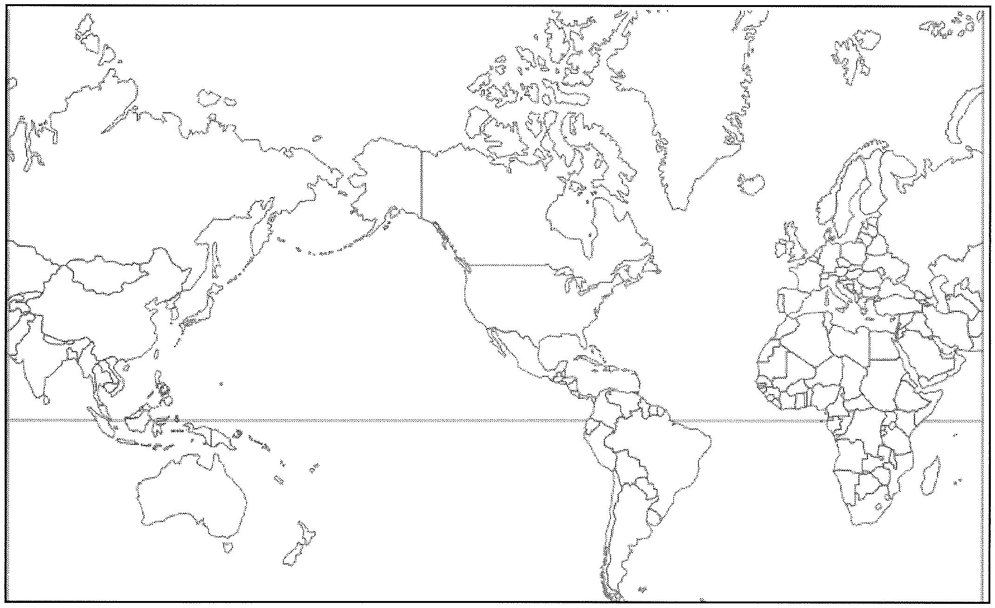

17. A region is an of defined by one or more

18. One contemporary (current) approach to studying the cultural landscape is called the regional studies approach. What do geographers who adopt this view believe regarding regions?

19. Geographers using the regional studies approach argue that that distinctive landscapes of different regions result from what two things?

a. b.

20. Complete the chart below which details types of regions identified by geographers.

|  |  |  |  |
| --- | --- | --- | --- |
|  | FORMAL REGION | FUNCTIONAL | VERNACULAR |
| 'ij  0 (l)  ...C...I..J::r:oI  ro u |  |  |  |
| ·.o  :s "-< (l)  'ij |  |  |  |
| ...(..l.)..  Sro"  ><  (l) |  |  |  |

21. How does a geographer conclude that two (or more) phenomena are "spatially associated," that is, that they bear some sort of cause and effect relationship?

22. Prepare a bullet chart about the word CULTURE

23. Very carefully define the following terms:

a. Cultural Ecology-

b. Environmental Determinism-

c. Possibilism-

24. How many major types of climates do geographers identify?

25. In what major way does climate influence human activities? (Give an example.)

26. List the four major biomes, or major plant communities, found naturally on earth.

a) c)

b) d)

27. What are the two major problems with which geographers are concerned, as far as soil is concerned?

a) b)

28. Complete two case studies which describe human modifications of and adaptation to the local environment. To do so, annotate the blank maps and bullet in brief notes to the right of each.

A) THE NETHERLANDS

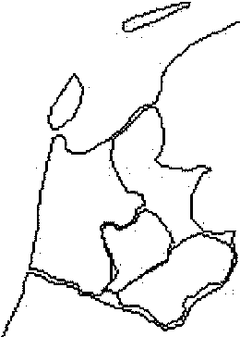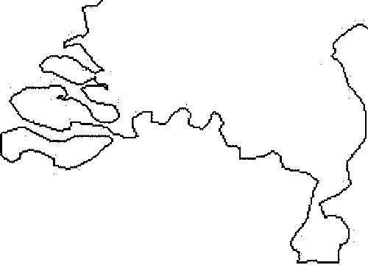

B) FLORIDA

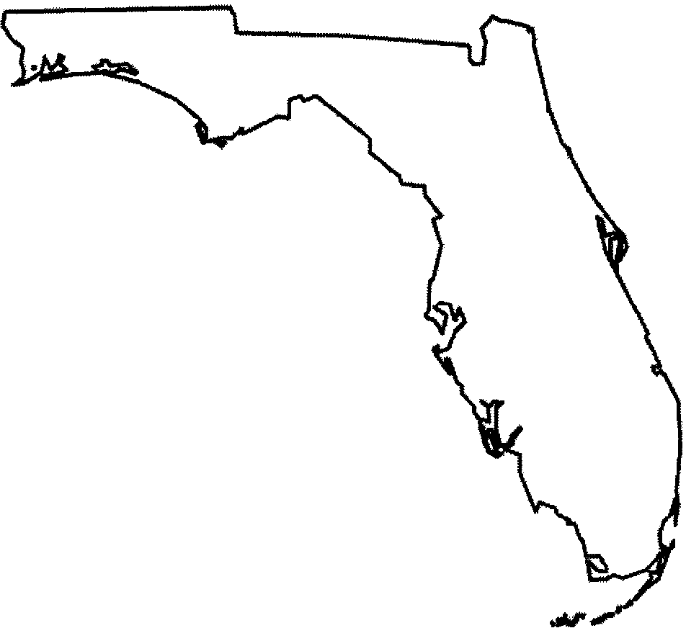

Chapter 1: Thinking Geographically

Key Issue 3: Why Are Different PlacesSimilar?

Rubenstein, pp. 30-40

**SCALE: FROM LOCAL TO GLOBAL**

1. Define globalization:

2. How has modern technology played a role in globalization?

3. In what ways is globalization of culture manifest in the landscape?

4. In what ways has the communications revolution played a role in globalization?

5. Make three bulleted statements about reactions against globalism and globalization.

(a) (b) (c)

SPACE: DISTRIBUTION OF FEATURES

6. The -------------------of a feature in ----------------is known as its distribution.

7a. Define density:

7b. What is arithmetic density?

7c. What is physiological density?

Sa. The way in which a feature is spread over space is known as concentration. What are the opposite ends of the spectrum of concentration?

a.

b.

8b. The boxes below - draw 10 dots in each so that the density is the same in each, but illustrate and label the two different kinds of concentration.

9. List the three different types of pattern given in the text. a.

b.

c.

10. What role does gender play in geography? (What is the "geography of gender"?)

11. In what way do each of the following play a role in geography?

|  |  |
| --- | --- |
| ETHNICITY | SEXUAL ORIENTATION |
|  |  |

**CONNECTIONS BE1WEEN PLACES**

12. What is space-time compression?

13a. In the past, most interaction between places required what?

13b. How has this changed?

Name: Period: _

14. Give some examples of things that slow interaction among groups.

15. Describe the phenomenon known as distance-decay.

16. Diffusion is defined as the process by which a characteristic spreads across space. With regard to diffusion, define and, where possible, give an example of each of the

Following:

|  |  |  |  |
| --- | --- | --- | --- |
| DIFFUSION | | |  |
| hearth | |  | |
| relocation diffusion | |  | |
| r:::::  ·0  [/'J  ;::;  ........  .·.......  "0  I=:  ·0  [/'J  I=:  ttl  p...  >< | hierarchical diffusion |  | |
| contagious diffusion |  | |
| stimulus diffusion |  | |

**Unit 2 Population Study Guide**

**Population Terms & Concepts**

• Agricultural density • Population pyramids (specific

• Arithmetic density examples & case studies)

• Crude birth rate • Sex ratio

• Crude death rate • Total fertility rate

• Demographic transition (specific • Zero population growth

examples & case studies) • "Cairo Conference" on

• Dependency ratio Population

• Doubling time • Natalist Neutral

• Epidemiologic transition • sterilization & abortion (specific

• Ecumene & non-ecumene countries & case studies on these

• Infant mortality rate issues)

• Life expectancy • Pro-natalist policies (where are

• Malthus & Malthusian Theory the strongest ones found?)

• Natural increase rate • Neo-Malthusians

• Natural checks • Replacement Fertility

• Pandemic • China's One-Child Policy

• Physiological density

**Points for Consideration**

1. How real is the fear of overpopulation? Will it result in the downfall of our planet or will people develop means to meet the needs of the world's population?

2. What role should a country play in the growth of its population?

3. How has the growth or decline in population been impacted by disease?

4. What difficulties face a nation moving through the four demographic transition models?

**Study Suggestions:**

• Review GDQs

• Study Quizlet & Kuby electronic notecards (see website 1st week of population unit) to help with vocabulary

• Know the vocabulary terms & concepts, but also know the in-depth application of this terminology

• Re-read chapter 2 key issues

• Anaylze charts, graphs, & maps from chapter 2

• Review & thoroughly understand the Demographic Transition Model and population pyramids

**FRQ Topics:**

• Ecumenes/non-ecumenes

• Population Pyramid

• Demographic Transition Model

Be familiar with case studies on each of the above topics. Be able to analyze, cite, and reference specific countries. Familiarize yourself with all the case studies/countries that are in the Kuby text and the Rubenstein text. The Kuby pop pyramids can be accessed at the [www.wiley.com](http://www.wiley.com/) website that you should be familiar with by now.

In a population pyramid, why ae men also shown on the left and women on the right? Because women are always right...bahahahahaha ;)

Chapter 2: Population

Key Issue 1: Where Is The World's Population Distributed?

Rubenstein, pp. 47-53

**POPULATION CONCENTRATIONS**

1. The world's population is highly clustered, or concentrated in certain regions. FOUR major population concentrations are identified in the text. Shade and label the areas of these concentrations on the map. TWO smaller concentrations, or emerging clusters, are also identified. Indicate these on the map as well.

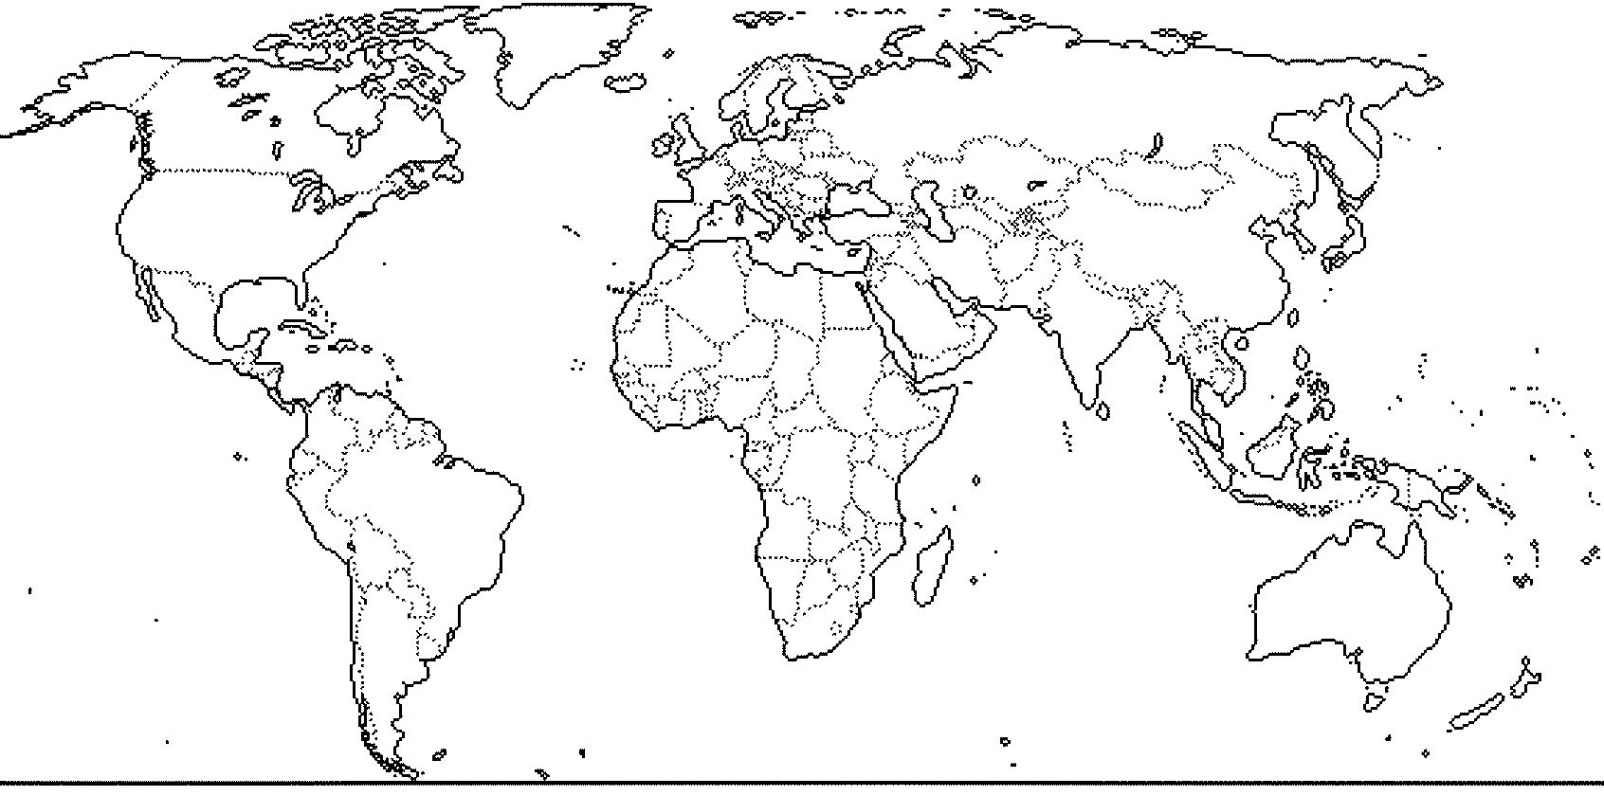

.,-

......

.......f.·•·•

2. In the boxes below, make note of significant facts, features, countries involved, and characteristics of the four most im ortant o ulation concentrations and two secondar ones.

EAST ASIA SOUTH ASIA

SOUTHEAST ASIA EUROPE

EASTERN NORTH AMERICA

WEST AFRICA

**SPARSELY POPULATED REGIONS**

3a. Define ecumene:

3b. What would non-ecumene mean?

4a. List the four LANDS,which are sparsely populated on earth in the table below. For each region, briefly explain the reason, which makes it inhospitable for human habitation.

|  |  |
| --- | --- |
| Sparsely population land | Reason for inhospitablity |
|  |  |
|  |  |
|  |  |
|  |  |

4b. Use the map on page 51 of your book or pages 30 and 31of your Goodes World Atlas to prepare a sketch map which shows non-ecumene and very sparsely inhabited lands. You may join them into a single category. Identify larger areas on the map with terms from the above charts leftcolumn.

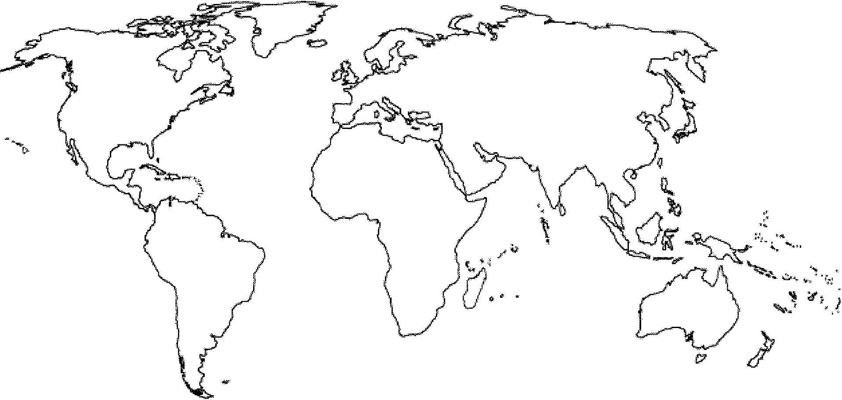

**POPULATION DENSITY**

5. Define each of the following terms:

a. Arithmetic density

b. Physiological density c. Agricultural density

Chapter 2: Population

Key Issue 2: Where Has the World's Population Increased?

Rubenstein, pp. 53-57

1. Define each of the following:

a. crude birth rate (CBR)

b. crude death rate (CDR)

c. natural increase rate (NIR)

**NATURAL INCREASE**

2. What is the NIR today?

3. When did global NIR peak, and what was it?

4. About how many people are being added to the world's population each year?

5. Define doubling-time:

6. In what world regions is most growth occurring?

**FERTILITY**

7a. Define total fertility rate (TFR):

7b. What is the global"average" TFR?

8. Note the rates and locations of the global "highs and lows" in TFR.

**MORTALITY**

9. Define the following:

a. infant mortality rate:

b. life expectancy

10. How are these mortality rates distributed globally, in terms of the developed and developing worlds?

Chapter 2: Population

Key Issue 3: Why Is Population Increasing at Different Ratesin Different Countries?

Rubenstein, pp. 57-69

THE DEMOGRAPHIC TRANSITION

1. The demographic transition is a with several and every is in one of them.

2. Fill in the chart below with characteristics describing each stage in the demographic transition model (CBR, CDR, NIR, etc.). Characterize the amount of growth of each stage (high, low, stable, etc.)

|  |  |  |  |
| --- | --- | --- | --- |
| Demographic Transition  Model | | | |
|  |  |  |  |

STAGE1 STAGE2 STAGE3 STAGE4

3. Read about how England passed through the various stages of the model on pages 61and 62. Describe a historical event for stages 1and 2 and a cultural attitude for stage 4.

|  |  |  |  |
| --- | --- | --- | --- |
| Stage 1event | Stage 2 Event | Demographic Transition  Model in England... | Stage 4 attitude |
|  |  |  |
|  | |  | |

**POPULATION PYRAMIDS**

4. The shape of a pyramid is primarily determined by what demographic rate?

5. What is the dependency ratio?

6. What age groups are categorized as *11*dependent"?

7. What does the *11*graying" of a population refer to?

8. What is the sex ratio?

9. What types of countries/regions are likely to have more males than females?

**COUNTRIES IN DIFFERENT STAGES OF DEMOGRAPHIC TRANSITION**

10. In the table below, which represents the four stages of demographic transition, identify a characteristic country which is in that stage and briefly describe how it *11*got there" as described in the textbook.

|  |  |  |  |
| --- | --- | --- | --- |
| Stages of Demographic Transition: Example countries | | | |
|  |  |  |  |

STAGE1 STAGE2 STAGE3 STAGE4

**DEMOGRAPHIC TRANSITION AND WORLD POPULATION GROWTH**

11. How many countries are in each of the following stages of the demographic transition?

a. Stage 1?

b. Stages 2 and 3?

c. Stage 4?

12. Identify the two "big breaks" in the demographic transition and their causes.. a. the first break

b. the second break

13. In what sense can we say that the first break came to different world regions for different reasons and in different ways?

a. it came to Europe and North America...

b. it came to Africa, Asia, and Latin America...

Chapter 2: Population

Key Issue 4: Why Might the World Face an Overpopulation Problem?

Rubenstein, pp. 69-76

**MALTHUS ON OVERPOPULATION**

1. Complete the table below to describe the views and theories of various population theorists.

|  |  |  |
| --- | --- | --- |
| Thomas Malthus | Neo-Malthusians | Critics of Malthus |
|  |  |  |

**DECLINING BIRTH RATES**

2a. Where was Malthus right?

2b. In what way was Malthus mistaken?

3. What are the only two ways to bring birth rates down?

a.

b.

4. What two strategies have proven successful to lower birth rates?

a. b.

5. Take notes on important facts regarding the distribution of contraceptives.

**WORLD HEALTH THREATS**

6. What is "epidemiologic transition"?

7. Complete the table below with notes on the stages of epidemiologic transition.

|  |  |  |
| --- | --- | --- |
| EPIDEMIOLOGIC | | |
| Stages 1 and 2 | Stages 3 and 4 | Possible Stage 5 |

**Unit 2: Migration Study Guide**

**Migration Terms & Concepts**

• Brain drain

• Chain migration

• Circulation

• Counterurbanization

• Distance decay

• Emigration

• Extreme value

• Floodplain

• Forced migration

• Gravity Model

• Guest workers

• Immigration

• Internal migration

• International migration

• Interregional migration

• Intervening obstacle

• Intraregional migration

• maquiladora (from learner.org video case study)

• Migration

• Migration counterstream

• Migration selectivity

• Migration stream

• Migration transition

• Mobility

• Net migration rate

• Outlier

• Pull factors

• Push factors

• Quotas

• Ravenstein's Laws of

Migration

• Refugee

• Remittances

• Residuals

• Scatter diagram

• Seasonal migration

• Spatial interaction

• Unauthorized immigration

• Voluntary migration

**Study Suggestions:**

• Review GDQs

• Study Quizlet & Kuby electronic notecards (see website from week of October gth & 15th) to help with vocabulary

• Know the vocabulary terms & concepts, but also know the in-depth application of this terminology

• Re-read chapter 3 key issues

• Analyze charts, graphs, & maps from chapter 3

• Review & thoroughly understand Newton's First Law of Migration: the Gravity Model

• Re-watch video case studies from [www.leamer.org](http://www.leamer.org/) (the Power of Place #2 and #21 and "Human

Geography: People, Places, and Change #8)

**FRQ Topics:**

• Mexico as a case study for migration

• Maquiladora

• Guest workers & population pyramids

• Demographic Transition Model + International Migration + Immigration from the 1800s-1900s

**Topics for Looping MCQs -and- Looped FRQS:**

• Population Pyramids

• Demographic Transition Model

• Malthusian Theory

Be familiar with case studies on each of the above topics. Be able to analyze, cite, and reference specific countries. Familiarize yourself with all the case studies that are in the Kuby & Rubenstein texts.

Chapter 3: Migration

Key Issue 1: Why Do People Migrate?

Rubenstein, pp. 85-90

REASONS FOR MIGRATING

1. What are push factors and pull factors?

2. Complete the table below with specific examples of push and pull factors.

ENVIRONMENTAL

|  |  |  |
| --- | --- | --- |
| PUSH FACTORS | | PULL FACTORS |
| ECONOMIC |  |  |
| CULTURAL |  |  |
|  |  |  |

3. Define: intervening obstacle

4. Briefly describe role of each of the following in examining intervening obstacles and migration:

a) physical geography

b) transportation

c) political concerns/laws

**DISTANCE OF MIGRATION**

5. Migration may be classified as either international or internal. What is the difference?

6. What types of push factors are usually responsible for each of the following categories of international migration?

a) voluntarymigration...

b) forcedmigration(refugees)...

7. Briefly state what one would expect to occur, in terms of migration, in each stage of the demographic transition model, as it is applied to a migration transition.

|  |  |  |
| --- | --- | --- |
| MIGRATION TRANSITION | | |
| STAGE1 | STAGE2 | STAGES3 &4 |

**CHARACTERISTICS OF MIGRANTS**

8. Complete the following table from the reading.

|  |  |  |  |
| --- | --- | --- | --- |
| Characteristics of Migrants | | | |
| Who? | | Where/distance? | Why? |
| l:.t:1  0  z  l:.t:1  (j | In the past.. Present trends... |  |  |
| *Cf)*  ::J  E-<  <t:  E--<  *Cf)*  -  <t:  :.I.; | In the past and still today...  Recent changes... |  |  |

9. Answer the following questions regarding migrants from Mexico who move to the United States.

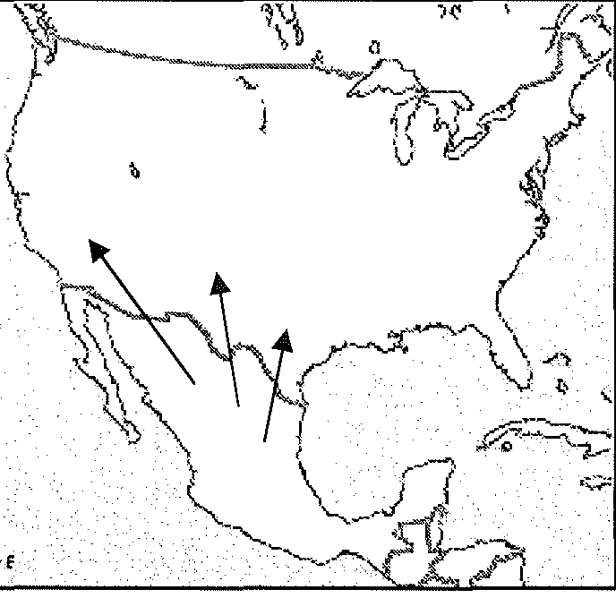

A) In what ways does migration from Mexico to the US

support each of the following geographic models?

i. Migration Transition Model (as adapted from the Demographic Transition Model):

ii. Distance-decay function:

B) In what ways does migration from Mexico to the US benefit... i. the Mexican migrants?

ii. Americans?

C) How does seasonality make this phenomenon as much a concept of human mobility, rather than permanent migration?

Chapter 3: Migration:

Key Issue 2: Where Are Migrants Distributed?

Rubenstein, pp. 90-98

**GLOBAL MIGRATION PATTERNS**

1. Read the section and then make 5 summary statements regarding global migration patterns.

(a) (b) (c) (d) (e)

U.S. **IMMIGRATION PATTERNS**

2. Finish this statement: The world's third most populous country (the US) is inhabited overwhelmingly by...

3. Annotate the graph below from your reading of pages 91 to 95. Be sure to label all "peaks" and ''valleys" (as indicated by arrows) as well as the national origins of immigrants during different periods.

900,000

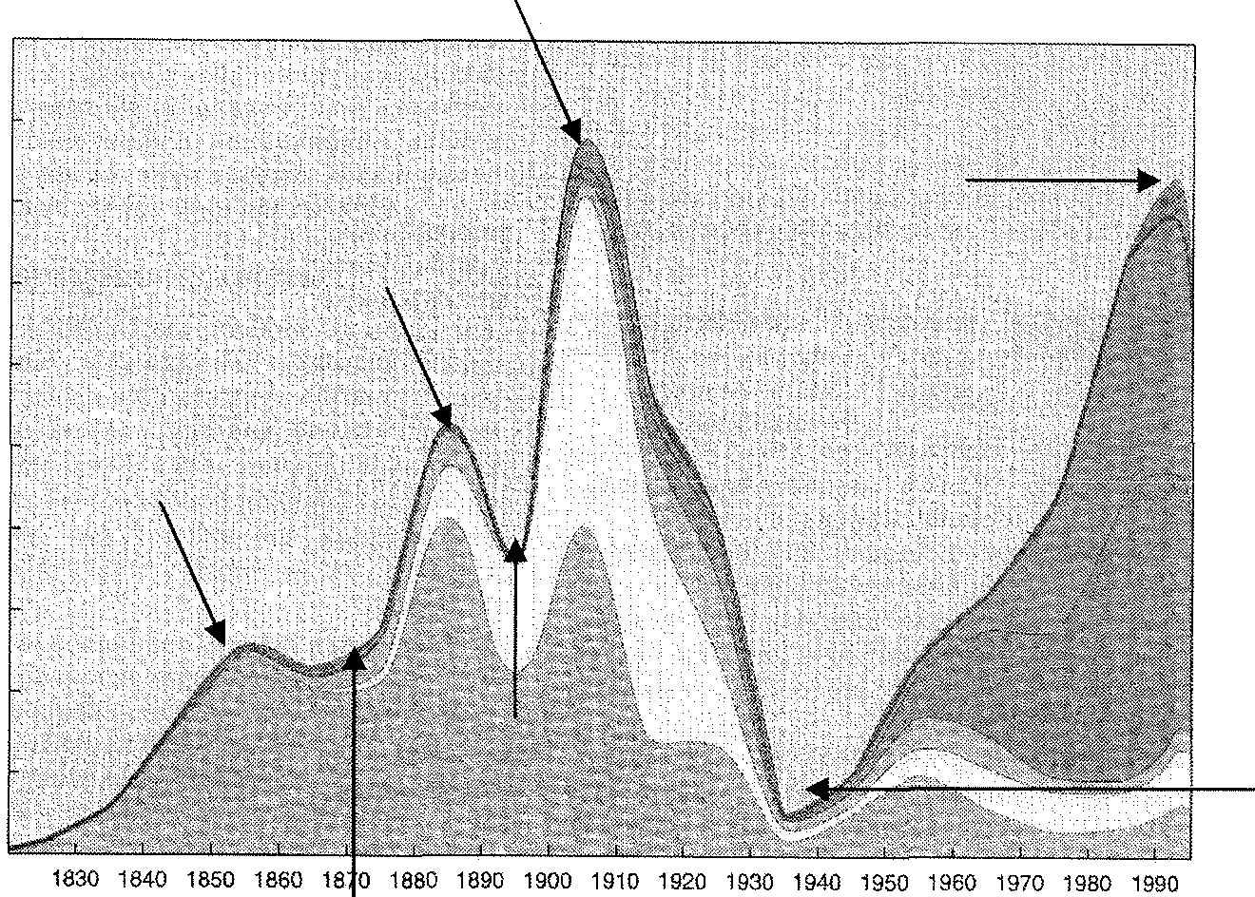

1"ii'

'0

Jg

800,000

700,000

:§ 600,000

£"'

g 500,000

<::

0

.!2'

E

.5

400,000

g 300,000

<"(

200,000

100,000

Year

:-R dR c t! ; ti& -L ;so p d R;gi (p 9Z5) d- he£ 11 -g--:

1 questions:

I

1---------------------------------------------------------1

4. During the 19th century and first half of the 20th century, how many Asian immigrated to the

US?

5. How many Asians immigrated to the US during the last quarter of the 20th century?

6. What were the FOUR countries which sent the most immigrants from Asia in recent years?

7. Describe three ways in which immigration to Canada is different than immigration to the

US in terms of the following ethnicities. a) Asians:

b) Europeans:

c) Latin Americans:

8. In what years did immigration from Latin American explode and peak?

9. What three Latin American countries send the most immigrants to the US in the last 25 years?

10. In what stage of the Demographic Transition are most countries that send immigrants?

11. Although the reasons people leave their countries to immigrate to the US have not changed over time, what has changed here in the US?

**IMPACT OF IMMIGRATION ON THE UNITED STATES**

12. Complete the table regarding below.

EUROPEAN IMMIGRATION

What were some of the important effects of

What were some of the causes of European

immigration to the United States?

European immigration to the US and other world regions?

13a. What are undocumented immigrants?

13b. Where do most undocumented immigrants to the US come from?

14. How did the 1986 Immigration Reform and Control Act attempt to change the status of some illegal immigrants, that is, which did it try to help (and how)?

(a) (b)

15. Read Destination of Immigrants Within the United States (p. 97) and annotate the map below. Write any important facts/notes around the map. Be sure to indicate; What states are the destination of most immigrants to the US? Where are immigrants coming from? Which states are the destinations of which groups of immigrants?

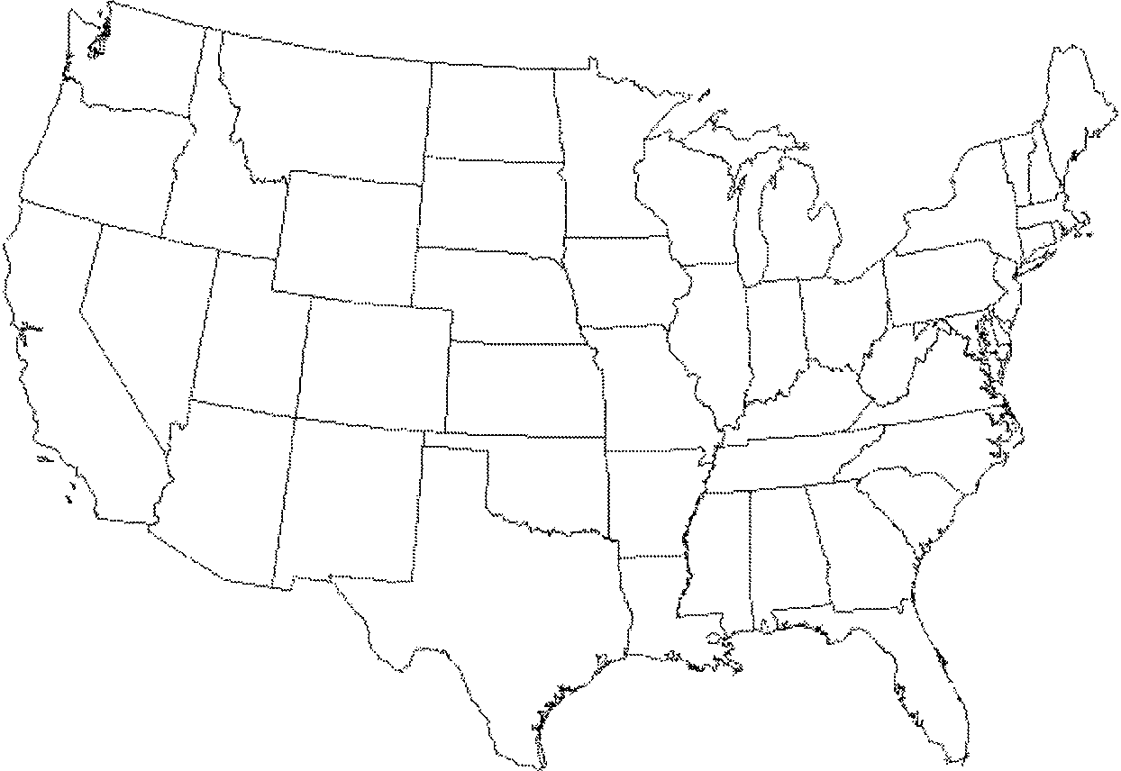

16. Define chain migration:

Chapter 3: Migration

Key Issue 3: Why Do Migrants Face Obstacles?

Rubenstein, pp. 98-104

**IMMIGRATION POLICIES OF HOST COUNTRIES**

I US Quota Laws I

1a. What did the Quota Act (1921) and the National Origins Act (1924) do?

lb. How did they favor immigration from certain regions?

2. How did the Immigration Act of 1965 change the existing quotas laws?

3. How was immigration law further changed in 1978?

4. US immigration law gives preferences to three groups. Identify them. a.

b.

c.

5. Define brain drain:

Temporary Migration for Work

6. Define guest worker:

7. Annotate this map with information from the book on pages 99 and 100, "Temporary

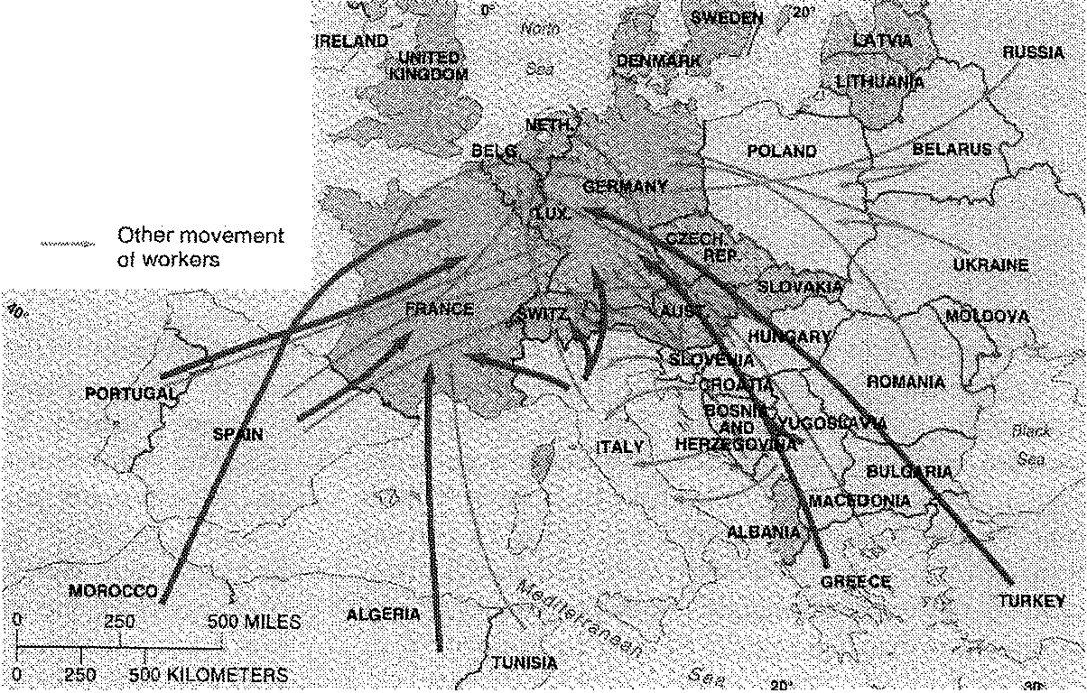

Migration for Work."

LABOR FLOW

Net Importer

Net exporter

No major flow

,: ernent

8. Define time contract worker:

9. Annotate the map below with information from the book on pages 100 and 101, "Time­ Contract Workers."

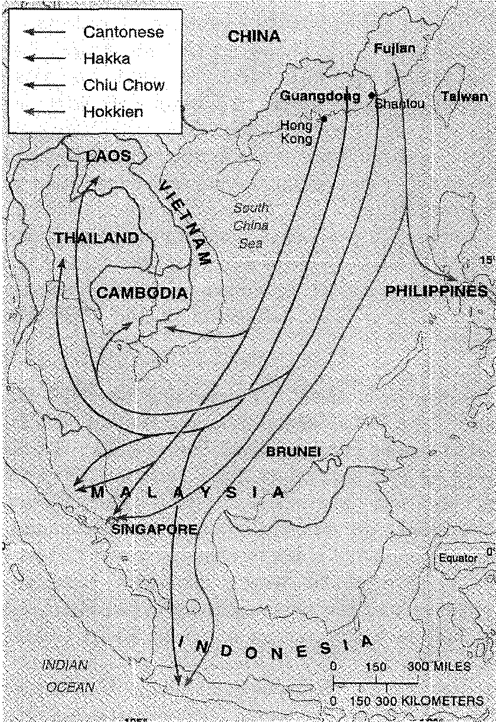

10. Prepare notes on three case studies of immigration in the table on the following page.

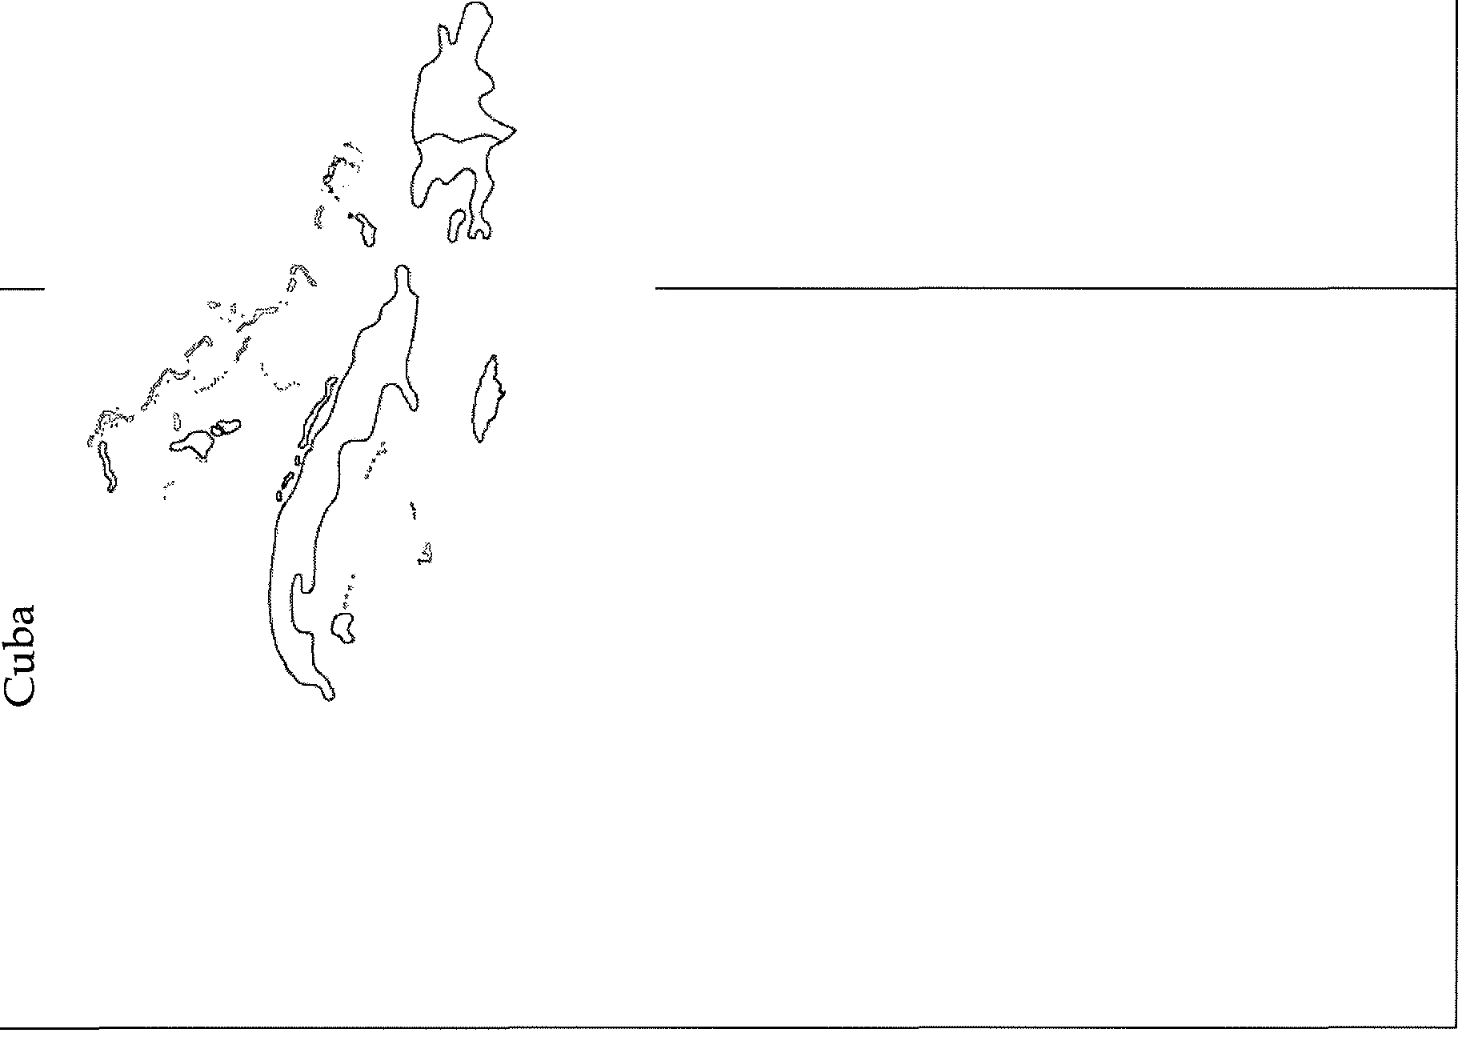

s

:6

.

>

d



**CULTURAL PROBLEMS LIVING IN OTHER COUNTRIES**

11. Carefully read this section and afterward, complete the Venn diagram below to compare and contrast attitudes in the US and Europe toward immigrants.

US ATTITUDES TOWARD IMMIGRANTS



EUROPEAN ATTITUDES TOWARD GUUEST WORKERS



Chapter 3: Migration

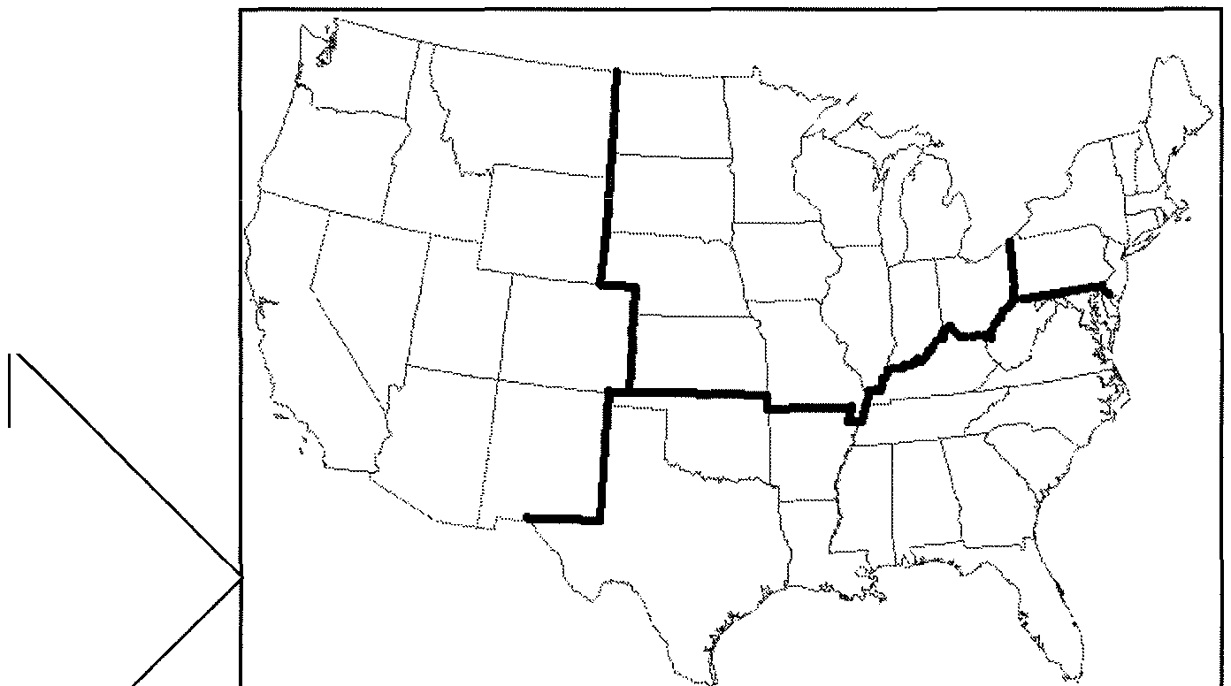

Key Issue 4: Why Do People Migrate Within a Country?

Rubenstein, pp.

**MIGRATION BETWEEN REGIONS OF A COUNTRY**

1. What is the most famous example of large-scale interregional migration in the US?

2. What is the "population center"?

3. What was the first "intervening obstacle" which hindered American settlement of the interior of the continent?

4. What developments in transportation eventually encouraged settlement to the Mississippi?

5. Why was settlement of the Great Plains slow to come, with settlers passing it by for

California and the west coast?

6. How did the railroads encourage settlement of the American interior?

7. For what two reasons have people been migrating to the South in recent years?

8. How is the migration pattern for African­ Americans different than that of whites?

9. Use the chart on page 106 to calculate the net growth (or loss) of US regions and place the appropriate number in each box in the map.

10. Make appropriate notes in the tables below on five specific examples/ case studies of interregional immigration.

|  |  |
| --- | --- |
| RUSSIA | |
| Where? | Why? |
| How? | |

|  |  |
| --- | --- |
| BRAZIL | |
| Where? | Why? |
| How? | |

|  |  |
| --- | --- |
| INDONESIA | |
| Where? | Why? |
| How? | |

|  |  |
| --- | --- |
| EUROPE | INDIA |
|  |  |

**MIGRATION WITHIN ONE REGION**

11. Define/ describe each of the following terms and summarize a single, important fact about its occurrence in the US.

|  |  |  |  |
| --- | --- | --- | --- |
|  | Urbanization | Suburbanization | Counterurbanization |
| ·:.so  .......  (l)  0 |  |  |  |
| [j)  ...s...  u  ...t..i.i.  .....  §  u  1......  [j) |  |  |  |

**APHG Unit 3 Exam Cultural Patterns & Processes Study Guide**

*The following are terms* & *concepts that you need to study for your test. These concepts are taken from our class work, from Rubenstein chapters 1 [culture-related terms), 4-7, and Kuby chapters 2* & *12 (Kuby Ch 2 was from unit 1}.*

[Rubenstein Ch. 1] • missionary Important Concepts:

• cultural diffusion • monotheism • Be able to explain how religion has

• diffusion of culture • pagan shaped the cultural landscape and be

• relocation diffusion • pilgrimage able to provide specific examples.

• examples of relocation diffusion

• polytheism • Be able to explain English as a the

• expansion diffusion • sect world's main lingua franca and be able to

• examples of expansion diffusion

•

explain the concept of lesser-used solstice

• contagious diffusion • universalizing religion

minority languages such as Welsh,

Basque, and lnuktitut and the revival of

• examples of contagious diffusion these lesser-used religions..

• hierarchical diffusion [Rubenstein Ch. 7] Be able to explain the distribution of

• examples of hierarchical diffusion

• apartheid •

religious groups in the United States,

• stimulus diffusion

• balkanization

factors that might influence this

• examples of stimulus diffusion • balkanized distribution, and the geography of religion

• cultural assimilation

• toponymy

• blockbusting in the United States.

• centripetal force • Globalization of western culture

• ethnic cleansing • Application of the term "cultural traits"

[Rubenstein Ch. 4) • ethnicity • Ancient cultural hearths

• custom • ethnocentrism • How religions impacts cultural patterns

• folk culture • genocide & processes

• habit • mult ethnic state • How language impacts cultural patterns

• popular culture • multinational state & processes

• taboo • nationalism • How ethnicity impacts cultural patterns

• nationality & processes

[Rubenstein Ch. 5) • nation-state • diffusion of modern languages

• British Received Pronunciation

• race

• adopting cultural traits

• Creole or creolized language

• Dialect

• Ebonies

• extinct language

• Franglais

• ideograms

• isolated language

• racism • Indo-European language family

• racist • facts about the English language

• self-determination • regional language variant

• sharecropper • linguistic isolation

• Shi'ite Muslims • countries that use English as an official

• Sunni Muslims language

• triangular slave trade • facts about official languages

• isogloss e why languages are protected and

• language [Kuby Ch. 12) preserved by cultural groups

• language branch • enclave • why British English is so widely spoken

• language family • ghetto around the world

• language group • integration • impact and influence of language on a

• lingua franca • plantation system culture

• literary tradition • residential segregation • hierarchical religion examples

• official language • segregation index • where various religions are found, their

• pidgin language • social distance hearths, founders, important religious

• revived language • spatial convergence locations, their diffusions, & distributions

• Spanglish • spatial divergence

• standard language • tenant farmer

- for all major world religions

• Similarities & differences between major world religions

• Vulgar Latin • Major Christian denominations

• vernacular language

(Kuby Ch.2]

• core

• Sacred sites in the major world religions

[Rubenstein Ch. 6)

• cultural landscape • Examples of cultural landscapes

• an1m1sm •

culture • Religions influence on cultural

• autonomous religion • culture region

• branch • culture trait

• caste • domain

• cosmogony • ecological trilogy

• denomination • perceptual region

landscapes

• Diffusion of popular culture

• Material aspects of culture v. non-

material aspects of culture

• Popular v. folk culture

• How folk cultures perceive their

• diocese • regional identity environment

• ethnic religion • sphere • Examples of popular & folk cultural

• fundamentalism • symbol landscapes

• ghetto • syncretism

• hierarchical religion

Chapter 4: Folk and Popular Culture

Key Issue 1: Where Do Folk and Popular Cultures Originate and Diffuse?

Rubenstein, pp. 117-122

**ORIGIN OF FOK AND POPULAR CULTURE**

--------------------------------------------------------,

1 This section looks at the origin and diffusion of specific examples of both folk and popular **1**

: culture. Specifically examined examples of folk culture are FOLK MUSIC and AMISH :

: CULTURE. Examples used to illustrate popular culture are POPULAR MUSIC and :

QCClliL

---------------------1

1. List elements of the origin and characteristics of FOLK

MUSIC.

2. List elements of the origin and diffusion of POPULAR MUSIC.

3. Shade and label the hearths of country music in the US and label the location of the origin of popular music with a dot.

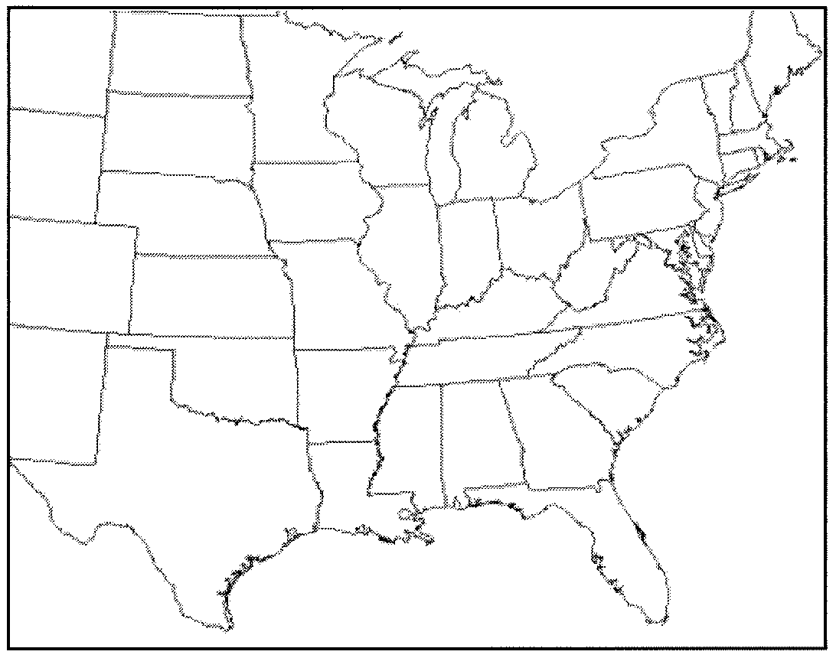

**DIFFUSION OF FOLK AND POPULAR CULTURE**

------------- -----------------,

THE AMISH

4. Where did Amish culture originate and how did it diffuse to the United States?

5. In what ways is Amish culture distinct from the popular culture of the United States?

What is happening to the Amish in the United

States today?

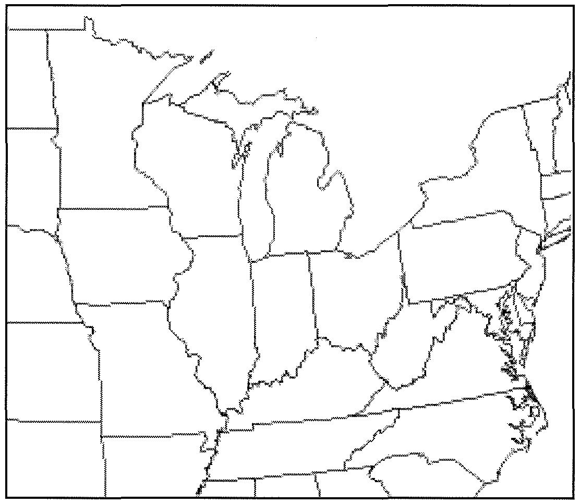

6. Identify Amish core areas (larger settlements) and then use dots and arrows to indicate the spread of Amish culture throughout a larger region.

7. How was soccer transformed from a folk custom into popular culture?

.""'•"

,,,,'

8. Despite their anonymous folk origins, what characteristics of organized spectator sports today characterize them as popular culture?

9. Draw a small graphic in the space below to link popular sports with the countries in which they are most popular and with which they are best associated.

Chapter 4: Folk and Popular Culture

Key Issue 2: Why is Folk Culture Clustered?

Rubenstein, pp. 122-128

**ISOLATION PROMOTES CULTURAL DIVERSITY**

1. Summarize how cultural diversity in the Himalayas is displayed in local art.

2a. What cultural institution is shaping these differences?

2b. What environmental conditions (which are the same for all groups here) are NOT ensuring similar art forms in this case?

**INFLUENCE OF THE PHYSICAL ENVIRONMENT**

3. How does clothingstyle (in this case, shoes) indicate the influence of the environment on folk culture?

4. List 5 different examples of food habits and the unique folk cultures each illustrates.

•

•

•

•

•

5. Indicate some food attractions and taboos, along with the cultures that practice them, in the table below.

|  |  |  |  |
| --- | --- | --- | --- |
| .J:<UUU AllKALllUl\1 | | .J:<UU*U* 1A lilJlJ | |
| Cultures/ regions | Foods/ reasons | Cultures/ regions | Foods/ reasons |
|  |  | |  |
|  | | |

6. In what sense are building materials of folk housing unique? Provide examples.

7. List 5 examples of house form and the unique folk cultures each illustrates.

US HOUSES

8. Fred Kniffen, a cultural geographer, has identified three source regions for American folk housing styles: New England, Middle Atlantic, and Lower Chesapeake. List the housing styles he identified with each region. Draw them.

New England (4 styles)

a. c.

b. d.

Middle Atlantic (1dominant style)

Lower Chesapeake

Chapter 4: Folk and Popular Culture

Key Issue 3: Why Is Popular Culture Widely Distributed?

Rubenstein, pp. 129-137

1. In contrast to folk customs, popular customs diffuse

surface to locations with a wide variety of

.across the earth's

. This

diffusion depends, however, upon a group of people having a sufficiently high level of

---------------

in order to obtain the --------

associated with the popular custom.

**DIFFUSION OF POPULAR HOUSING, CLOTHING, AND FOOD**

HOUSING

2. Complete the chart below to indicate the decade(s) during which each housing style was dominant and a fact about the particular style of house.

|  |  |  |
| --- | --- | --- |
| Style | Decade(s) | Fact |
| minimal traditiona  1 |  |  |
| ranch house |  |  |
| split-level |  |  |
| contemporary style |  |  |
| shed style |  |  |

3. List the so-called neo-eclecticstyles of the 1960's and 70's.

a. c.

b. d.

CLOTHING



4. In Western countries where popular culture predominates, clothing styles generally reflect

rather than particular _

5. Complete a bullet chart with 5 facts about clothingstyles associated with popular culture.

•

•

•

•

•

6. Summarize the four facts you believe to be most important to remember about jeans as an example of popular culture in the box at right.

I FOOD I

7. Consumption of large quantities of what two food products are characteristic of popular culture?

a. b.

8. How is each of these food preferences expressed regionally, according to culture? A (from above).

B (from above).

9. Summarize the four facts you believe to be most important to remember about wine production in the box at right. ------------

**wi**•**ne**

**ROLE OF TELEVISION IN DIFFUSING POPULAR CULTURE**

10. Give two reasons for which television is an especially significant element of culture:

A) B)

11. Complete this chart with countries and/ or regions.

|  |  |  |
| --- | --- | --- |
| Television is universal | Television is common | Television is rare |
|  |  |  |

12a. Currently, where is the Internet most widely available?

12b. To what regions will it most likely spread next?

12c. What regions, then, does that leave as still relatively untouched by the Internet, in the foreseeable future?

13. Describe the differences between US/Westernhemisphere television control and that found elsewhere.

TELEVISION CONTROL, ETC.

Western Hemisphere Elsewhere

14. Regarding governmental control of television... a.howisitchanging?

b. what is causing the changes?

c. what are the effects of these changes?

Chapter 4: Folk and Popular Culture

Key Issue 4: Why Does Globalization of Popular Culture Cause Problems?

Rubenstein, pp. 137-142

**THREAT TO FOLK CULTURE**

1. How and where has folk clothing styles worldwide been threatened by popular culture?

2. How have women in many parts of the world been helped by the spread of popular culture? How have they been hurt?

3. What three countries dominate worldwide television markets? What regions does each dominate?

Country dominating television ...

Region it dominates ...

4. Why do developing nations view television as a new source of cultural imperialism?



5. What are the world=s two largest newspaper organizations? Who owns them?

6. In many parts of the world, what is the only reliable and unbiased source of news information?

**ENVIRONMENTAL IMPACT OF POPULAR CULTURE**

7. How is the playing of golf and golf courses an example of a popular custom which is not generallyinharmony with the local environment?

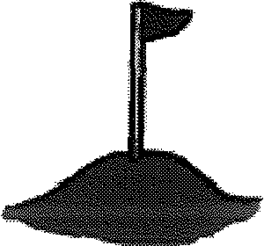

8. What is a Auniform landscape@?

9. How and why is this concept utilized by fast-food restaurants?

10. What are the twoways in which popular customs have an adverseeffect on the natural environment?

a. b.

Chapter 5: Language

Key Issue 1: Where Are English-Language Speakers Distributed?

Rubenstein, pp. 149-156

**ORIGIN AND DIFFUSION OF ENGLISH**

1. How did English become so widely diffused?

2. What three European peoples originally came together to form the English people and English language?

3. Where did these people come from?

4. What two subsequent invasions added additional words to the evolving English language?

**DIALECTS OF ENGLISH**

5. Dialects are defined as Aregional variations of a language@and are distinguished by three things. List them.

a. b. c.

6. Define standard language:

7. What is the standard language form of English? Where did it come from (3 cities)? How was it diffused throughout Britain?

8. In a single word, why is American English different from that spoken in England?

9. In the table below, complete bullet charts of salient and interesting facts regarding each of the following differences between the British and American dialects of English.

|  |  |  |
| --- | --- | --- |
| Differences between British and American English | | |
| VOCABULARY | SPELLING | PRONUNCIATION |

10. Three distinct dialect regions are identified in the Eastern US. What was the source region of settlers for each?

|  |  |
| --- | --- |
| REGION | SOURCE OF SETTLERS |
| Northeastern US |  |
| Midlands (Tidewater, Chesapeake Bay area) |  |
| Southeastern coastal region |  |

11. Finish the two following sentences and fill in the blanks:

a. In most instances, words which are different in various dialects are words which are related to ....

b. Language differences, as exhibited in dialects, tend to be greater in

than because ...

12. People from all three eastern regions migrated into the Midwest, Great Plains, and the Western United States. Why, then, is there a relatively uniform form of English (dialect) spoken across this enormous area? (Hint: a single word will do.)

Chapter 5: Language

Key Issue 2: Why Is English Related to Other Languages?

Rubenstein, pp. 156-165

**INDO-EUROPEAN BRANCHES**

1. Germanic branch: Complete this chart from the reading.

**GERMAI'IIC BRANCH**

**WEST I'IORTH GERMANIC GERMAI'IIC GROUP GROUP**

I

I

I /

I I I I

2. Indo-Iranian Branch: Make two bullet charts from the reading.

IRANIAN GROUP (WESTERN)

INDIC GROUP (EASTERN)

3. Balto-Slavic Branch: Answer the questions below.

A. How did Russian become the most important East Slavic language? B. What is the most important West Slavic language?

C. Describe the controversy between Czech and Slovak languages under

Czechoslovakia=s government? What happened?

D. Why are South Slavic languages, which were once very similar to each other, becoming increasingly different today?

4. Romance Branch: Answer the questions.

(a) From what language did all Romance languages descend? (b) List the four most important Romance languages.

1. iii. ii. IV.

(c) Make a note about each of the following minor Romance languages:

• Romanian

• Romansch

• Catalan

• Sardinian

• Ladino

(d) What is Francien?

(e) What are the two important dialectical divisions of France today? (f) What is Castillian?

(g) How many countries in Latin America have Spanish as their official language?



(h) How does Spain maintain control of Spanish?

(i) Why is Portugal upset about the standardization of Portuguese?

**ORIGIN AND DIFFUSION OF INDO-EUROPEAN**

Sa. What is the name of the (theoretical) common ancestral language of all languages discussed in this key issue of the chapter?

Sb. Why is its existence difficult (impossible?) to prove?

"Kurgan" theory Renfrew hypothesis

Chapter 5: Language

Key Issue 3: Where are Other Language Families Distributed?

Rubenstein, pp. 165-171

**Classification of Languages**

1 compJIete thischart f rom therea mg.

|  |  |  |  |  |
| --- | --- | --- | --- | --- |
| Language Family | | Percent of  Speakers |  | Examples |
| Indo-European Family | |  |  |
| Tibetan Family | |  | |  |
| Afro-Asiatic | |  | |  |
| Austronesian | |  | |  |
| N!ger-Congo  Dravidian |  |  | |  |
|  |  | |  |

2. Analyze the Language family tree in figure 5-12. Answer the following questions. a. What do the tree trunks represent?

b. What do the leaves represent?

c. What does the size of the trunk of the tree represent?

d. Why is Celtic not shown on the language family tree?

**Distribution of Language Families**

3. Name the two branches of Sino-Tibetan branch, as well as, examples and numbers of speakers. a.

b.

4. Describe four specific features of the Chinese language. a.

b.

c.

d.

5. Explain how Japanese and Korean are distinctively different.

6. Explain key points for each of the following language families. Annotate and color code the Africa map.

|  |  |  |
| --- | --- | --- |
| Afro-Asiatic Family | Altaic and Uralic Family | African Family |
| 1.  2.  3.  4.  5. 1  6. The United Nations added Arabic I as its 6th official language in the General Assembly in and  the Security Council in . I | Altaic  1.  2.  3.  4. Uralic  1.  2.  3.  4. | 1.  2.  Niger-Congo  1.  2.  3.  Nilo-Saharan  1.  2. Khoisan  1.  Austonesian  1.  2. |

Chapter 5: Language

Key Issue 4: Why Do People Preserve Local Languages?

Rubenstein, pp. 171-180

Assignment: Prepare rather detailed notes (including sketch maps) on four "case studies" of language issues and much simpler notes (no sketch maps necessary) on three other countries whose experience provides a real-world example/ illustration of a concept in linguistic geography.

CASESTUDIES

• Nigeria: Problems in a multi-linguistic state (p. 171 [Key Issue 3])

• Celtic Languages: The struggle for survival of a language family ( pp. 172-73)

• Belgium: Political and linguistic divides ( pp. 173-

74)

• Swahili: A creolized lingua franca (see reading attached)

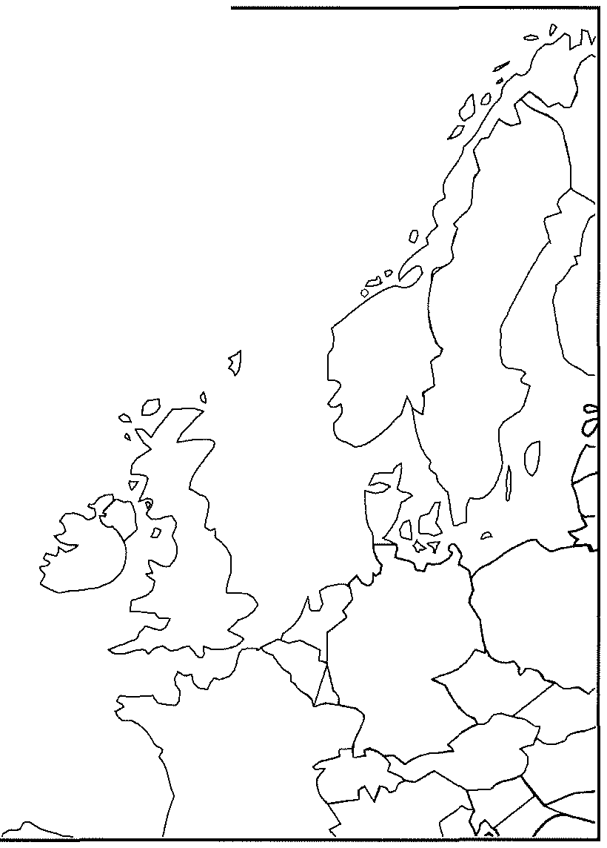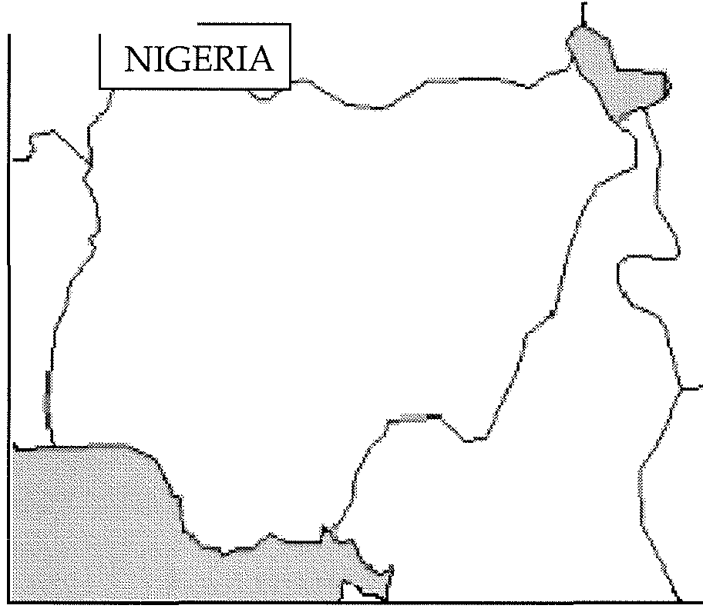

I CELTIC I

0

Q

REAL-WORLDEXAMPLES

• Hebrew:an extinct/ revived language

- p. 172

• Switzerland: successful multilinguilism

- p. 174

• Basques:an isolated language- p. 175

• Icelandic: an unchanging language- p.

175

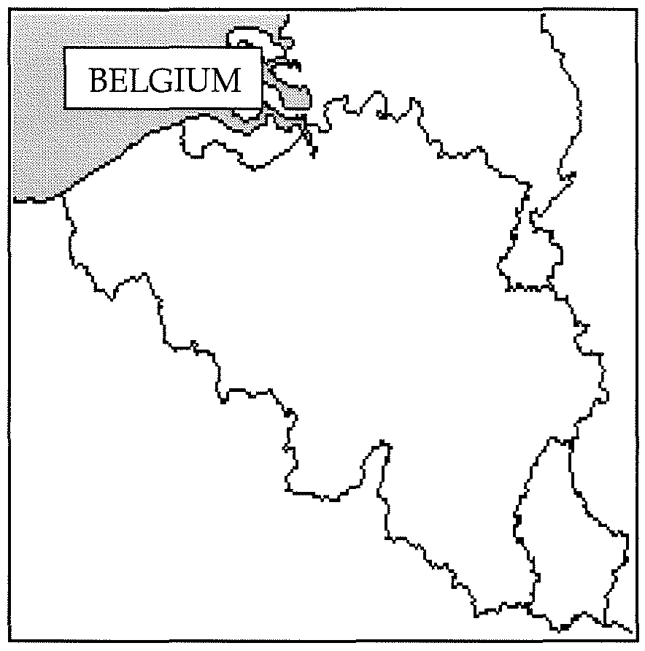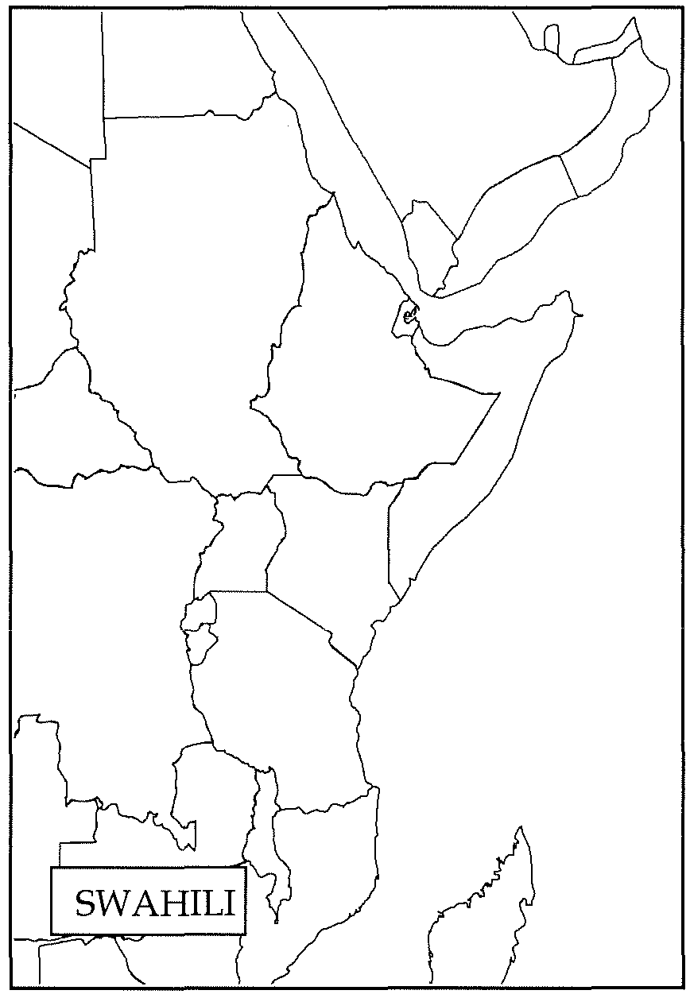

|  |
| --- |
| HEBREW |
| SWITZERLAND |
| BASQUE |
| ICELANDIC |

GENERAL INTRODUCTION

Swahili (also, and more properly, called Kiswahili) is an African language spoken mainly by the people of eastern and central Africa. That is, people who live in Tanzania, Kenya, Uganda, Rwanda, Burundi, eastern Zaire, northern Zaire, northern Malawi, northern Mozambique, northern Zambia and Somali Republic. Although not widely as in the above mentioned countries, Kiswahili is also used by some people in Congo Brazzaville, southern Sudan, the Comoro Islands, the northern part of Malagasy Republic, and the Persian Gulf states.

Swahili is spoken by an estimated 50 million people and, after Arabic, is the most widely understood language in Africa. It is the official language of Tanzania and Kenya and is used extensively in Uganda and the eastern provinces of Zaire. In Burundi and Rwanda, it is known and used in major urban centers, but is not widely known or extensively used in the monolinguistic countryside.

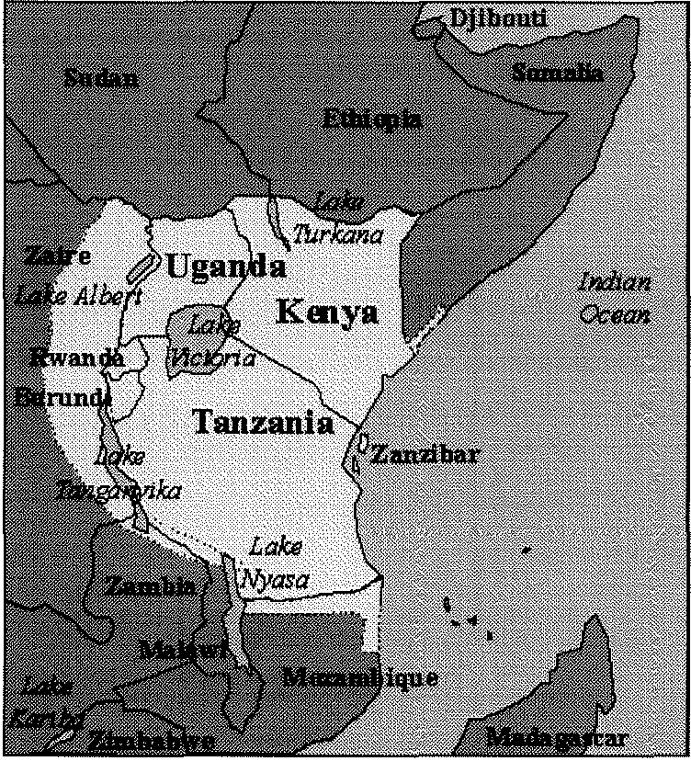

In countries that flank the area where Swahili functions as the common mode of communication, use of the language does spill over the border areas in small towns and villages along major transportation arteries, for example, in northern Mozambique, northern Zambia, and southern Ethiopia. Along the East African coastal strip from well

into Somalia and as far south as northern Mozambique there are communities of Swahili speakers. Of less significance are small and declining communities in the Comoro Islands, where local Swahili related vernaculars and French are the rule, and along part of the northwestern coast of Madagascar.

In spite of its large number of speakers and the huge area in which the language is spoken, Swahili has less than two million native speakers, most of whom live along the east African coast of southern Somalia, Kenya, Tanzania, northern Mozambique, and on the off shore islands of Lamu, Zanzibar, and Pemba. Most speakers in Tanzania and Kenya acquire Swahili as a second language, being native speakers of other African languages. Many speakers of Swahili, especially those further into the interior of the continent (up country) speak two or more other languages, and use Swahili as a lingua franca. A growing number of first language speakers, however, live in the urban areas of East Africa, where inter-ethnic communities prevail.

ROLE IN SOCIETY

Although English is still an important language in post independence East Africa, Swahili plays an increasingly vital role in the daily commercial, political, cultural, and social life of the region at every level of society. This is especially true in Tanzania, where the language is used throughout the country in government offices, the courts, schools and mass media. It has, in fact, become a more important language than English and, in some cases, is replacing English as the

this is less the case, and English still enjoys virtual equal status with Swahili. In Uganda the popularity of Swahili as a national or official language often reflects the attitude of the political faction that is currently in control. Swahili has never enjoyed high status among the major Christian oriented Bantu ethnolinguistic groups of southern and western Uganda, but was an important lingua franca in the northern areas of the country and has always been an important language among the military and police. For a period shortly after the Tanzanian Ugandan conflict the status of Swahili received a boost because people observed how effectively it functioned as the language of their liberators, the Tanzanians. In eastern Zaire it remains an important lingua franca and is spoken by growing numbers of native speakers in parts of the region.

HISTORY

Swahili spread through eastern Africa beginning in the nineteenth century when Arab/Swahili trade expanded along the East African coast, on Zanzibar, and in trading centers in the interior. Long before the arrival of European colonizers, it was the Swahili dialect of Zanzibar Town (Kiunguja) that spread inland and eventually became the basis for Standard Swahili in colonial and post independence East Africa. Furthermore, Swahili is one of the few African languages the has a precolonial written tradition. A thousand years of contact between Indian Ocean peoples and Swahili resulted in a large number of borrowed words entering the language, mainly from Arabic, but also others such as Persian and various Indian languages. At different periods Swahili also borrowed vocabulary from Portuguese and English. Such borrowing is comparable to the proportion of French, Latin, and Greek loans used in English. Although this proportion for Arabic loans may be as high as 50 percent in classical Swahili poetry (traditionally written in Arabic script), it amounts to less than twenty percent of the lexicon of the spoken language.

The oldest surviving documents written in Swahili date from the early 1700s. They are written in an Arabic script, reflecting the influence of Islamic culture on Swahili society. Most of these documents are transcriptions of Swahili epic poetry, recording on paper an oral tradition of works intended for chanting or singing. The most common of these poems are called Utenzi (Utendi), drawing upon conventions of both Arab verse and Bantu song. Its earliest composers most likely worked in Kenya, in the Lamu archipelago, using one of the northern Swahili dialects. The tradition later spread south to Mombasa and Pemba, where

the focus of the verse shifted from religious legends to social commentary, which continues to

be a theme used by contemporary Swahili poets. The classical poetry still plays a major role in Swahili culture; it is recited on special occasions and regularly quoted; newspapers often devote space to poetry that has been submitted by their readership.

Chapter 6: Religion

Key Issue **1:** Where Are Religions Distributed?

Rubenstein, pp. 187-194

**UNIVERSALIZING RELIGIONS**

I CHRISTIANITY I

1. Give the percentage of the world's Christian population belonging to each of Christianity's three major branches

Roman Catholic- Eastern Orthodox - Protestant-

2. Regarding Eastern Orthodox churches ...

How many separate churches are there? Which has by far the largest membership?

3. What percentage of Latin Americans are Roman Catholic?

4. Protestants comprise 40% of North Americans. List the five largest denominations (#5 is a tie) by percentage.

1.

2.

3.

4.

5.

5. Complete the chart with names of smaller branches of Christianity and their location of concentration.

|  |  |
| --- | --- |
| Branch of Christianity | Region of predominance |
|  |  |
|  |  |
|  |  |
|  |  |

ISLAM

6. Half of the world's Muslims live in the Middle East. The other half live in four countries outside the Middle East. List them.

1.

2.

3.

4.

7. Give the percentage for each of Islam's two great branches:

• Sunni-

• Shia-

8. Only in three countries do Shia Muslims number more than Sunni. List them and give the % Shia.

1.

2.

3.

BUDDHISM

9. Buddhism is built around "Four Noble Truths" as taught by the Buddha. Summarize them.

(a)

(b) (c) (d)

10. Complete this chart dividing Buddhism into its three main branches.

|  |  |  |
| --- | --- | --- |
| Branch | % of all global Buddhist population | Regions where predominant |
|  | | |

11. Why are Buddhists difficult to count?

OTHER UNIVERSALIZING

12. Where are Sikkhs concentrated?

13. What is the main belief of the Bahai?

**ETHNIC RELIGIONS**

HINDUISM I

14a. Where are Hindus concentrated? What% of all Hindus live there?

14b. Where are the rest? (include %)

15. Hinduism does not have different branches but, because it is polytheistic, does have some more populargods than others. Complete the chart below regarding the more popular forms of Hinduism.

|  |  |  |
| --- | --- | --- |
| FORM | %of global  Hindus | God worshiped (include a brief description) |
|  | | |

I OTHER ETHNIC RELIGIONS'

16. Make a note or two (that seem of geographic interest) about each of the following ethnic religions

A. CONFUCIANISM

B.DAOISM

C. SHINTOISM

D. JUDAISM

E. ANIMISM

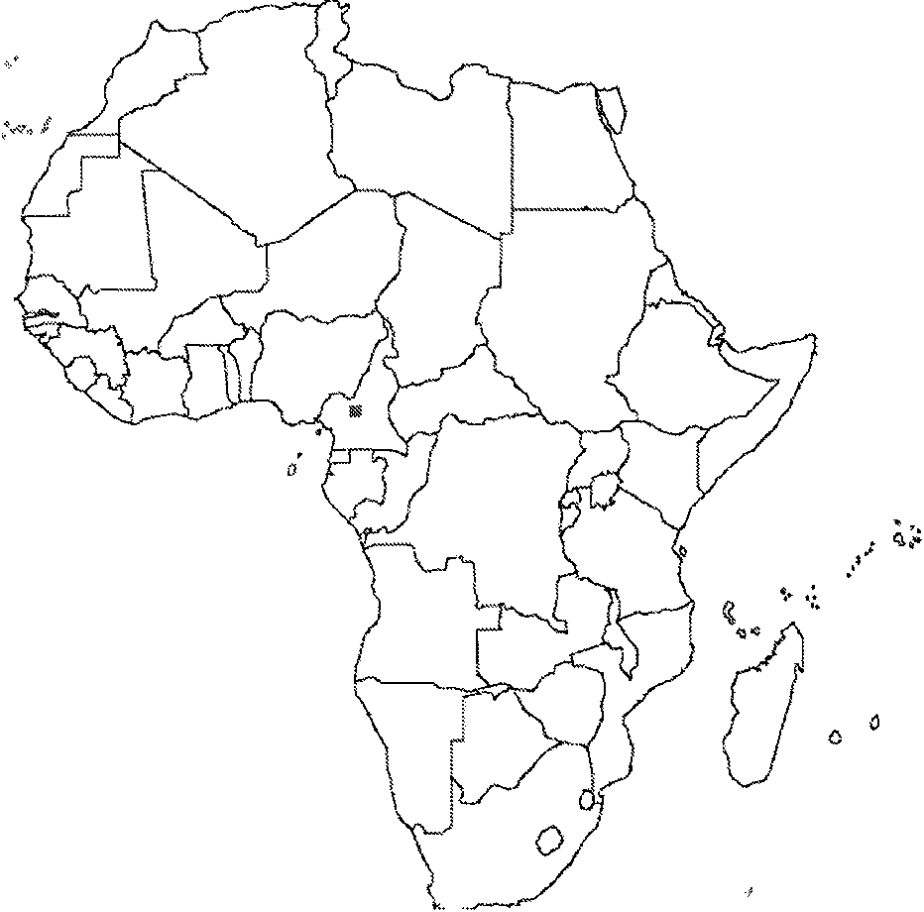

Shade, label, and annotate this map to illustrate animistic belief in Africa today.

Chapter 6: Religion

Key Issue 2: Why Do Religions Have Different Distributions?

Rubenstein, pp. 194-207

**ORIGIN OF RELIGIONS**

1. Complete the table below describing the origins and branches of the major universalizing religions.

|  |  |  |  |
| --- | --- | --- | --- |
|  | Lhnstiamty | lslam | tluddhlsm |
| Year of Origin |  |  |  |
| Founder |  |  |  |
| Major branches and main belief  of each branch |  |  |  |

2. Regarding Hinduism:

a. How was its origin different than universalizing religions?

b. When did it originate?

c. Where did it originate?

d. What twoancientpeoples beliefs blended to form Hinduism?

**DIFFUSION OF RELIGIONS**

3. Give 4 explanations for the diffusion of Christianity. a.

b. c. d.

4. Give 3 ways in which Islam spread.

a. b. c.

5. Give 2 reasons for the expansion of Buddhism. a.

b.

6. Provide 4 examples of cases in which religions, or religious practices, have blended.

|  |  |
| --- | --- |
| Religions which have blended | Location and description |
| A |  |
| B |  |
| c |  |
| D |  |

7. Regarding Judaism:

a. How is its distributionverydifferent from other ethnic religions?

b. What was the diaspora?

c. How were most Iewstreated as they lived amongothernationalities?

d. What is the origin of the term ghetto?

**HOLY PLACES**

8. What is a pilgrimage?

9. Read the section (pp. 201-204) and make notes on three case studies; Buddhism, Islam, and Hinduism. Then read the section titled Places of Worship (pp. 195-97) and complete the right hand side of the table. Naturally, drawing a little sketch map of locations would be helpful .

Buddhist Holy Sites

Islamic Holy Sites

Hindu Holy Sites

10. What is a cosmogony?

**THE CALENDAR**

11. What is the most prominent feature of the calendar in ETHNIC religions?

12. What is the principle purpose of the calendar in UNIVERSALIZING religions?

13. How does the Jewish calendar typical of ethnic use of the calendar?

14. What is the solstice?

15. Both the Jewish and the Muslims use a lunar calendar, yet in a different way and with very different results. Explain.

16. How is the date of Easter related to physical geography (the natural world) through the calendar?

17. Why do different Christian branches celebrate Easter on different days?

18. How is this similar to Buddhism's major holidays?

Chapter 6: Religion

Key Issue 3: Why Do Religions Organize Space in Distinctive Patterns?

Rubenstein, pp. 207-212

1. In what two ways do religious structures often stand out in a landscape?

PLACES OF **WORSHIP**

2. For what two reasons does a church, the physical structure, play a more critical role than in other religions?



3. Give two symbols present in Christian church architecture.

4. Complete the following table to express unique visible features of Christian churches.

|  |  |
| --- | --- |
| CHRISTIAN BRANCH or REGION | Unique design or typical feature |
| Orthodox Christianity |  |
| Protestant- esp. North America |  |
| Northeast US |  |
| Southeast US |  |
| Southwest US |  |
| Latin America |  |

5. How is a Muslim mosque viewed differently than a Christian church?

6. Identify 3 specific, visible, features of a typical mosque.

a. b. c.



7. How are Hindu temples different than both churches and mosques?

8. List 3 typical, visible features of a Hindu temple. a.



b. c.

9. What is the religious purpose of a Buddhist pagoda?

10. How was pilgrimage a part of the development of pagodas?



11. Formal worship in a pagoda is not typical. Where does is usually take place?

**SACRED SPACE**

12a. Christians practice burial of the dead. Complete the flowchart below to indicate the history of this practice.

.. H. _

,HL-_

12b. Make two notes about the use of cemetery land in urban areas a.

b.

12c. Complete the table below with brief notes on the disposal of the dead in ways other than burial.

|  |  |
| --- | --- |
| Hindus |  |
| Parsis (Zoroastrians) |  |
| Micronesians |  |

13. Complete the table below with brief notes on the religious settlements indicated.

|  |  |
| --- | --- |
| Utopian settlements |  |
| Salt Lake City, Utah |  |
| Puritans |  |

**ADMINISTRATION OF SPACE**

14a. Define hierarchical religion:

14b. List the Roman Catholic hierarchy, indicating geographic region and leader who heads it.

14c. Why are parishes in Latin America so much larger than those in Europe?

15a. Describe an autonomous religion:

Re on Leader

15b. In the absence of a hierarchy, what is the only formal organization of territory in

Islam?

15c. What holds Islam together?

16. Complete the table below to categorize other religions and denominations.

|  |  |
| --- | --- |
| Autonomous religions | Hierarchical religions |
|  |  |

Chapter 6: Religion

Key Issue 4: Why Do Territorial Conflicts Arise Among Religious Groups?

Rubenstein, pp. 212-221

1. Define fundamentalism:

2. Fundamentalism is increasing in the world today and its growth contributes to conflicts. Why is it increasing?

**RELIGION VERSUS GOVERNMENT POLICIES**

3. In what ways did the Taliban government of Afghanistan raise conflicts with

Western/modem ideas after it took control of the country in 1996?

4a. What aspect of Hinduism has clashed with Western/modem ideas?

4b. What western groups criticized this aspect? Why?

4c. How has the Indian government responded to this issue?

5. In Russia/Soviet Union, how did each of the following attempt to limit the influence of religion, specifically the Eastern Orthodox Church?

a) Czar Peter the Great:

b) Communism:

6. What happened, and is continuing to happen, in each of the following regions of the Russian Empire/Soviet Union since the fall of communism in the 1990s? Complete the table below by adding THREE more countries to each category and then describing what is going on at the present time in that region.

|  |  |
| --- | --- |
| Historic Catholic Regions | Historic Muslim Regions |
| Croatia, Czech Republic, Hungary, Lithuania | Kazakhstan, Kyrgyzstan, Tajikistan |
| Currently... | Currently... |

7. How were and are each of the following detrimental to Buddhism in Southeast Asia?

a) Vietnam War:

b) Communist regimes:

**RELIGION VERSUS RELIGION**

8. Describe in detail the conflicts occurring in the following locations.

Mt' rumumo£ f1' ve pteces o£histonca11'nformation f or each Sl'de.

|  |  |
| --- | --- |
| Middle East | Ireland |
| Groups/countries involved: | Groups involved |
|  |  |
|  |

**Unit 4 Study Guide: Ethnicity & Political Organization of Space**

KNOW

*All the vocab included on your Vocab Notecard Project guidelines for Unit 4! ©

BE ABLE TO

• explain the concept of "state" by:

• identifying necessary qualifications and characteristics

• listing examples of states in various regions

• describing "quasi-states"

• describe the problems of multinational states and stateless nations.

• list advantages and disadvantages of different types of boundaries and provide examples.

• list advantages and disadvantages of different shapes of states and provide examples.

• discuss the concepts of imperialism, colonialism and illustrate some of their consequences on the contemporary political map.

• explain the role of the following in the intemal structure of states:

• civil divisions

• federal or unitary structure

• irredentism, separatism, autonomy, and self-determination

• define and provide examples of forward capitals.

• summarize the history of the United Nations and identify issues of current importance regarding it.

• Discuss the evolution of the modem concept of the state.

• What are the major types of physical and cultural boundaries, and what conflicts can occur between states because of the manner in which boundaries are drawn.

• What geographic elements contributed to the development of the United States and Soviet Union/Russia as superpowers, and what geographic elements contribute to the weakness of these two countries?

• Describe the changes in world politics, economics, and military activities because of the rise of regional authorities.

Reading, Notes, & Videos to Review:

• Rubenstein, Chapter 7-8

• Ku by, Chapter 13

• Leamer.org Case Study Videos

• PPT Notes

• Ethnicity Quiz

Potential FRO Topics:

• Nation, State, & Nation-State

• Supranationalism & Devolution

• Political Boundary Issues

• Emergence of the Modern State

• Centripetal/ Centrifugal Forces

• Specific Case Studies:

Cyprus (Greeks & Turkish Cypriots)

Israel *j* Palestine

Kurds

European Union

UN/NATO/NAFTA Soviet Union Czech & Slovakia

Strasbourg, Germany

- Yugoslavia

- Taiwan/China

- Western Sahara/Morocco North/South Korea Cyprus

Kurds

Chechens

- Antarctica

Berlin Conference

- Japan & Denmark's Cultural

Homogenity

Iraq/Kuwait border issues Genocide case studies ShiajSunni

Brazil & forward capital

Chapter 7: Ethnicity

Key Issue **1:** WHERE ARE ETHNICITIES DISTRIBUTED?

Rubenstein, pp. 227-236

**DISTRIBUTION OF ETHNICITIES WITHIN THE UNITED STATES**

la. Define ethnicity:

lb. Define race:

|  |  |
| --- | --- |
| **Ethnic group** | **%of US**  **pop.** |
|  |  |
|  |  |
|  |  |
|  |  |

2. In the table at left, identify America's four major ethnic groups (other than white). Give their percentage of the total US population and shade areas in which they are clustered on the map.

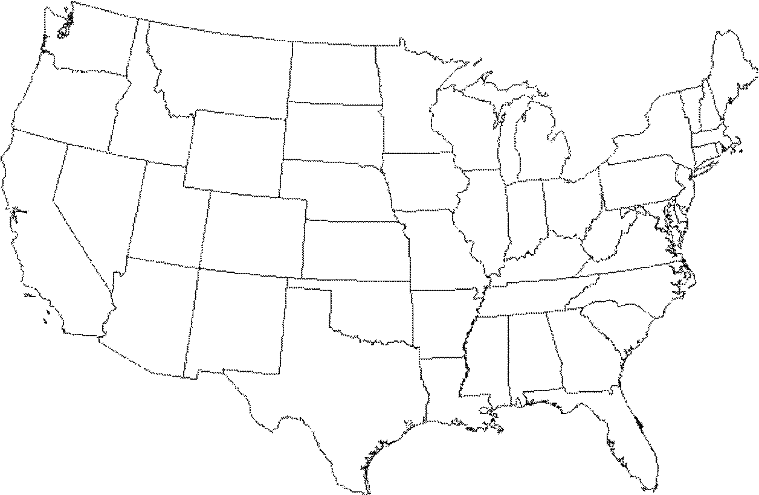

2a. What are the major Hispanic groups in the US?

2b. What are the major Asian groups in the US?

2c. Provide an example to illustrate that African-Americans or Hispanics in the US are more urbanized (likely to live in cities) than whites.

2d. In what region of a typical American city are ethnic groups concentrated? Why there?

3. Complete the table below to summarize the historic migration patterns of African-Americans.

|  |  |  |  |
| --- | --- | --- | --- |
| Migration from Africa | Migration to the North | Migration wi | thin cities (ghetto) |
|  |  |  |

**DIFFERENTIATING ETHNICITY AND RACE**

4. In terms of the concept of race...

a. what is the "problem" with the way the US Census Bureau defines"Asian"?

b. what is the difference between"African-American" and "black"?

c. how does the US Census Bureau consider Hispanic/ Latino?

5. What is racism?

6. Describe each of the following concepts dealing with the geography of race.

• "Separate Bu Equal"

• White Flight

• Blockbusting

7. Complete the case study as organized below.

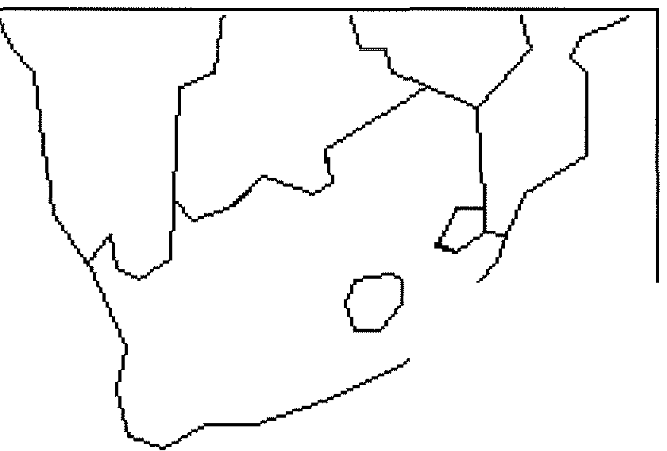

CASE STUDY IN DIVISION BY

RACE

SOUTH AFRICA

A. Define apartheid:

B. Explain the key components of the apartheid system:

C. Complete the following timeline of South African history and annotate the map.

• 1652

• 1795

• 1833

• 1860's-70's

• 1902

• 1948

• 1970's-80's

• late 1970's

• 1991

• 1994

Chapter 7: Ethnicity

Key Issue 2: WHY HAVE ETHNICITIES BEEN TRANSFORMED INTO NATIONALITIES?

Rubenstein, pp. 237-244

1. Define nationality:

2. Though they are very similar, use the table below to show how nationality differs from ethnicity.

(2nd paragraph of reading.)

|  |  |
| --- | --- |
| Ethnicity | Nationality |
|  |  |

**RISE OF NATIONALITIES**

3. Define each of the following related terms:

a. SELF-DETERMINATION-

b. NATION-STATE-

4. Use the table below to note briefly how some European examples of nationalities dealt with the issue of statehood and the pursuit of the nation-state ideal.

|  |  |  |
| --- | --- | --- |
| FRANCE | OTTOMAN-EMPIRE  AUSTRO-HUNGARIAN | GERMANY |
|  | | |

CASE-STUDY: DENMARK

5. Why is Denmark a fairly good example of a nation-state?

6. Three regions of Denmark prevent the country from being a perfectnation-state. List and describe them in the table below.

|  |  |  |
| --- | --- | --- |
| Denmark=s non-Danish regions | | |
| Region: | Region: | Region: |
| Description: | Description: | Description: |

7. Shade and label Denmark and her territories on this map of the North Atlantic region. Label several other countries in the region.

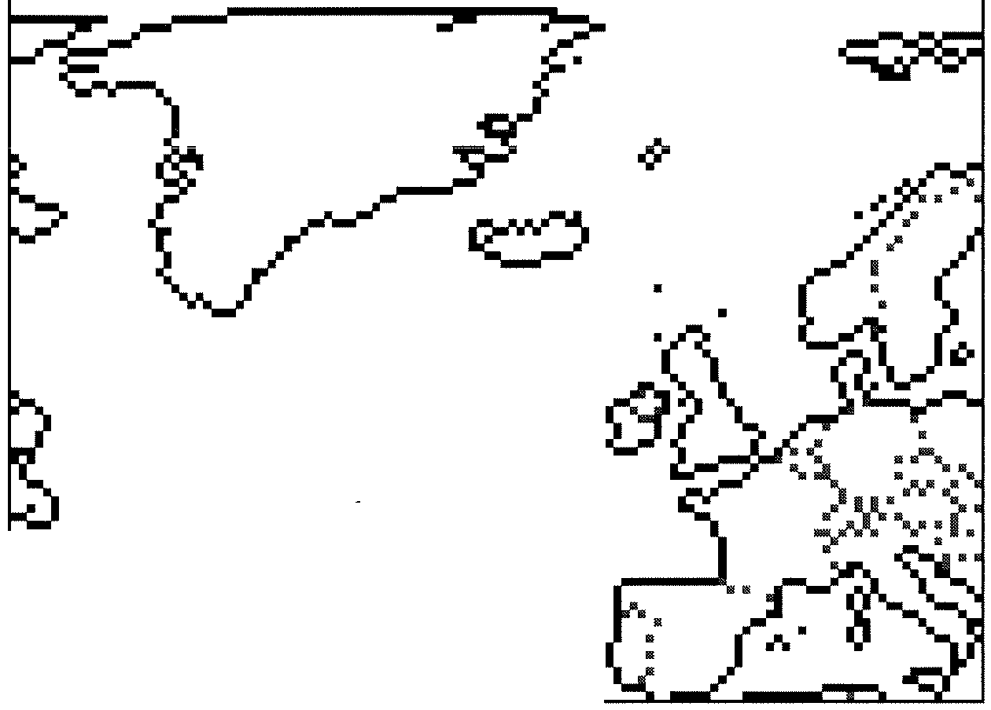

-...

8. Regarding NATIONALISM" (a) What is it?

(b) How do nations and states foster it?

(c) What are centripetal forces?

**MULTINATIONAL STATES**

9. What is a multiethnic state? Give an example.

10. What is a multinational state? Describe how the United Kingdom is an example.

11. When the Soviet Union dissolved into 15 countries in the 1990s, the new countries were based on ethnicities. They can be divided into 4 groups based on their location. Complete the chart below to indicate the countries in each group. NOTE: Be sure to look at the map on p. 240 to familiarize yourself with the locations of these countries.

|  |  |
| --- | --- |
| Baltic region  (3 states) |  |
| Eastern Europe  (3 states) |
| Central Asia  (5 states) |
| Caucasus  (3 states) |  |

12. Note the major religion and language of each of the Baltic states. a)

b)

c)

13. The ethnic divisions among the Eastern European states are blurred for what reasons?

14. Why has the Crimean Peninsula of Ukraine, been a bit of a problem?

15. What did the majority of Moldovans want when they gained independence? Who opposed this?

16a. What religions and languages are most common in the Central Asian countries?

16b. Have there been ethnic problems in Central Asia and, if so, where? If not, why not?

17a. How many different nationalities (ethnicities) are found in the country of Russia?

17b. Why are independence movements flourishing among these groups?

17c. Russia has resisted the independence movement in Chechnya for what TWO reasons?

i. ii.

18. In the Caucasus region, there have been many problems with the new nations and ethnicities. Summarize the main problem, and note specifics of regions and peoples, for each of the four main ethnicities.

|  |  |
| --- | --- |
| AZERIS (Azerbaijan) | ARMENIANS (Armenia) |
|  |  |
| GEORGIANS (Georgia/ Gruzny) |
|  |

**REVIVAL OF ETHNIC IDENTITY**

19. How did communists suppress the issues of ethnicity and nationalism? (Give several examples.)

20. With the fall of communist governments in the 1990's, what kinds of problems have arisen in what places? (Give several examples.)

Chapter 7: Ethnicity

Key Issue 3: WHY DO ETHNICITIES CLASH?

Rubenstein, pp. 244-250

**ETHNIC COMPETITION TO DOMINATE NATIONALITY**

1. Make notes on major issues in each of these ethnic conflicts and shade and annotate the map at right as necessary.

ETHIOPIA and

ERITREA

Case Study: AFRICA

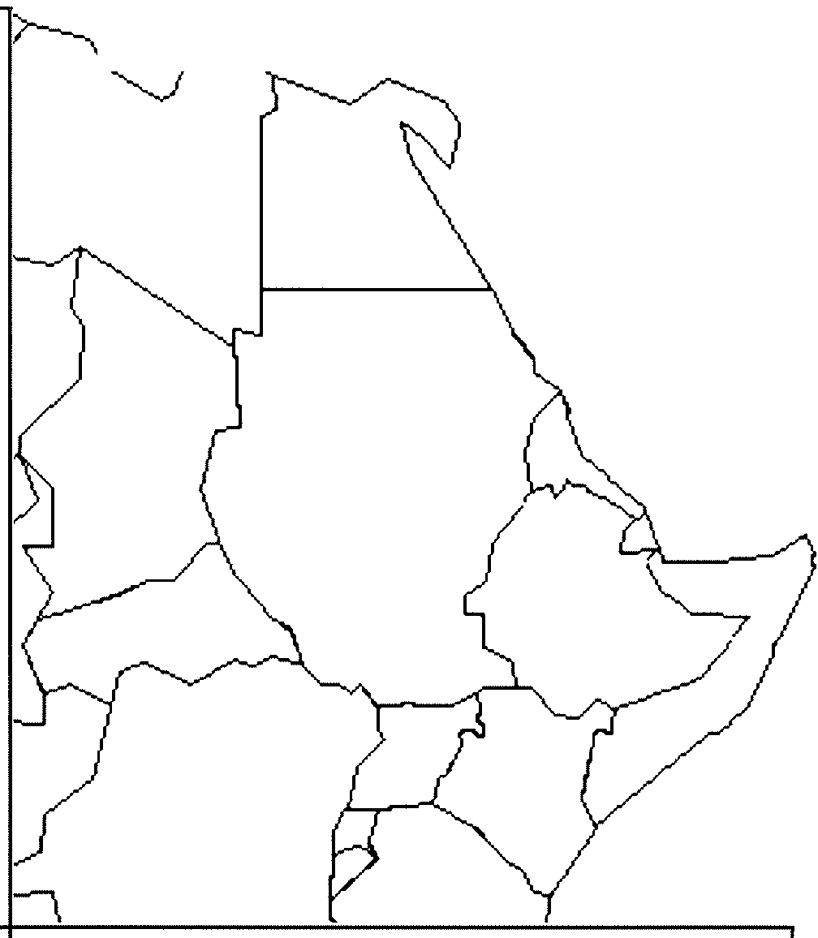

SUDAN SOMALIA

Case Study: LEBANON

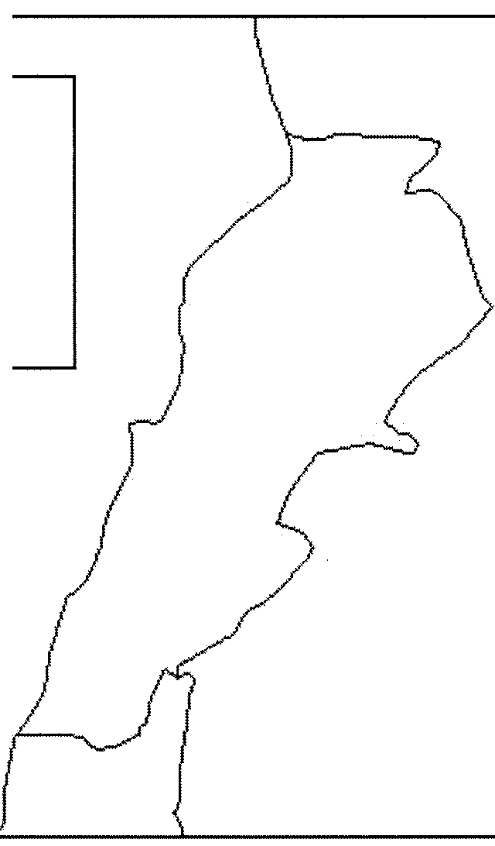

2. Read Ethnic Competition in Lebanon on page 246 and complete the case study as organized here.

2b.

2a. Label the map of Lebanon and the surrounding region. Indicate the religious geography of the country. Use the map on page 247

|  |  |
| --- | --- |
| CHRISTIANS of  LEBANON (largest to smallest in # | %of population |
|  |  |
|  |  |
|  |  |
|  |
|  |
|  |

c. Describe the breakdown of Muslim branches and their percentages in Lebanon.

d. What is the most important non-Muslim non-Christian group? Describe their belief.

e. How did Lebanon's 1943 constitution seek to solve the religion problem?

• The president...

• The premier ...

• The speaker of the chamber of deputies...

• The foreign minister...

f. How has the make-up of the population changed since 1943?

g. What happened in 1975? How has it been resolved?

**DIVIDING ETHNICITIES AMONG MORE THAN ONE STATE**

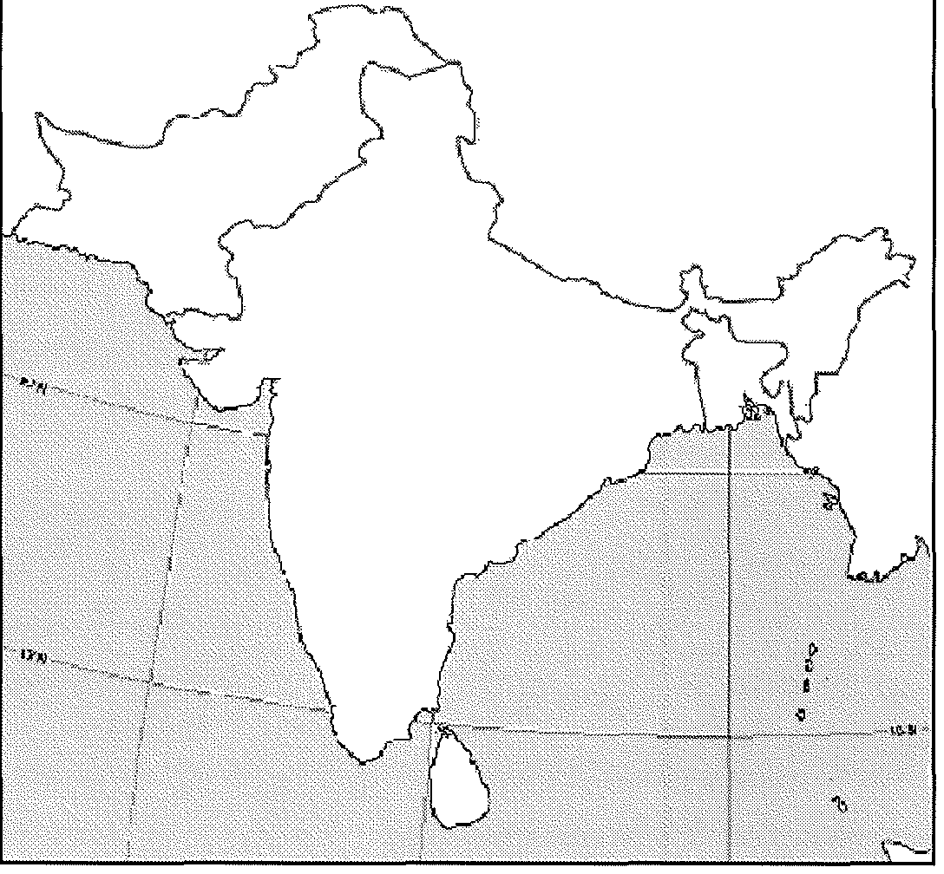

3. When the British ended colonial control of South Asia in 1947, what did they do in the region?

a. politically?...

b. ethnically (religiously)?...

4. Some BIG numbers of forced migrants:

i. How many people found themselves "on the wrong side of [the] boundary" in the

1940s?

ii. How many Muslims migrated from India to West Pakistan (Pakistan, today)?

iii. How many Muslims migrated from India to East Pakistan (Bangladesh, today)?

iv. How many Hindus migrated from East and West Pakistan into India?

v. What happened to many of the refugees as they traveled?

5. Why is the region of Kashmir problem?

a. politically?

b. in terms of religion?

6. Note the following regions on the map a) India

b) Pakistan

c) Bangladesh

d) Jammu and Kashmir

Also label: Sri Lanka, Nepal, Butan, Myanmar, China, and Afghanistan.

7. Read Dividing Sri Lanka Among Ethnicities on page 249 and complete the case study as organized here.

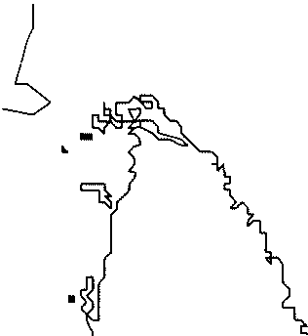

CaseStudy:SRILANKA

7a. Create a map of the religious-ethnic geography of the island of Ceylon, the country of Sri Lanka.

7b. Make a chart which compares the two ethnicities o 1s country m terms o anguage an religion.



c. How has violence between these two groups (which goes back 2,000 years) been suppressed during the past 300 years?

d. What occurred in1948?

e. Which group is unhappy? Why?

Chapter 7: Ethnicity



Key Issue 4: What Is Ethnic Cleansing

Rubenstein, pp. 250-255

1. When boundaries were redrawn in Europe after World War II, what was the effect on various ethnic groups?

2a. Define the term ethnic cleansing:

2b. How is ethnic cleansing different than normal warfare?

**ETHNIC CLEANSING IN YUGOSLAVIA**

3. List the countries of the Balkan Peninsula.

4. List important/interesting facts regarding the creation of the post-WWI country of

Yu oslavia

5. Regarding the Yugoslav refrain that was common during the rule of Josip Tito, identify the following:

Yugoslavia's

• FNE NATIONALITIES...

• FOUR LANGUAGES...

• THREE RELIGIONS...

• TWO ALPHABETS...

6. What ethno-political problems did the country face after the death of Tito in the

80's and fall of communism in the 90's?

7. Why did Serbs and Croats in Bosnia (aka Bosnia-Herzogovina) ethnically cleanse themselves of Bosnian Muslims?

8a. What was agreed upon at the accords signed between these rival ethnicities in

Dayton, Ohio in 1996?

8b. Who got the best deal? the worst? Explain.

9. Regarding the region of KOSOVO...

a. What country and ethnicity controls it today?

b. What ethnic group lives in Kosovo (and %)?

c. with the breakup of Yugoslavia, what began to happen in Kosovo?

d. How did the US and UN respond?

10. What is the meaning of the terms

• balkanized:

• balkanization:

11. If peace comes to the Balkan Peninsula in the next few years, why will it be "in a tragic way," according to the author of the textbook?

**ETHNIC CLEANSING IN CENTRAL AFRICA**

12. Give the historical background of the two rival groups of Central Africa's countries of Rwanda and Burundi.



13. Who were the colonial powers over Rwanda and Burundi? How did they reinforce ethnic rivalries there?

14. What happened when independence came to the countries?

15. How did the problem spread to Zaire?

16. How did Angola, Namibia, and Zimbabwe and other countries come to be involved?

17. What is the situation today?

Chapter 8: Political Geography

Key Issue 1: WHERE ARE STATES LOCATED?

Rubenstein, pp. 263-270

1. Define state:

2. Define sovereignty:

**PROBLEMS OF DEFINING STATES**

3. There is some disagreement about how many states there actually are in the world because of regions which may, or may not, actually be states. Complete the table to demonstrate three cases...

|  |  |  |
| --- | --- | --- |
| KOREA (North and South) | People's Democratic Republic  of China (CHINA) and/ or  Republic of China (TAIWAN) | WESTERN SAHARA or  SAHRAWI REBPUBLIC |
| Argument for one state: | Argument for one state: | Argument for one state: |
| Argument for two states: | Argument for two states: | Argument for not creating a state: |

4. List the 6largest states in order:

5. How many microstates are recognized? What do many have in common? List 6 that you can find on a map. (If you can only find three, you'll have to look three more up!)

**DEVELOPMENT OF THE STATE CONCEPT**

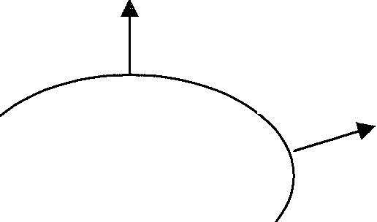

6. Complete the graphic organizers on the topics indicated below as they relate to the history of the concept of political states and their developments.

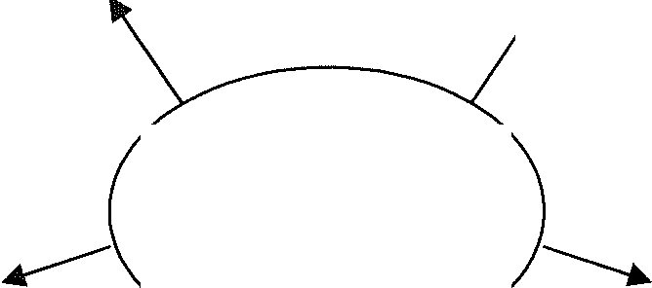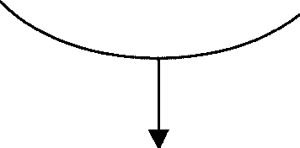

Ancient

States

Early

European

......S..t.ates

COLONIES

7. By definition, what is a colony?

8. Define colonialism.

9. Define imperialism.

10. Summarize three reasons Europeans sought colonies. a.

b.

c.

11. Which country had the largest empire? Second largest?

12. Use the table below to list major colonies (by modern state name) and/ or regions of these two countries.

|  |  |
| --- | --- |
| Colonies of: | Colonies of: |
|  |  |

13. Use the table below to contrast the basic colonial policies of these two countries.

|  |  |
| --- | --- |
| Colonial practices of: | Colonial practices of: |
|  |  |

14. List the largest remaining colonies in the world.

Chapter 8: Political Geography

Key Issue 2: Why Do Boundaries Cause Problems?

Rubenstein, pp. 270-281

**SHAPES OF STATES**

1. Complete this table based on your reading. The text gives examples which you should list. To the right of the last column also give one or your own examples.

|  |  |  |
| --- | --- | --- |
| SHAPES | | EXAMPLES |
| compact | greatest advantage ... |  |
| prompted | reasons for prompting the shape of a state ... |  |
| elongated | biggest problem ...  best way to minimize the problem ... |  |
| perforated | how is the perforator state dependent on the  "perforatee"? |  |
| fragmented | different kinds ... |  |

LANDLOCKED STATES

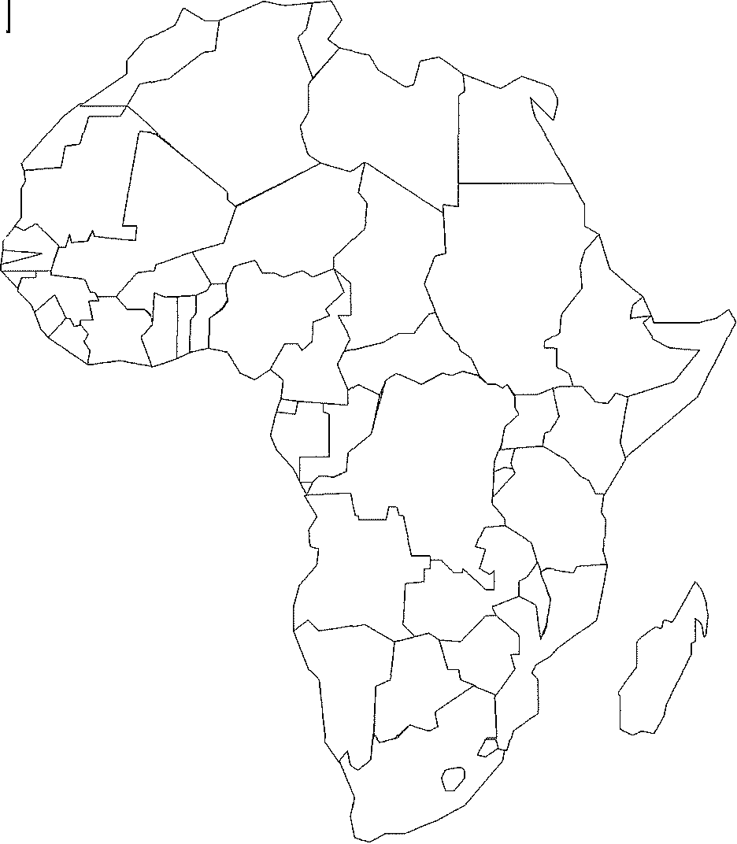

2. Where are most of the world's landlocked states?

3. Why there?

4. What problems do landlocked states have?

5. Shade and label all of Africa's landlocked states.

CASE STUDY: Zimbabwe's access problems

6.In what different ways has Zimbabwe historically had access to seaports?

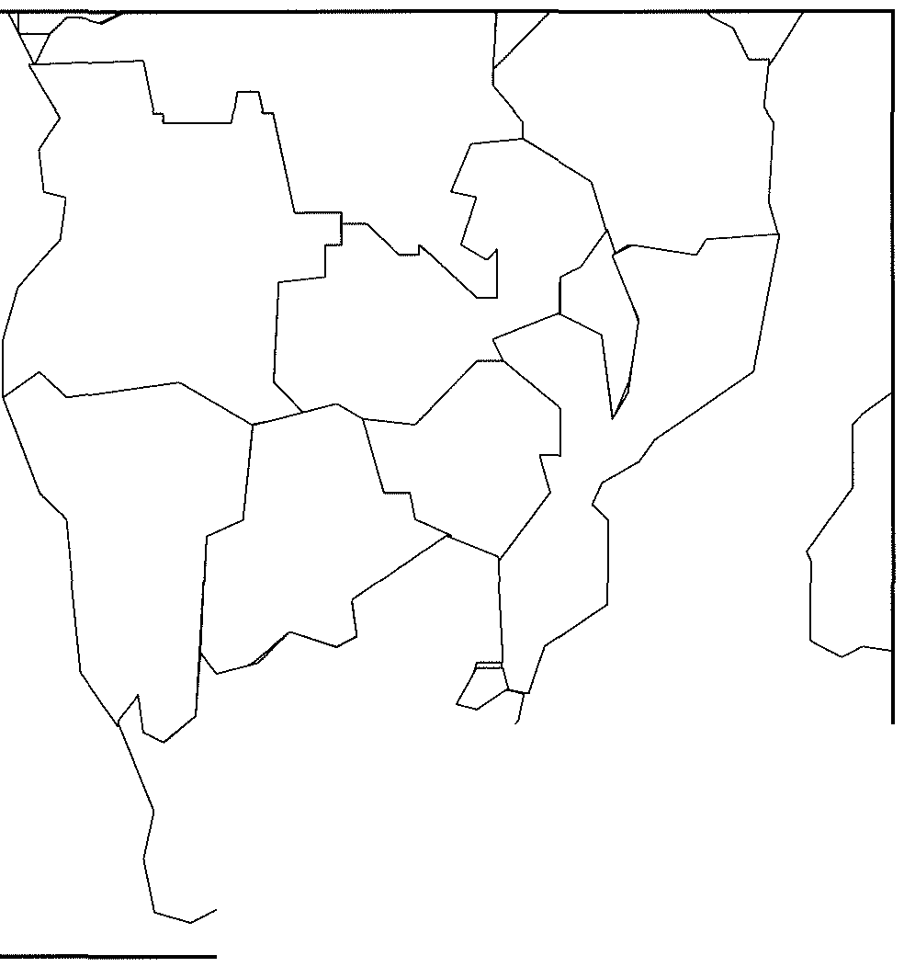

7. What specific obstacles has each presented? (Note: Some obstacles were ideological.)

0

8. Label the countries surrounding Zimbabwe. Do not show all rail routes shown on page 272, but onlythose discussed in the text as part of Zimbabwe's history of attempts to reach the sea through her neighbors.

**TYPES OF BOUNDARIES**

9. Regarding the concept of a frontier... a. define it:

b. list the characteristics of frontiers:

I PHYSICAL BOUNDARIES I

10. Complete the table below to describe the advantages of each type of physical boundary.

|  |  |  |
| --- | --- | --- |
| mountains | deserts | water (rivers) |
|  |  |  |

CULTURAL BOUNDARIES



11. What are three types of cultural boundaries which have often been used? Give an example of each.

Type of cultural boundary describe an example

a.

b.

c.

CASE STUDY: CYPRUS

12. Bullet in the most significant facts regarding the boundary and ethnic situation in

Cyprus. Annotate the map as appropriate.



• BOUNDARIES INSIDE STATES

13. Define the following types of internal organization of states:

a. Unitary State

b. Federal State

14. Regarding unitary states, what are the two geographic conditions that tend to favor it for a country?

a.

b.

15. Where are unitarystates most common?

16. Multinational states often adopt unitary systems for what reason? Also, describe an example where this has occurred.

17. Regarding federalstate, what are three geographic conditions that tend to favor it for a country?

a.

b.

c.

18. List good examples of federalstateswhichfulfilltheseconditions rather well.

19a. Why has tiny Belgium adopted a federalsystem?

19b. Why has enormous China adopted a unitarysystem?

CASE STUDY: FRANCE

20. Describe the internal political organization France in the box below.

FRANCE: Internal Political Organization

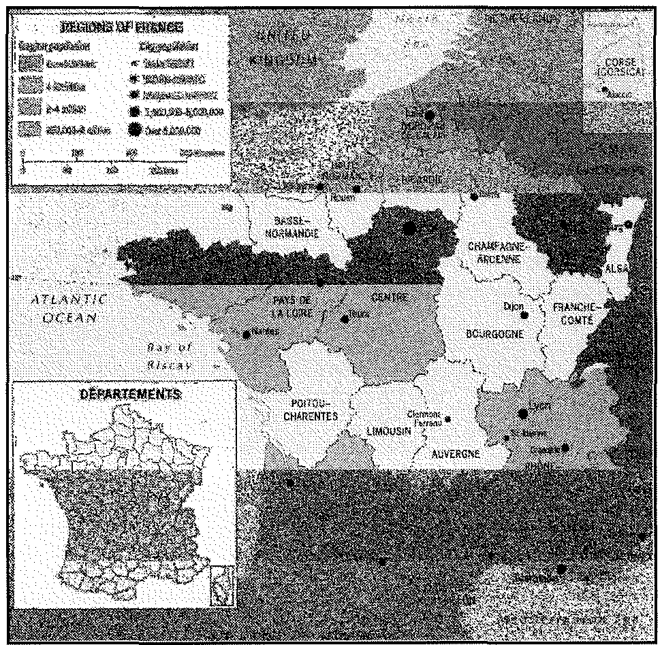

ELECTORAL

GEOGRAPHY

21. Why are the boundaries of legislative districts occasionally redrawn? How often is

this done in the US?

22. How is this type of boundary redrawing different in the US than in Europe?

23. What is gerrymandering?

24. What are the three types of gerrymandering?

i. ii. iii.

25. How is gerrymandering combined with ethnicity for political use?

Chapter 8: Political Geography



Key Issue 3: Why Do States Cooperate With Each Other?

Rubenstein, pp. 281-287

**POLITICAL AND MILITARY COOPERATION**

1. When was the United Nations established? by whom?

2. Identify the reason for which membership in the UN grew significantly in each of the following periods:

(a) 1955 (b) 1960 (c) 1990's

3. Who are the fivepermanentmembers of the Security Council?

4. Identify some of the problems the UN faces as it attempts to operate and influence world affairs.

REGIONAL MILITARY ALLIANCES

5. Why is the idea of only two superpowers a relatively new one?

6. Define balance of power:

7. Describe the purpose of NATO.

8. Describe the purpose of the former "Warsaw Pact" countries.

9. List 4 facts about the OSCE.

REGIONAL ORGANIZATIONS

10. Complete the chart on notable non-military regional organizations.

|  |  |  |
| --- | --- | --- |
| Regional Organization | Member | Purpose |
| OAS  Organization of  American States |  |  |
| OAU  Organization of  African States |  |  |
| Commonwealth of Nations |  |  |

**ECONOMIC COOPERATION**

11. What states have joined the "superpowers" based on their economic success? What former power has "slipped" from its earlier status?

12. The leading (economic) superpower since the 1990s is not a single state. What is the leading (economic) superpower in the world today?

13. Regarding the European Union.... (a) when was it formed?

(b) by what states?

(c) for what purpose?

(d) what are some important changes in recent years?

(e) what former Communist East European states have joined the EU? (f) why these- what separated them from the others?

(g) what other states are waiting and anxious to join?

(h) for what reasons is the EU reluctant about new members?

Chapter 8: Political Geography

Key Issue 4: Why Has Terrorism Increased?

Rubenstein, pp. 288-292

1. What is terrorism, by definition?

2. List typical methods/ acts of terrorists?

3. Why is terrorism different from other acts of political violence?

4. It is sometimes difficult to determine whether a group is a "terrorist group" or a legitimate political entity in rebellion. For each of the following countries, identify a group which they consider to be terrorists but which others (including the "terrorist group" itself) may believe to be a legitimate political entity.

Israel Russia Britain

**TERRORISM BY INDIVIDUALS AND ORGANIZATIONS**

5. List places in which Americans were attacked by terrorists in the late 20th century.

6. Identify each of the following terms as they relate to the terrorist organizations known as

Al-Qaeda.

(a) Osama bin-Laden

(b) Afghanistan

(c) Yemen and Somalia

(d) "the base"

(e) Majis al Shura

(f) cell

(g) fatwa

7. In what ways does Al-Qaeda, its religious and political views, and its methods pose a challenge to...

a. Muslims

b. Americans

STATE **SUPPORT FOR TERRORISM**

8. List the three ways in which states (particularly in the Middle East in recent decades)

have given support to terrorists. a)

b)

c)

9. Note in which of the above ways each of the following states has supported terrorism and then very briefly describe it.

|  |  |  |
| --- | --- | --- |
| STATE | type of support  (from question #*8) | summary of issues |
| ('lj  :>-.,  **,**..**.**.**0**...  **,...J** |  |  |
| ......  **·***C***s***fJ*  ('lj  fa |  |  |
| *a"*  ('lj  **H** |  |  |
| **H** |  |  |

**Unit 5 Agriculture & Rural Land Use Review & Study Guide**

Complete table:

1. In column 2 indicate two or three of the main regions or countries in the world where the agricultural region is found.

2. In column 3 indicate one or two MAIN climatic regions for each agricultural region. Indicate A if the predominant climate region is tropical rainy; B for the dry region; C for warm temperate; D

for subarctic; and E for snow.

3. In column 4 indicate the one or two main population distributions for each agricultural region.

Indicate C if the agricultural region is located in areas of population concentration; 0 if predominantly in other settled areas; and S if predominantly in sparsely populated areas.

|  |  |  |  |
| --- | --- | --- | --- |
| **Agricultural Region** | **Main Regions** | **Climate** | **Population** |
| Subsistence |  |  |  |
| Shifting cultivation |  |  |  |
| Intensive-wet rice |  |  |  |
| Intensive- other |  |  |  |
| Pastoral Nomadism |  |  |  |
| Plantation |  |  |  |
|  |  |  |  |
| Commercial |  |  |  |
| Mixed crop and livestock |  |  |  |
| Dairying |  |  |  |
| Grain |  |  |  |
| Ranching |  |  |  |
| Mediterranean |  |  |  |
| Commercial Gardening |  |  |  |

1. Where are the agricultural hearths and patterns of diffusion for ... a. . ..vegetative planting?

b. . ..seed agriculture?

(make sure you can tell me where these began and to what regions did these spread)

2. Describe the three agricultural revolutions.

3. What are the three phases of the third agricultural revolution?

4. How has the industrialization of agriculture changed the relationship between MDCs and LDCs (think about the core/periphery model)

5. What type business has evolved from the industrialization of agriculture, especially in MDCs?

6. What impact does culture have on the availability of crops in a region?

7. Compare and contrast agriculture in LDCs and MDCs in terms of a. Farm size

b. Type of agriculture c. Technology

d. Number of farmers e. Location of farms

f. Percentage of population involved in agriculture

g. Problems facing farmers in the various regions

CONCEPTS

• agribusiness • luxury crops • shifting cultivation

• Boserup hypothesis • pastoral nomadism • slash-and-bum (swidden)

• Carl Sauer • market gardening (truck • subsistence agriculture

• commercial agriculture farming) • Thomas Malthus/ Malthusian Theory

• domestication • Mediterranean agriculture • ranching

• plantation • milkshed • shifting cultivation

• fallow • Neolithic Revolution • subsistence agriculture

• horticulture • "Green Revolution" • von Thtinen's model of agriculture

• intensive subsistence agriculture • Ranching • transhumance

• capital • truck farm • comparative advantage

• capital-intensive agriculture • 1st 2nd 3rd Agricultural • extensive agriculture

' '

• commercial agriculture

Revolution • free trade

• globalization

• irrigation

• global-local continuum • friction of distance

• labor-intensive agriculture • hunting & gathering

• land cover •

land use • livestock

• monoculture • nomadism

• mixed farming

• remote sensing • sedentary agriculture •

•

• yield

BE ABLE TO

• explain how agriculture originated and identify its various hearths.

plantation

time-space convergence

• describe the evolution of agricultural practices from their first use until today.

• correlate climate and terrain with various agricultural regions.

• describe and apply the von Thunen model to both small and large scale situations.

• map linkages between regions of production and consumption at different scales

• world regions of export and import

• production and consumption (market) regions within a single state

• use agricultural practice to differentiate between less developed and relatively developed countries.

• describe rural settlement in terms of:

• survey systems; long lot (seigneurial), rectangular, metes and bounds)

• settlement types; linear, dispersed, clustered)

• causes, effects, and regions associated with different settlement patterns

POTENTIAL FRO TOPICS:

• Enclosure Movement

• Food Production in LDCs & MDCs

• Green Revolution

• Von Thunen's Model

• Subsistence & Commercial Farming Compare/Contrast

• Shifting Cultivation vs. Plantation Compare/Contrast

• Genetically Modified Foods/GMOs

READING ASSIGNMENTS:

1. Kuby Chapter 8 "Food for Thought: The Globalization of Agriculture"

2. Rubenstein, Chapter 10: "Agriculture"

3. Rubenstein: "Services in Rural Settlements," pp.409-412.

STUDY, STUDY, STUDY...

* Study your vocabulary notecards!!!! *

Chapter 10: Agriculture

Key Issue 1: Where **Did** Agriculture Originate?

Rubenstein, pp. 333-339

**ORIGINS OF AGRICULTURE**

1. Define agriculture:

2. Define crop:

3a. What are the characteristics of a hunter-gatherer society?

b. How many hunter-gatherers are there today?

c. Where do they live?

4a. Define vegetative planting:

b. What types of plants were first propagated in this way?

c. What animals were associated with the societies that used vegetative planting? Sa. Define seed agriculture:

b. What crops were first propagated in this way?

c. What animals were associated with the societies that used seed a iculture?

6. Indicate the hearth areas for vegetative planting and seed agriculture on the map below.

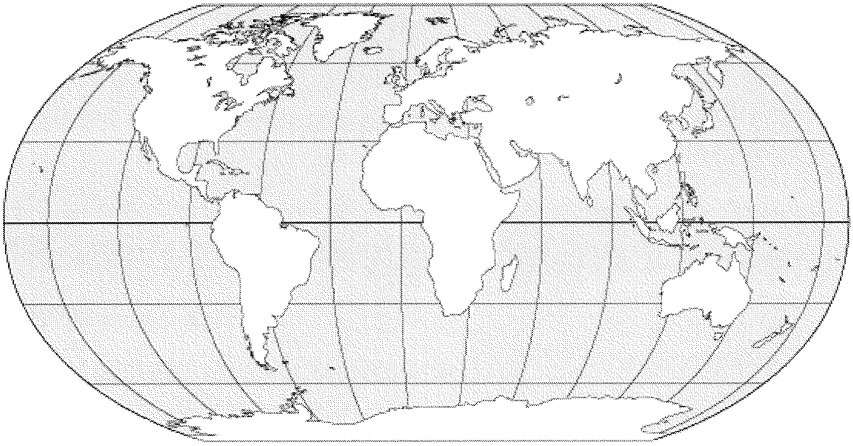

**CLASSIFYING AGRICULTURAL REGIONS**

7. Read this section of the chapter and complete the table below with pertinent information. The text will generally explain commercial agriculture and you will need to deduce the situation of subsistence agriculture on your own.

|  |  |  |
| --- | --- | --- |
|  | Subsistence Agriculture  (mostly in LDCs) | Commercial Agriculture  (mostly in MDCs) |
|  |  |  |
|  |  |  |
|  |  |  |
|  |  |  |
|  |  |  |

8. Who prepared the most widely used map of world agricultural regions? When?

Chapter 10: Agriculture

Key Issue 2: Where Are Agricultural Regions in Less Developed Countries?

Rubenstein, pp. 339-347

SHIFTING CULTIVATION

1. In what climate does shifting cultivation predominate? What are its two characteristics?

2. Identify the two hallmarks of the technique of shifting cultivation. (a)

(b)

3 Regarding a swidden... a. what is it?

b. What is potash?

c. How long are swiddens used?

-------------------------------------------------------,

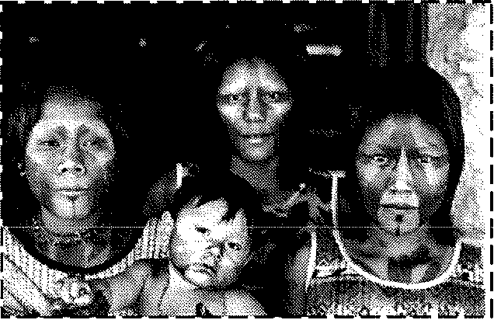

4. CASE STUDY: A Kayapo swidden field in Brazil's Amazon region.

Make notes and draw a diagram to illustrate the description given in the text.

5. How is land owned in a typical village that practices shifting cultivation?

6a. What percentage of the world's land area is devoted to shifting cultivation?

6b. What percentage of the world's people work it?

7. Describe the pros and cons of shifting cultivation, or the arguments made for it and criticisms

1eve1ea agamst It, m me spaces oe10w.

PROS (Arguments against replacing CONS (How is shifting cultivation being replaced?)

shifting cultivation.)

**PASTORAL NOMADISM**

8. What is pastoral nomadism?

9. In what type of climate is it usually found?

10. What regions of the earth are currently occupied by this practice?

11. How do pastoral nomads obtain grain (several ways)?

12. What animals are chosen, and where?

13. Describe territoriality among pastoral nomads.

14. What is transhumance?

15. In what ways is pastoral nomadism currently threatened by modern governments?

**INTENSIVE SUBSISTENCE FARMING**

16. What is meant by "intensive"?

17. Where is intensive subsistence agriculture practiced? Why there?

18a. What is "wet rice"?

18b. What is a "sawah"? a "paddy"?

19. Wet rice requires a flat field- but some farmers must cultivate it in hilly or mountainous regions. How do they accomplish this?

20. Where is double-cropping possible? Not possible?

21. In areas of intensive subsistence agriculture where wet rice is not dominant, what is the major crop?

22. How are multiple harvests made possible in these less mild regions?

23. Using the map on pp. 340-41, identify regions outside of Asia where "wet-rice not dominant'' intensive subsistence agriculture is practiced.

24. Make some notes about intensive subsistence farming in communist China.

|  |  |
| --- | --- |
| Agriculture in Communist China | |
| • Agriculture following the communist revolution,  communes. | • Agriculture in Communist China today, post-commune. |
|  |  |
|  |

Chapter 10: Agriculture

Key Issue 3: Where Are Agricultural Regions in More Developed Countries

Rubenstein, pp. 347-355

**MIXED CROP AND LIVESTOCK FARMING**

1. Where is mixed crop and livestock farming common?

2. Describe the irony between the amount of land devoted to crops vs. animals and the income generated by each in this region.

3. How does this type of agriculture allow farmers to more evenly "distribute their workload"?

4. Define/ describe the following as they relate to croprotation:

a. cereal grains:

b. fallow:

c. rest crop:

5. Where is the US Corn Belt and what crop is making rapid inroads among farms there.

6. In what different ways is the corn used?

**DAIRY FARMING**

7. What is a milkshed?

8. Why do some regions specialize in "milk products" like cheese and butter rather than fluid milk? Identify some these important regions.

9. What country is the world's largest producer of dairy products?

10. What problems do dairy farmers currently face?

**GRAIN FARMING**

11. What is the principal difference between grains grown in"commercial grain farming" regions and grains grown in "mixed crop and livestock" regions?

12. Identify the three regions of large-scale grain production in North America.

13. How do farmers and combine companies make use of the fact that the wheat matures at different times in the spring and winter wheat belts?

WHEAT



14. Complete a bullet list which details the importance of wheat as a crop.

**LIVESTOCK RANCHING**

15. What type of climate is livestock best adapted to?

16. Describe the "stages" of ranching as it has evolved in the US (and very similarly elsewhere) in the flowchart below.

!.Introduction II. Open range and III. Fixed and cattle drives... location establishment. .. ranching...

--+

17. Describe each of the following as they relate to cattle ranching in the US today:

a. Herefords (as opposed to Longhorns):

b. feed lots:

c. recent ranch ownership patterns:

18. Make brief notes to describe the following:

Ranching in South America Ranching in Australia

**MEDITERRANEAN AGRICULTURE**

19. Describe the climatic conditions of Mediterranean climate and agriculture.

20. Most crops in Mediterranean lands are grown for rather than for ---------------

21. What is horticulture?

22. List the two most important cash crops of Mediterranean regions.

23. Describe the role (and changing role) of California in Mediterranean agriculture.

**COMMERCIAL GARDENING AND FRUIT FARMING**



24. What three conditions make the US southeast an ideal location for this type of agriculture?

25. What are the two groups to whom "truck farmers" sell their crops?

26. List the three ways that truck farmers keep labor costs low.

i. ii.

iii.

27. What is "specialty farming" and where has it spread in the US?

**PLANTATION FARMING**

28. Define/ describe plantation farming by filling in the table below.

Continents...

Situated in... Owned an operated by... Workers...

Types of crops... Definition...

Chapter 10: Agriculture

Key Issue 4: Why do farmers face economic difficulties?

Rubenstein, pp. 355-364

**ISSUES FOR COMMERCIAL FARMERS**

1. What two economic factors influence the choice of crops by commercial farmers?

2. Who was von Thunen?

3. According to his model, what two factors does a farmer consider when deciding what to plant?

4. Assuming the climate permits cultivation of two crops "X" and "Y" - why might a farmer plant Crop X if

he/ she is able to sell Crop Yon the market for a higher price?

5. In the box below draw and label von Thunen's theory of crop production and distance to city center.

6. List items that von Thunen did NOT consider in his model, but which influence farmers' choices of crops. NOTE: these might be cited as weaknesses or criticisms.

7. How could von Thunen's model be applied at a global scale?

8. Describe three reasons for overproduction in commercial farming.

9. Explain three ways the U.S. government programs have increased agricultural production.

10. Define sustainable agriculture:

11. Explain ridge tillage.

12. What are "round-up ready" seeds and who created them?

ISSUES FOR SUBSISTENCE FARMERS

13. Define subsistence farming:

14. Describe two issues faced by subsistence farmers.

15. Who is Ester Boserup?

16. According to Boserup, what two ways do subsistence farmers increase production?

17. Explain how International trade has forced LDC's to produce something they can sell in MDC's.

18. What dilemma do governments face in LDC's regarding crop production?

**STRATEGIES TO INCREASE THE FOOD SUPPLY**

19. Using the grid below, explain three ways each concept would increase the food supply:

|  |  |  |  |
| --- | --- | --- | --- |
| **Expand Agricultural**  **Land** | **Increased Productivity (Green Revolution)** | **Identifying New Food**  **Sources** | **Increasing Exports from other countries** |
|  |  |  | |
|  | |

20. Africa's food-supply crisis:

a. What percent of African's have too little to eat?

b. What happens when farmers overplant?

c. What happens when forests/trees are cleared?

d. How has (African) government price controls harmed farmers?

RURAL SETTLEMENTS

Rubenstein, pp. 387-390 ("Services in Rural Settlements")

Clustered Rural Settlements

1. What does a clustered rural settlement include?

2. What is it commonly called?

3. Traditionally (in European/Western history) what happened when the settlement grew too large?

4. Identify the "where" and "when" of each of the following types of settlements. Also note any particular characteristics of note for each. You may want to sketch a simple plan for the village from its description.

|  |  |  |  |
| --- | --- | --- | --- |
| Circular form:  KRAAL | Linear form:  FRENCH LONG-LOT | Colonial US (north):  TOWNSHIP | Colonial US (south):  PLANTATION |
|  | |  |  |
|  | | |
|  | | | |

Dispersed Rural Settlements

1. Where have they become more common?

2. Why?

3. Why were people in the American Midwest able to buy such large farms?

4. What was the "enclosure movement''?

Chapter 10: VON THUNEN'S MODEL OF AGRICULTURAL LAND USE

Rubenstein, p. 356

1. Who was von Thiinen?

2. According to this model what two factors does a farmer consider when deciding what to plant?

a.

b.

3. Assuming the climate permits cultivation of two crops - "X" and "Y" - why might a farmer plant "crop X" if he is able to sell "crop y" on the market for a higher price?

4. Draw and label agricultural land use according to von Thiinen.

5. List things that von Thiinen did NOT consider in his model, but which influence farmers' choices of crops. Note: these might be cited as weaknesses, or criticisms, of his model.

6. How could von Thiinen's model be applied at a global scale?

**APHG Unit 6 Industrialization & Economic Development Study Guide**

• Review Rubenstein Ch 9, 11, & 14

• Review information from packets

• Review Kuby Ch 6, 7, & 14

• Review Woodyard APHG Study Guide Unit 6 (Economic Geography on website)

• Know all of the following concepts (many of which can be reviewed on Quizlet):

|  |  |  |  |
| --- | --- | --- | --- |
|  | Kuby Ch 6: | D | dependency school |
| D | agglomeration economies | D | development |
| D | basic industry | D | economic indicators |
| D | break of bulk | D | gross domestic production (GDP) |
| D | capital goods | D | gross national production (GNP) |
| D | cost minimization | D | human welfare indicators |
| D | division of labor | D | import substitution |
| D | economic base model | D | modernization |
| D | economies of scale | D | neocolonialism |
| D | externalities | D | neoliberal counterrevolution |
| D | industrial economy | D | polarization effects |
| D | labor productivity | D | spread effects |
| D | localization economies | D | structural change |
| D | labor productivity | D | subsistence economy |
| D | localization economics | D | substitution of capital for labor |
| D | maquiladora | D | sustainable development |
| D | market oriented | D | technology transfer |
| D | nonbasic industry | D | transition economies |
| D  D | outsourcing postindustrial economy |  | Kuby Ch 14: |
| D | primary activity/primary sector | D | adverse consequences |
| D | secondary activity/secondary sector | D | biosphere |
| D D D  D | tertiary activity/tertiary sector quarternary activity  raw material oriented  regional multiplier | D D D D | cycle  direction biological interference energy and material redistribution environmental change |
| D | secondary activity | D | equilibrium |
| D D D D D  D | services  spatial division of labor technological spillovers transaction costs ubiquitous  urbanization economies | D D D D D D | flow  human activities human driving forces  human-environmental interactions  IPAT  negative feedback loop |
| D | appropriate technology | D  D | pollution  population pressure |
|  | Kuby Ch 7: | D | positive feedback loop |
| D | appropriate technology | D | renewable resources |
| D | circular and cumulative causation | D | solutions |
| D | core periphery | D | stakeholder |

|  |  |  |  |
| --- | --- | --- | --- |
| 0 | stock | 0 | animate power |
| 0 | system | 0 | biochemical oxygen demand (BOD) |
|  | Rubenstein Ch 9: | 0 | biodiversity |
| 0 | development | 0 | biomass fuel |
| 0 | fair trade | 0 | breeder reactor |
| 0 | foreign direction investment (FDI) | 0 | chlorofluorocarbon (CFC) |
| 0 | gender empowerment measure (GEM) | 0 | conservation |
| 0 | gender-related development index (GDI) | 0 | ferrous |
| 0 | gross domestic production (GDP) | 0 | fission |
| 0 | human development index (HDI) | 0 | fossil fuel |
| 0 | less developed country (LDC) | 0 | fusion |
| 0 | literacy rate | 0 | geothermal energy |
| 0 | millennium development goals | 0 | greenhouse effect |
| 0 | more developed country (MDC) | 0 | hydroelectric power |
| 0 | productivity | 0 | inanimate power |
| 0 | structural adjustment program | 0 | nonferrous |
| 0 | transnational corporation | 0 | nonrenewable energy |
| 0 | value added | 0 | ozone |
|  |  | 0 | passive solar energy systems |
|  | Rubenstein Ch 11: | 0 | photochemical smog |
| 0 | break-of-bulk point | 0 | photovoltaic cell |
| 0 | bulk-gaining industry | 0 | pollution |
| 0 | bulk-reducing industry | 0 | potential reserve |
| 0 | cottage industry | 0 | preservation |
| 0 | fordist production | 0 | proven reserve |
| 0 | industrial revolution | 0 | radioactive waste |
| 0 | labor-intensive industry | 0 | recycling |
| 0 | new international division of labor | 0 | renewable energy |
| 0 | post-fordist production | 0 | resource |
| 0 | right-to-work state | 0 | sanitary landfill |
| 0 | site factors |  |  |
| 0 | situation factors |  | Geogra,Qhy Alive Ch 21: |
| 0 | textile | 0 | gender-based division of labor |
|  |  | 0 | informal economy |
|  | Rubenstein Ch 14: | 0 | micro-enterprise |
| 0 | acid deposition | 0 | micro-entrepreneur |
| 0 | acid precipitation |  |  |
| 0 | active solar energy systems |  |  |
| 0 | air pollution |  |  |

Cha.Qter 11 Review Questions:

1. What is the term given to a U.S. factory that locates manufacturing operations in Mexico?

2. In what country did the industrial revolution start?

3. Where in the U.K. did the industrial revolution start?

4. What was the geographic distribution of industry prior to the industrial revolution?

5. When did the industrial revolution officially begin?

6. What is the term given to manufacturing goods in a factory?

7. Overall, what did the industrial revolution improve for most people?

8. After the industrial revolution how did the geographic distribution change?

9. What is the term for when people produce goods in their own home?

10. What is it called when people are paid by the number of items they produce?

11. Who invented the steam engine?

12. What invention was considered the catalyst for the industrial revolution?

13. What was the first industry to benefit from the invention of the steam engine?

14. What was the most important heat source for the industrial revolution?

15. Why did the iron industry locate near coal fields?

16. Name two ofthe three areas of innovation that the iron industry spawned?

17. What was the first transportation innovation that helped move raw materials and goods at a cheaper price?

18. What transportation innovation helped make N.Y.C. the most important city in the United States?

19. What transportation innovation helped expand the impact of the industrial revolution the most?

20. What is the term for woven fabric?

21. What is the most visible symbol ofthe industrial revolution in the U.K.?

22. Why was the diffusion ofthe industrial revolution delayed in NW Europe?

23. What was the second most industrially advanced country by 1860?

24. Name two ofthe four countries in Europe that started to industrialize in the late 1800s.

25. When and where was the first textile mill in America built?

26. Who brought the industrial revolution to America?

27. In general, where is the major manufacturing center of the Untied States?

28. Where is the oldest manufacturing center in the United States?

29. Where is the largest market in the United States?

30. What city used to be the biggest producer of steel in America?

31. What is it called when a state has passed laws preventing a union and company from negotiating a contract that requires workers to join a union as a condition of employment?

32. What city has recently become the country's largest clothing and textile manufacturing center?

33. Where is the most important manufacturing area in Europe?

34. In what country is the Po River valley?

35. Which country in Asia has most deposits of iron ore and coal?

36. What are the three main categories with respect to site costs?

37. Copper is an excellent example of a bulk industry.

38. Raw materials/ :Markets *I* outputs.

39. The production ofbeer is an example of a bulk industry.

40. Name three bulk gaining industries mentioned in the text.

41. The distribution of motor vehicle production has changed from to in the last

25 years.

42. In what region of the country does most auto manufacturing take place?

43. Between which two states do most motor vehicle manufacturing take place from a north/south perspective?

44. A good example of a weight gaining industry that has only one location for production is

45. Autos parts and the high fashion garment industry are examples of market manufacturers.

46. "Just in Time" delivery contributes to the of parts manufacturing for Japanese auto makers.

47. Why do newspapers, dairies, and bakeries locate near the market?

48. What is the least expensive way to sent things long distance?

49. What is the cheapest form oftransportation overland?

50. What is a location where the transfer of goods from one transportation mode to another called?

51. In a metropolitan area, why do most factories tend to locate in suburban areas?

52. What was the primary reason why Boeing located in Seattle?

53. Prior to WWII, where in metropolitan areas did factories tend to locate?

54. What is an industry called where labor costs are a high percentage of the expenses?

Unit VII Discussion Questions:

1. Nearly all residents ofMDCs lead urban lifestyles even if they live in rural areas. In contrast, many residents in LDCs lead rural lifestyles, even through they live in large cities. They practice subsistence agriculture, raising animals or growing crops. Lacking electricity, they gather wood for fuel. Lacking running water and sewers, they dig latrines. Why do so many urban dwellers in LDCs lead rural lifestyles?

2. Officials of rapidly growing cities in LDCs discourage the building of houses that do not meet international standards for sanitation and construction methods. Also discouraged are privately owned transportation services, because the vehicles generally lack decent tires, brakes, and other safety features. Yet the residents prefer substandard housing to no housing, and they prefer unsafe transportation to no transportation. What would be the advantages and problems for a city if health and safety standards for housing, transportation, and other services were relaxed?

3. What steps has your community taken to recycle solid waste and to conserve energy?

a. Do you feel these steps have been enough? Explain.

4. A recent study compared paper and polystyrene foam drinking cups. Conventional wisdom is that foam cups are bad for the environment, because they are made from petroleum and do not degrade in landfills. However, the manufacture of a paper cup consumes 36 times as much electricity and generates 580 times as much wastewater. Further, as they degrade in landfills, paper cups release methane gas, a contributor to the greenhouse effect. What types of cups should companies like McDonald's be encouraged to use? Explain your answer.

a. Can you think of an alternative product- follow what you believe would be the supply chain from resource to product, to use by consumer, and finally- disposal.

5. Malthus argued 200 years ago that overpopulation was inevitable, because population increased geometrically while food supply increased arithmetically. Was Malthus correct? Why or why not.

6. Pollution is a byproduct of producing almost anything. How can more developed countries, which historically have been responsible for generating the most pollution, encourage less developed countries to seek to minimize the adverse effects of pollution as they improve their levels of development?

7. What effects has the increasing use of fossil fuels over the past 200 years had on the environment?

a. What is *acid rain,* and where is it a problem?

b. What factors affect the type and degree of air pollution found at a place?

c. What is the relationship of *ozone* to *petrochemical smog?*

8. Suggest ways in which your study of human geography has increased your understanding of the relationship between the environments of culture and those of nature.

Chapter 9: Economic Development

Key Issue 1: Why Does Development Vary Among Countries?

Rubenstein, pp. 299-306

1. What four different factors does the UN consider when determining a country's level of development, its HDI (Human Development Index)?

**ECONOMIC INDICATORS OF DEVELOPMENT**

2. What is gross domestic product (GDP)?

3. How much does a typical worker in an MDC earn? in an LDC?

4. What is the annual per capita GDP in an MDC? in an LDC?

5. What has been happening to the gap between MDCs and LDCs in terms of GDP?

6. Explain this statement: "Per capita GDP measure average (mean) wealth, not its distribution."

TYPES OF JOBS

7. What types of jobs comprise the primary sector of an economy? secondary sector?

tertiary sector?

8. How is the % of workers in agriculture different in LDCs and MDCs?

9. Within MDCs, what is the trend (increasing or decreasing) for each of the sectors?

Primary-

Secondary- Tertiary-

PRODUCTVITY

10. Define each of the following related terms:

• productivity

• value added

RAW MATERIALS

11. What is the role of raw materials in development?

12. How did raw materials figure into the trade flows during the colonial period of the 19th

century?

13. List 4 countries that have developed, despite their lack of resources, through world trade.

CONSUMER GOODS

14. What three "consumer goods" are considered to be particularly good indicators of development?

15. What is the ratio of people to these types of goods in a typical MDC? in a typical LDC?

16. The people in LDC's who do have access to consumer goods are usually concentrated in

what regions?

**SOCIAL INDICATORS OF DEVELOPMENT**

EDUCATION AND LITERACY

17. Quantity of education: How many years of schooling does a person get in an average MDC? LDC?

17a. How does gender separate MDCs and LDCs in terms of education?

17b. What is the literacy rate in MDCs? in LDCs?

HEALTH AND WELFARE

18. What are three ways in which the level of health and welfare are measured in a country?

DEMOGRAPHIC INDICATORS OF DEVELOPMENT

19. Indicate the statistic for each of the following demographic characteristics.

|  |  |  |
| --- | --- | --- |
|  | MDC | LDC |
| Life Expectancy |  |  |
| Infant Mortality  Rate |  |  |
| Natural Increase  Rate |  |  |
| Crude Birth Rate |  |  |

Chapter 9: Economic Development

Key Issue 2: Where Are More and Less Developed Countries Located?

Rubenstein, pp. 306-315

As you read the text, identify the average HDI (Human Development Index) for each region in the left column and make any necessary commentary regarding the level of development in the region in the right column. Minimum of three bullet points.

|  |  |
| --- | --- |
| Anglo­ America  HDI=.94 |  |
| Western  Europe |  |
| Eastern  Europe |  |
| Japan |  |
| South Pacific |  |
| Latin America |  |

|  |  |
| --- | --- |
| East Asia |  |
| Southeast  Asia |  |
| Middle East |  |
| South Asia |  |
| Sub-Saharan  Africa |  |

Chapter 9: Economic Development

Key Issue 3: Where Does Level of Development Vary by Gender?

Rubenstein, pp. 315-321

**GENDER-RELATED DEVELOPMENT INDEX**

1. The GDI considers what four areas as it compares the situation of women to that of men in various countries?

2a. Where are the highest GDis?

2b. Where are GDis the lowest? f'

3. What is the average "income gap" between men and women in the United States?

4. In LDCs, at what level of schooling does an "education gap" between boys and girls become very great?

5. Read the following statements regarding literacy and mark them as true or false. If

false, repair the statement to make it true.

_ a. In MDCs literacy is universal among both women and men.

_b. In Latin America and Asia, literacy is universal among men, but rates are low for women.

_c. In sub-Saharan Africa and the Middle East, female literacy is low, but it is slightly higher than that of men.

6. In what sense is the "gender gap" actually greater in MDCs than in LDCs?

**GENDER EMPOWERMENT**

7. What does the GEM (Gender Empowerment Measure) measure?



8. What two things are measured in order to calculate the GEM?

a)

b)

9. What types of barriers restrict women from obtaining professional and technical jobs?

10. List countries in which women comprise a majority in the national parliament or congress.

11a. In what country/ region do women comprise a larger part of national government than anywhere else in the world?

11b. What percentage of legislators there are women?

12. What is that percentage in the United States?

Chapter 9: Economic Development

Key Issue 4: Why Do Less Developed Countries Face Obstacles to Development?

Rubenstein, pp. 321-327

1. Complete the table below with notes from the text on two different models of development.

|  |  |  |
| --- | --- | --- |
| APPROACHES TO ECONOMIC DEVELOPMENT | | |
|  | Self-Sufficiency Model | International Trade Approach  (Rostow's Development Model) |
| ..(.J.'.J.  *Q*s*)*  -*Q)* |  |  |
| (sJ'J  ..(.J.'.J.  ..........  ......  H  u  (sJ'J  -*Q)*  ...a  0  H  0-. |  |  |

India Persian Gulf States

en

·

*0,)*

**"0**

**::J** Four Asian Dragons

**+-1**

Vl

*0,)*

en

**1'0**

u

2. Which of the two models for development has shown the most success?

3. Mark each of the following statements, regarding the WTO, as true or false. If false, make them true.

_(a) The WTO was formed by countries which conduct the majority of international trade.

_(b) The WTO seeks to increase import quotas and reduce import and export tariffs.

_(c) Though it can hear accusations, the WTO cannot order remedies.

_(d) The WTO seeks to eliminate restrictions on the flow of money between countries.

4. Why have each of the following groups been critical of the WTO?

i. Liberals:

ii. Conservatives:

**FINANCING DEVELOPMENT**

5. What are the two principal ways in which LDCs obtain money to finance development?

a.

b.

Loans

6. Identify the two main sources, both controlled by MDCs, of loans for LDCs. a.

b.

7. What is the THEORY behind using loans for infrastructure projects in LDCs?

8. In PRACTICE, what has usually happened when loans have been used for these infrastructure projects?

9. What are structural adjustment programs?

10. Why do LDCs enact structural adjustment programs, even though they may be unpopular with the citizens of their countries?

Transnational Corporations

11. What is a transnational corporation?

12. List the five countries in which most transnational corporations are headquartered.

a. b. c. d. e.

13. The flow of money in transnational corporations is not balanced. This is true in TWO ways. Explain.

14. Who is making the primary investments in South America? in Asia?

On the map, shade in RED the five countries in which most transnational corporations are headquartered. In BLUE, shade the 11 or 12 countries which have received the bulk of the money from transnationals. Draw the Brandt Line on the map.

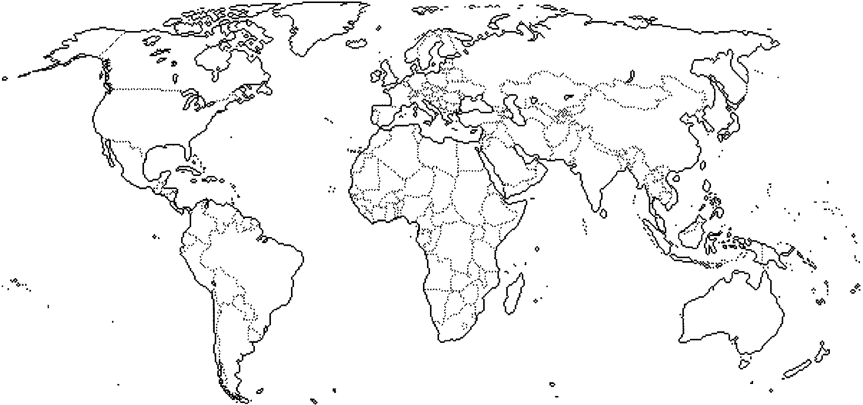

• ••••6

Chapter 11: Industry

Key Issue 1: Where Did Industry Originate?

Rubenstein, 371-375

THE INDUSTRIAL REVOUTION

1. Regarding the Industrial Revolution:

• What?

• Where?

• When?

2. Cottage Industry: Industry before the Industrial Revolution was widespread, rather than strongly localized (clustered) and was known as "cottage industry." Define this term.

DIFFUSION OF THE INDUSTRIAL REVOLUTION

3. Iron Industry: Define the following.

• iron ore

• pig iron

4. Coal:

a. define coke:

b. How is the distribution of steel and iron industry influenced by coal?

5. Transportation:

a. Why was development in transportation necessary?

b. What two forms of transportation grew rapidly?

6. Textiles:

a. define: textiles

b. How did steam power transform this industry?

7. Food Processing:

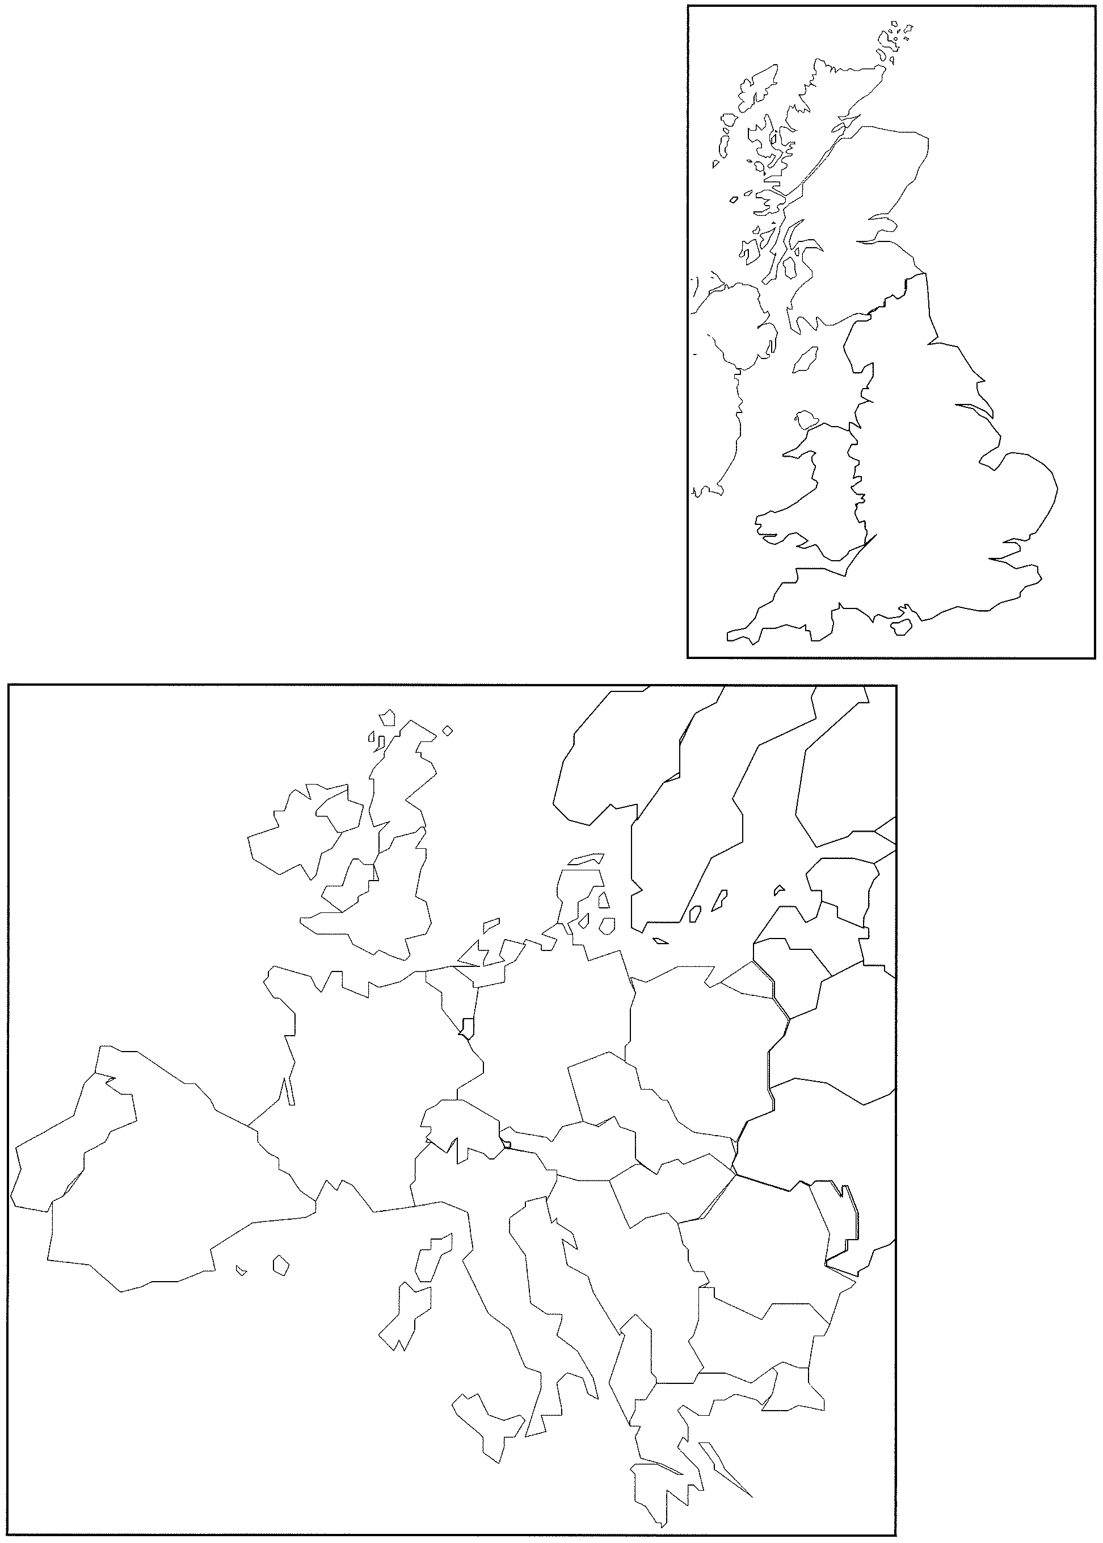

How did the industrial revolution and factory system contribute to the growth of food processing?

8. MAP 1: (p. 372, base map) Indicate the coalfields and major areas of iron or in Britain. Show the first major canal (Worsley-Manchester), first iron track and iron bridge (Coalbrookdale), and first commercial railway (Stockton-Darlington).

9. MAP 2: (p. 374, base map) The spread ofrailways mirrors the spread of the Industrial Revolution. Show this on the map. Clearly indicate the "hearth region" of industrialization. Which European regions were last to receive the benefits of industrialization?

Chapter 11: Industry

Key Issue 2: Where Is Industry Distributed?

Rubenstein, pp. 375-381

1. How is the distribution of industry on the planet dramatically different to that of agriculture?

--------------------------------------------------------,

: As you read the section, make notes on the resources, advantages, conditions, and issues in :

I each of the subregions of industrial development discussed. Shade and label each of the :

:- Q D1Qe £ w w a ----------------------------------J

2. NORTH AMERICA

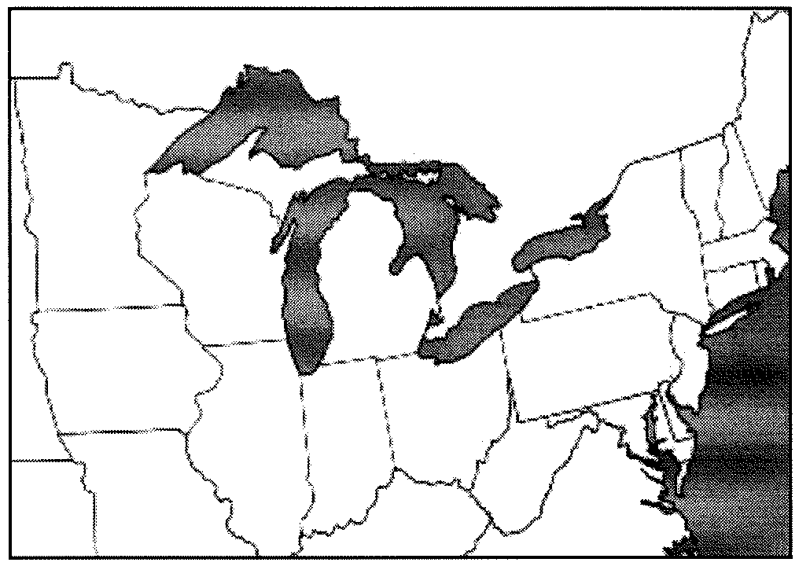

3. WESTERN EUROPE

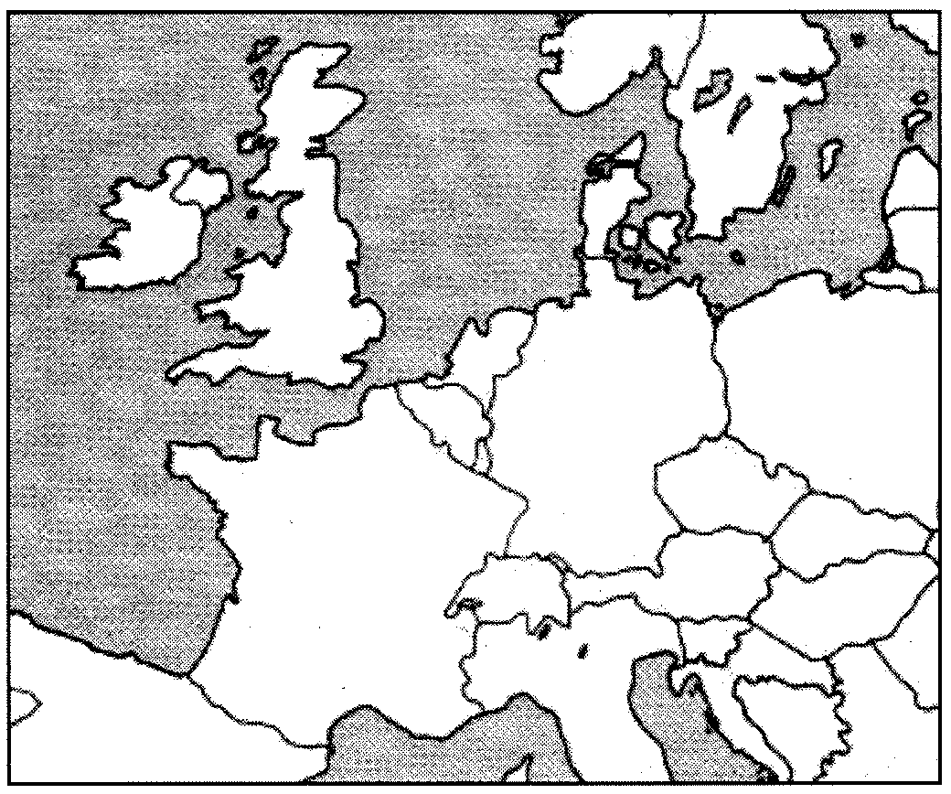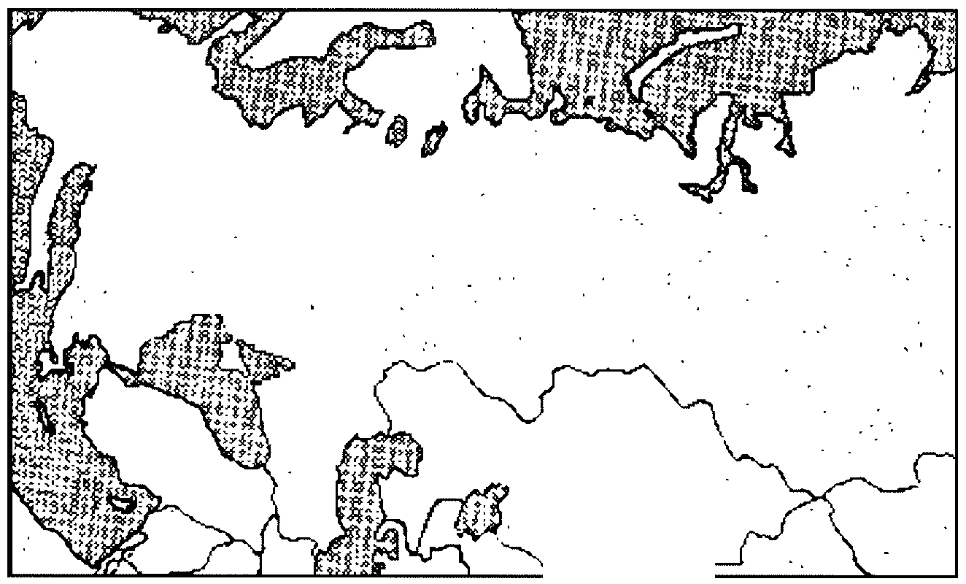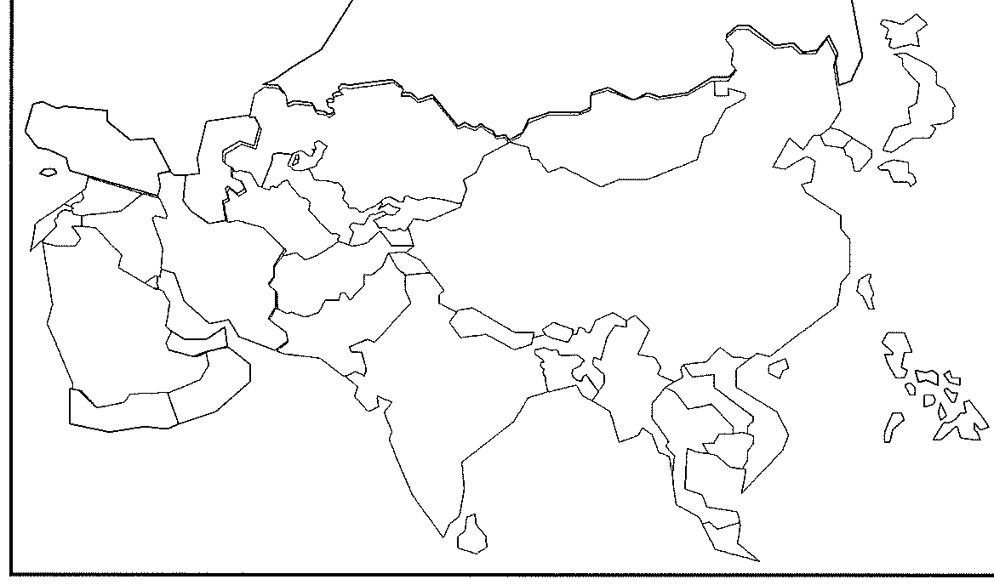

4. EASTERN EUROPE

*ttr=-··*

5. EAST ASIA

Chapter 11: Industry

Key Issue 3: Why Do Industries Have Different Distributions?

Rubenstein, pp. 381-393

1. Define each of the following. a. Situation factors:

b. Site factors

**SITUATION FACTORS**

2. Location near inputs: COPPER INDUSTRY

a. What is a "bulk-reducing industry"?

b. Make a brief flowchart to illustrate how copper is an example of this.

c. How does energy play a role in the siting of copper mils?

3. Location near inputs: STEEL MILLS

The text describes the changing location of steel mills in the US. Explain why each location was preferred.

a. Pittsburgh, southwestern Pennsylvania

b. locations around southern shore of Lake Erie

c. Southern Lake Michigan (Gary, Indiana and Chicago)

d. East and West Coasts (Trenton, NJ and Los Angeles CA)

e. Current production- Why are the newest steel mills (minimills) beginning to move closer to markets and away from inputs?

4. Location near markets.

a. What is a Abulk-gaining industry?

b. Give three examples of these industries.

i. ii.

ill

5. Single-market manufacturers.

a. Specialized manufacturers make products that are designed to be sold primarily in _

b. Describe one example of this phenomenon.

6. Perishable Products.

List examples of "perishable products" that must be located near their markets.

7. Give reasons for which each of the following modes of transportation might be selected by a manufacturer to deliver their products to market.

|  |  |
| --- | --- |
| SHIP |  |
| RAIL |  |
| TRUCK |  |
| AIR |  |

8. What is a break-of-bulk point?

(a) What happens to costs at these points?

(b) Give two examples of important break-of-bulk points.

SITE FACTORS

9. What are the threeproduction cost£actors associated with the site of an industry? (Memorize them.)

10. What factors about a given piece of land make it attractive to industry and manufacturing?

11. Define: labor intensive industry

12. List 5 facts about the TEXTILE INDUSTRY worldwide:

a. b. c. d. e.

13. Fill in this flowchart to depict WHERE and WHY the US textile industry has moved historically.

|  |  |  |  |
| --- | --- | --- | --- |
|  |  |  |  |
|  |  |

14a. Give an example of an industry which requires skilled labor.

14b. In what three states is it concentrated?

14c. Why is there abundant skilled labor there?

15. Define the following:

a. Fordist

b. Post-Fordist

16. Describe the relationship between capital and the computer industry in California.

17. How do local communities and national governments attract industry by providing financial incentives?

18a. Define "footloose" as it is used to describe industry.

18b. Describe characteristics of footloose industries.

19. Give three reasons why an executive might locate an industry in a "less-than-optimum" location. a. b.

c.

Chapter 11: Industry

Key Issue 4: Why Do Industries Face Problems?

Rubenstein, pp. 393-399

**INDUSTRIAL PROBLEMS FROM A GLOBAL PERSPECTIVE**

1. What is stagnant demand?

2. Give three reasons for the growth of stagnant demand. a.

b.

c.

3. Why has global industrial capacity increased despite stagnant demand?

4. Sketch two simple pie graphs below showing global steel production for 1975 and 2000.

NOTE: The outer circle on each graph should be identical in size since total output in both years was approximately equal. The two divisions of the pie graphs will be "MDC production" and "LDC prooucnon.

5. Give two reasons for which governments (particularly in Europe) are willing to subsidize steel mills to keep them operating in the face of declining demand.

a.

b.

6. Use the map on page 395 (bottom) to complete the chart below.

|  |  |
| --- | --- |
| CHANGE IN STEEL PRODUCTION: 1973-2002 | |
| Countries which DECREASED the most | Countries which INCREASED the most |
|  |  |
|  |  |
|  |  |
|  |  |

**INDUSTRIAL PROBLEMS IN MORE DEVELOPED COUNTRIES**

7a. What are the three main trading blocs in the world?

7b. In general, how do they encourage cooperation among their respective members?

7c. Identify a way in which each of the following trading blocs has restricted the US others from encroaching upon it:

i. European Union...

ii. Japan...

iii. the US.. .

7d. In terms of the US steel industry...

i. What did the US do between 1982 and 1992?

ii. How did this affect US steel workers?

iii. The textbook offers approximate data on the workers in the two major US "steel towns." Using two colors, one for each city, label and plot the data on the table here.

Steelworkers: Gary, Indiana and Youngstown, Ohio

30000



**25000**

'-

-

20000

0 15000

'-

'EQ)

::J

1oooo

c 5000

0

1970s 1980s 1990s

Sa. What is another name for "transnational corporation"?

8b. In what four countries are most transnational corporations headquartered?

8c. List the three benefits (reasons) given for which corporations seek to have international operations.

i.

ii.

iii.

8d. What two nations have active with operations within the US?

9. Give an example of a regional disparity in several regions by completing the table below.

|  |  |  |
| --- | --- | --- |
| REGIONAL DISPARITIES OF WEALTH DISTRIBUTION | | |
|  | Wealthy region | Poor region |
| Europe |  |  |
| France |  |  |
| United Kingdom |  |  |
| Sweden |  |  |
| United States |  |  |

**INDUSTRIAL PROBLEMS IN LESS DEVELOPED COUNTRIES**

10. Describe each of the following problems faced by LDCs as they consider industrializing. a. world markets

b. infrastructure

11. How is labor an advantage in LDCs?

12. Define "international division of labor":

Chapter 14: Resource Issues:

Key Issue 1: Where Have Urban Areas Grown?

Rubenstein, pp. 473-489

**ENERGY RESOURCES**

1. Define the term resources and explain the following terms:

a. animate power

b. inanimate power c. biomass fuel

d. fossil fuel

2. Three of Earth's substances provide of the world's energy: , _

and _

3. Define fossil fuel:

4. Explain the two characteristics of fossil fuel that cause concern:

5. The World Energy Council estimates potential oil reserves to be what amount and where do they believe they are located?

6. Analyze the map and pie chart on page 478, List the FOUR countries with the largest coal production and explain the pie chart regarding each country (HINT: Read the section titled *Location of Reserves).*

7. What are the two geographic consequences for the future when it comes to consumption of fossil fuels?

8. What does OPEC stand for:

9. Who are the ELEVEN members states of OPEC?

10. OPEC flexed their economic muscle in because they were angered over the support of Israel from which countries?

11. Explain how and why OPEC raised petroleum prices from $3.00 a barrel to $35.00 a barrel.

**MINERAL RESOURCES**

12. Describe the two nonrenewable substitutes for petroleum:

a. b.

13. Nuclear energy biggest advantage is:

14. Explain the serous problems that Nuclear power present:

15. Describe what happened at Chernobyl in the former Soviet Union (Russia).

|  |  |
| --- | --- |
| 16. Define: nonmetallic and metallic minerals, examples of, primary location. | |
| NONMETALLIC: | METALLIC: |
| Examples: | Examples:  Ferrous- Nonferrous- |
| Location: | Location: |

Chapter 14: Resource Issues

Key Issue 2: Why are resources being polluted?

Rubenstein, pp. 489-498

**AIR POLLUTION**

1. Earth's average atmosphere comprises % nitrogen, % oxygen and less than

% argon. The remaining % includes several

some of which are critical.

2. What are the most common air pollutants are:

3. Explain the three human activities that generate the most air pollution.

4. How does Global Warming occur? Explain the process.

5. Why is the term"greenhouse effect" somewhat misleading?

6. Explain the impact of global warming to polar ice caps and precipitation.

7. Define chlorofluorocarbons n(CFC's):

8. Explain how CFC's damage the ozone.

9. What creates acid depostion?

10. How does concentration of acid in the soil injure plants?

11. Analyze the maps on page 492 in *Figure* 14-13: Describe what the correlation is between the

U.S and Europe's sulfate levels.

12. Poland is estimated to have between and additional deaths due to pollution.

13. Describe the three basic components of air pollution:

a. b. c.

**WATER POLLUTION**

14. Explain how water is used a U.S. urban resident and ways in which water become contaminated.

15. What three main sources generate the most water pollution? Explain each. a.

b.

c.

16. Explain what causes fish to die in polluted waters?

17. Why did Charles Dickens call the Thames river *"London's Styx,"* after the underworld river that the dead had to cross in Greek mythology?

**LAND POLLUTION**

18. Define Land Pollution:

19. Explain the difference in numbers between residences and businesses.

20. Solid waste is held in and buried under _

21. Which cities truck their garbage to other cities? Why do you think they do this?

22. How is incineration of garbage positive and negative on the environment?

23. Explain, in detail, what occurred in the city of Love Canal, NY.

24. Which countries have signed contracts to accept toxic waste from Europe and North America? Why?

**APHG Unit 7 Cities & Urban Geography Study Guide**

• Review Rubenstein Ch 12-13

• Review information from packets

• Review Kuby Ch 9, 10, 11

• Review Woodyard APHG Study Guide Unit 7 (on website)

• Know all of the following concepts (many of which can be reviewed on Quizlet):

|  |  |  |  |  |  |
| --- | --- | --- | --- | --- | --- |
|  | KubyCh 9: | 0 | scenario | 0 | city |
| 0 | central place | 0 | stakeholder | 0 | combined statistical |
| 0 | central place function | 0 | trade-off |  | area (CSA) |
| 0 | central place theory | 0 | urban fringe | 0 | concentric zone model |
| 0 | market area | 0 | urbanized area | 0 | core based statistical |
| 0 | order | 0 | urban realm |  | area (CBSA) |
| 0 | range | 0 | urban sprawl | 0 | council of government |
| 0 | threshold | 0 | urban village | 0 | density gradient |
| 0 | urban hiearchy | 0 | win-win solution | 0 | edge city |
|  |  | 0 | zonmg | 0 | filtering |
|  | Kuby Ch 10: |  |  | 0 | gentrification |
| 0 | census tract |  | Rubenstein Ch 12: | 0 | greenbelt |
| 0 | central business district | 0 | basic industries | 0 | metropolitan statistical |
|  | (CBD) | 0 | business services |  | area (MSA) |
| 0 | concentric ring model | 0 | central place | 0 | micropolitan statistical |
| 0 | creative class | 0 | central place theory |  | area (MSA) |
| 0 | edge cities | 0 | city-state | 0 | multiple nuclei model |
| 0 | gentrification | 0 | clustered rural | 0 | peripheral model |
| 0 | invasion and succession |  | settlement | 0 | primary census |
| 0 | modernism | 0 | consumer services |  | statistical area (PCSA) |
| 0 | multiple nuclei model | 0 | dispersed rural | 0 | public housing |
| 0 | postmodemism |  | settlement | 0 | redlining |
| 0 | sector model | 0 | economic base | 0 | rush hour |
| 0 | slums | 0 | enclosure movement | 0 | sector model |
| 0 | suburbanization | 0 | gravity model | 0 | smart growth |
| 0 | urban realm | 0 | market area/hinterland | 0 | social area analysis |
| 0 | urban underclass | 0 | nonbasic industries | 0 | sprawl |
|  |  | 0 | primate city | 0 | squatter settlement |
|  | Kuby Ch 11: | 0 | primate city rule | 0 | underclass |
| 0 | congestion | 0 | public services | 0 | urban renewal |
| 0 | ecologically sensitive | 0 | range (of a service) | 0 | urbanized area |
| space 0 rank-size rule 0 zoning ordinance | | | | | |
| 0 edge cities 0 | | | service | | |
| 0 growth boundary 0 | | | settlement | | |
| 0 infill development 0 threshold Geography Alive Ch | | | | | |
|  | | |  |  | |
| 0 mass transit | | |  | 0 capital city | |
| 0 metropolitan | | | Rubenstein Ch 13: | 0 primate city | |
| government 0 | | | annexation | 0 site | |
| 0 mixed-use development 0 | | | census tract | 0 situation | |
| 0 new urbanism 0 | | | central business district |  | |

0 leapfrog development 0 urbanization 25:

Chapter 12 Review Questions:

1. Determine the economic base of your community. Consult the U.S. Census of Manufacturing or County Business Patterns. To make a rough approximation of your community's basic industries, compute the decimal fraction of the nation's population that lives in your community. It will be a small number, such as 0.0005. Then, find the total number ofU.S. firms (or employees) in each industrial sector that is present in your community. Multiply these national figures by your local population fraction. Subtract the result from your community's actual number of firms (or employees) for that type of industry. If the difference is positive, you have identified one of our community's basic industries.

2. Your community's economy is expanding or contracting as a result of the performance of its basic employment.

Two factors can explain the performance of your community's basic employment. One is that the sector is expanding or contracting nationally. The second is that the sector is performing much better or worse in the community than in the country as a whole. Which of the two factors better explains the performance of your community's basic employment?

3. Rural settlement patterns along the U.S. East Coast were influenced by migration during the Colonial era. To what extent do distinctive rural settlement patterns elsewhere in the United States result from international or internal migration?

4. Nearly all residents ofMDCs lead urban lifestyles even though they live in large cities. They practice

subsistence agriculture, raising animals or growing crops. Lacking electricity, they gather wood for fuel. Lacking running water and sewers, they dig latrines. Why do so many urban dwellers in LDCs lead rural lifestyles?

5. What evidence can you find in your community of economic ties to world cities located elsewhere in North

America, Europe, or East Asia?

Chapter 13 Review Questions:

1. Compare the CBDs of Toronto and Detroit. What might account for differences?

2. Draw a sketch of your community or neighborhood. In accordance with Kevin Lynch's *The Image of the City,* place five types of information on the map - districts (homogenous areas), edges (boundaries that separate districts), paths (lines of communication), nodes (central points of interaction), and landmarks (prominent objects on the landscape). How clear an image does your community have for you?

3. Jane Jacobs wrote in *Death and Life of Great American* Citiesthat an attractive urban environment is one that is animated with an intermingling of a variety of people and activities, such as found in many New York City neighborhoods. What are the attractions and drawbacks to living in such environments?

4. Land-use activities in Communist cities were allocated by government rather than made by private market decisions. To what extent would the absence of a private-sector urban land market affect the form and structure

of socialist cities? What impacts might Eastern European cities experience with the switch to market economies?

5. Officials of rapidly growing cities in LDCs discourage the building of houses that do not meet international standards for sanitation and construction methods. Also discouraged are privately owned transportation services, because the vehicles generally lack decent tires, brakes, and other safety features. Yet the residents prefer unsafe transportation to no transportation. What would be the advantages and problems for a city if health and safety standards for housing, transportation, and other services were relaxed?

Potential FRO Topics:

|  |  |  |
| --- | --- | --- |
| 0 Cristaller's Central Place Theory  0 Core, Periphery, & Urban Models | 0  0 | Urban Sprawl  First tier cities |
| 0 Squatter Settlements | 0 | Primate cities |
| 0 Urban Landscapes | 0 | Rank-size rule |
| 0 Transportation in Cities |  |  |
| 0 Urban Planning  0 CBD |  |  |

Chapter 12: Services

Key Issue 1: *Where Did Services Originate?*

Rubenstein, pp. 405 - 412

TYPES OF SERVICES

1. Define the services listed below and provide notes for each one.

|  |  |  |
| --- | --- | --- |
| Services | | |
| Consumer Services | Business Services | Public Services |
| What is a *Retail Service?*  Basic information about this service: | What is a *Producer Service?*  Basic information about this service: | What is a *Public Service?*  Basic information about this service: |
| What is a *Personal Service?*  Basic information about this service: | What is a *Transportation*  and *Information Service?*  Basic information about this service: |  |

2. Look at figure 12-2: Identify the job/ occupation that coincides with each type of job sector. a. Primary Sector -

b. Secondary Sector - c. Tertiary Sector-

3. Explain how primary, secondary, and tertiary sector employment trends have changed from 1970 to 2000.

ORIGIN OF SERVICES

4. How did early personal services develop?

5. How did early public services develop?

6. How did early retail and producer services develop? SERVICES IN RURAL SETTLEMENTS

7. What does a clustered rural settlement include?

8. What is it commonly called?

9. Traditionally (in European/ Western history) what happened when the settlement grew too large?

10. Identity the "where" and "when" of each of the following settlements. Also note any particular characteristics of each. You may want to sketch a simple plan for the village from its description.

|  |  |  |  |
| --- | --- | --- | --- |
| Circular form:  KRAAL | Linear form: French  Long-Lot | Colonial US (north):  Township | Colonial US (south):  Plantation |
|  |  |  | |
|  | | |
|  | | | |

11. Where have dispersed rural settlements become more common?

a. Why?

12. Why were people in the American Midwest able to buy such large farms?

13. What was the **"enclosure movement"?**

14. Why is Mrs. Smith so cool? Use the entire space below to answer the question. If you need extra space to fully respond, just attach an additional sheet of paper.

Chapter 12: Services

Key Issue 2: Why Are Consumer Services Distributed in a Regular Pattern?

Rubenstein, pp. 412-418

**CENTRAL PLACE THEORY**

1. What is a central place?

2. What does central place theory seek to explain?

3a. What is a market area?

3b. What other term is sometimes used to refer to a market area?

4a. What shape does central place theory hypothesize for market areas?

4b. Why this particular shape?

5. Complete the pyramid belY" ?•- 0-

Definition

*.1•* "" 1-."".,..,,.. .,..,. rvf: ? ,.ge

-o -r

l .

RANGE

Services with LONG ranges Services with SHORTER ranges



Definition

THRESHOLD

Not all people within a market area can be counted when deter · · ·

of a service by considering its threshold.

**MARKET AREA ANALYSIS**

7a. According to geographers, where is the best location for a service (once range and threshold have justified its viability)?

7b. The gravity model helps explain this inasmuch as the optimal location is _

related to the number of people in the area and

must travel.

**HIERARCHY OF SERVICES AND SETTLEMENT**

related to the distance they

8. Small settlements have services with 9. Larger settlements provide services having.

i. thresholds i. thresholds

li. ranges,and

li. ranges,and

ill. .market areas.

iii. -----

market areas.

10. However, small neighborhoods within larger settlements must also do what?

11 a. Who made the original study in central place theory?

b. Where did he do his study?

c. Who documented the central place phenomenon in the US? Where?

12. In MDCs, the pattern of cities follows the rank-size rule. This states that:

13. If the largest city in a country is more than twice the size of the second city, it is said to be what?

14. What is the situation Europe and LDCs with regard to "rank-size" distributions and primate cities?

|  |  |
| --- | --- |
| Europe | LDC |
|  |  |

Chapter 12: Services

Key Issue 3: Why Do Businesses Locate in Large Settlements?

Rubenstein, pp. 418-426

**WORLD** CITIES

1. Identify four potential"hearth regions" for the world's first urban settlements.

2. List 5 characteristics of the world first cities which emerged around 2000 BCE, as deduced from the excavations of Ur (in modern Iraq) and Titris Hoyuk (in modern Turkey).

3a. What was a city-state?

3b. What services did the city-state provide to the surrounding hinterland?

4. Athens, likely the first city to attain a population of 100,000, flowered in the 5th century BCE. Large cities, such as ancient Athens, began to supply what types of things not available in smaller settlements?

5. Urbanism as a way of life, and the number of cities, grew markedly during the Roman Empire. Why did these large centers collapse with the fall of the empire in the 6th century CE?

6a. Who led the establishment of new urban centers in Europe in the Medieval period

(Middle

Ages)?

6b. What role did trade play in the revival of urbanism at this time?

6c. What were the five largest cities in the world during the Middle Ages (ca. 900)?

7. How did the Industrial Revolution reinforce urbanism?

**HIERARCHY OF BUSINESS SERVICES**

8. Read this section and answer the questions in the graphic below.



a. List the three

**1** largest world cities.

b. Whatdo they share?

c. List the "second tier" of world cities.

WORLD CITIES

2

REGIONAL COMMAND &

..........................................................................2L..Whafse!V1ce.s.................... ..c;i.. ; i·..............

do these cities examples contain? cities.

f. Give examples of specializations and cities represented

3

by each.

SPECIALIZED

SERVICES CENTERS

**4**

g. List the four sub­ types of dependent centers and an example city for each.

DEPENDENT CENTERS

**ECONOMIC BASE OF SETTLEMENTS**

9. Define the following terms.

(a) basic industry:

(b) nonbasic industry:

10. What is the economic base of a community?

11. Explain how a basic industry creates new types of jobs.

12a. Complete the following statement:

--------------------------------------------------------,

: Basic industries originally referred to but in a I

I I

I I

1 postindustrial society increasingly the basic industries are in , 1

I I

1 and 1

I I

------------------------------------ j

12b. Complete the graphic below to illustrate the statement from question #12a with regard to the city of Baltimore, Maryland.

Baltimore's economic base during the INDUSTRIAL period.

Baltimore's economic base in

POST- INDUSTRIAL society.

.••...·l>

Chapter 12: Services

Key Issue 4: Why Do Services Cluster Downtown?

Rubenstein, pp. 427-433

**CENTRAL BUSINESS DISTRICT**

1. Define the term CBD in one word:

2. List some of the characteristics of a typical CBD.

3. Two types of shops located in CBDs are those which tend to have either a high threshold

or a high range. Define each term and giveanexample of a typical downtown shop with that characteristic.

a. high threshold

b. high range

c. Why are these shops decreasing in the CBD?

4a. Another type of shop in the CBD are those which provide services to downtown workers. Give some examples.

4b. Why are these shops increasing?

5. Still other types of businesses that locate in CBDs are those in which workers require face­

to-face contact with other workers. Give some examples of these.

6. Describe how the intense land use of CBDs has created expansion of the CBD "above" and

"below" in order to maximize the small space of the downtown.

SKYSCRAPERS

7. Identify three problems associated with the proliferation of skyscrapers in

American CBDs.

a. b. c.

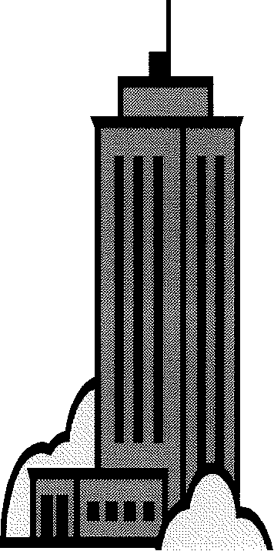

8. How is "land use" distributed within typical skyscrapers?

9. What is the only major US city without skyscrapers?

10. Due to the intensive use of CBDs certain types of activities are being pushed out of downtowns and are rarely found there today. These include manufacturing and residential uses.

a. What is happening to the old manufacturing districts in American CBDs?

b. Regarding residential uses - identify a factor pushing them out of the CBD and another that is pulling them elsewhere.

Pushing ..

. Pulling ..

THE EUROPEAN CBD

11. List 5 ways that a European CBD differs from a North American example. a.

b. c. d. e.

12. How have these three European cities been distinctive in terms of their

CBDs?

a. PARIS

b. ROME

c. WARSAW

**SUBURBANIZATION OF BUSINESSES**

13a. Since when did most retail activities begin to move from CBDs to suburban locations?

13b. Why?

14. Where do malls tend to locate?

15. Why have factories and warehouses moved to suburbs?

16. What are the advantages of having offices in suburban locations?

Chapter 13: Urban Patterns

Key Issue 1: Where Have Urban Areas Grown?

Rubenstein, pp. 439-445

URBANIZATION

1. Define urbanization and identify its two dimensions.... (a) definition:

(b) dimensions (i) (ii)

2. What is the percent of the world=s population that could be defined as urban for each of the following years?

a. 1800 b. 1850 c. 1900 d. 1950 e.2000

3. Describe what is happening in MDCs and LDCs as far as the percentage of urban dwellers is concerned.

|  |  |
| --- | --- |
| MDC | LDC |
|  |  |

4. List the largest cities in

Largest cities in the world

MDCsandLDCs as defined in MDCs in LDCs by the US Bureau of the

Census and the United

Nations

5. How does the growth of urban areas in LDCs represent a reversal of the trend in urban growth historically?

**DEFINING URBAN SETTLEMENTS**

6. During the 19301 s, Louis Wirth argued that people living in urban areas led a different kind of life than people in rural areas. He believed that human sociology was affected by three characteristics of urban areas. These are listed in the table below in the left column. Complete the table with a description of the sociological effect he believed each condition had upon people in cities.

|  |  |
| --- | --- |
| Large Size |  |
| High Density |  |
| Social Heterogeneity |  |

Physical Definitions of Urban Settlements

7. What are threecharacteristics of a "city" as it is defined legally?

a. b. c.

8. Define the term urbanized area as it is used to define a "city".

9. What does MSA stand for?

10. What are the characteristics of an MSA?

11. Identify an advantage and a disadvantage of using an MSA to define "city"?

a. advantage:

b. disadvantage:

12. Regarding micropolitan areas... a. what is their size?

b. what were these cities classified as previously?

c. how many, and where, are they in the US?

13. What is the meaning of the term megalopolis? (and what was the original example?)

14. Use an atlas map showing American cities to sketch/ shade in the three major American megalopolis (as described in the text, pp. 444-45) on the map below.

NOTE: Label the major cities in each.

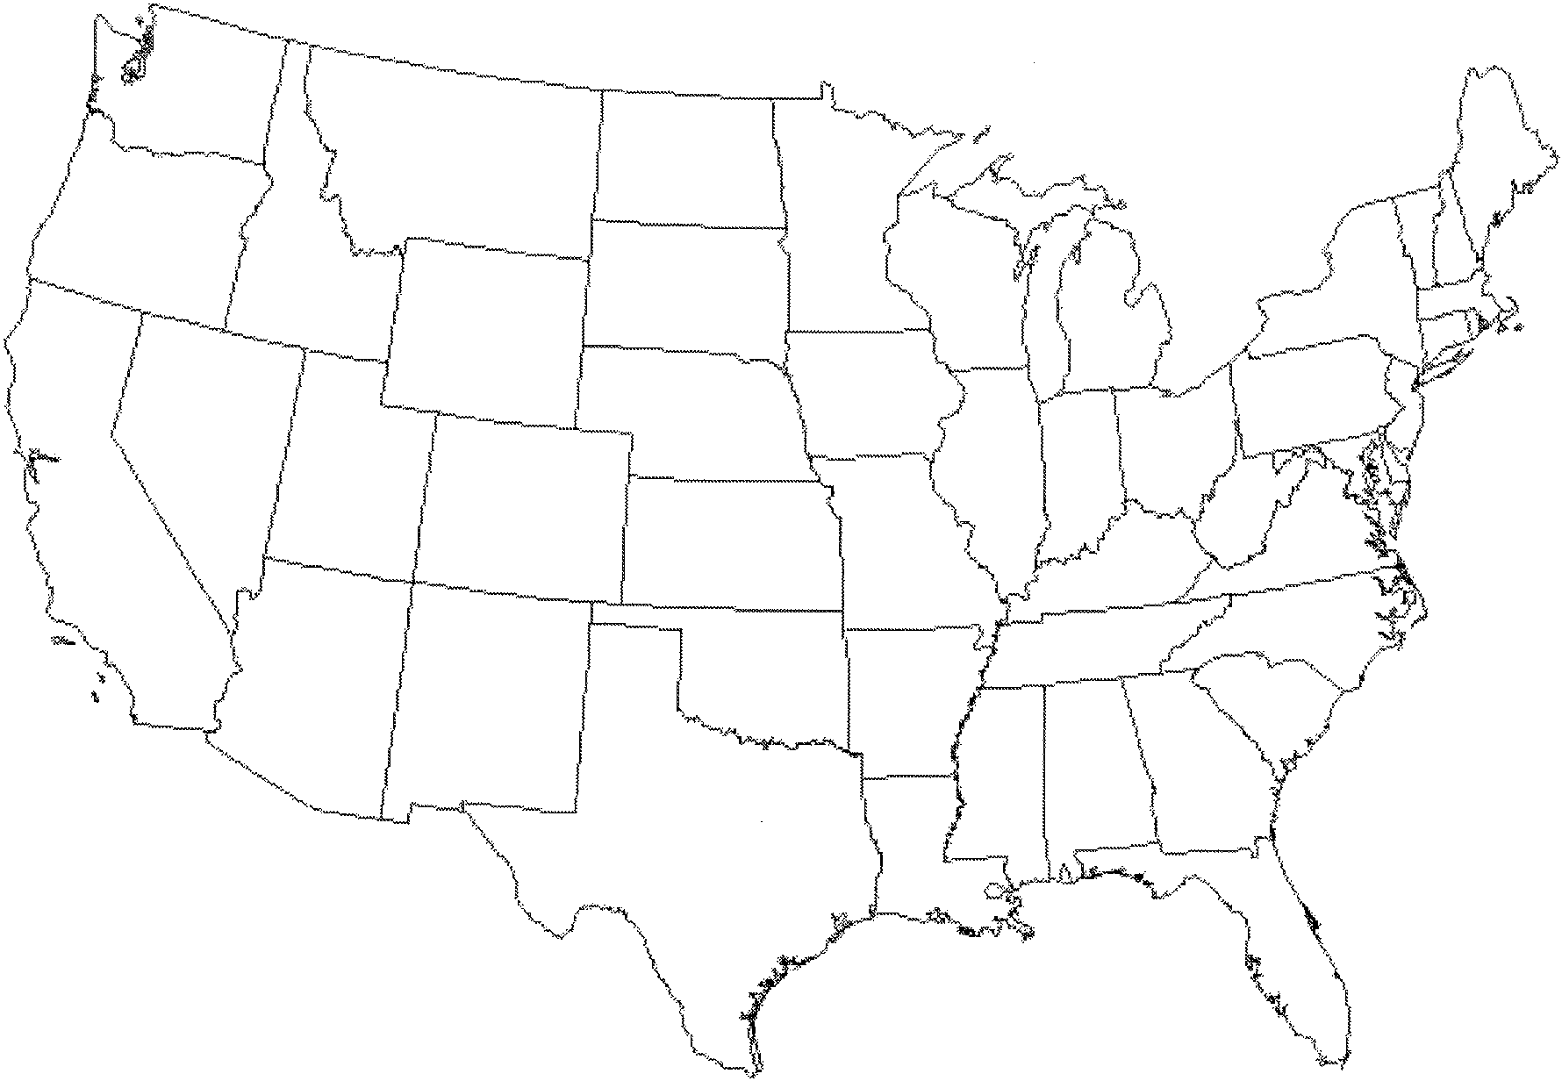

15. Identify two European megalopoli (regional name and major cities)

A.

B.

16. Identify an Asian megalopolis (country and major cities)

Chapter 13: Urban Patterns

Key Issue 2: Where Are People Distributed Within Urban Regions

Rubenstein, pp. 445-454

THREE MODELS OF URBAN STRUCTURE

1. Read the first section of this key issue and for each of the three models, annotate the diagrams below and do the following:

a) identify the model by name

b) name the geographer(s) who devised the model by name c) identify and label the key parts of the model

d) bulletin other important characteristics and/ or features of the model

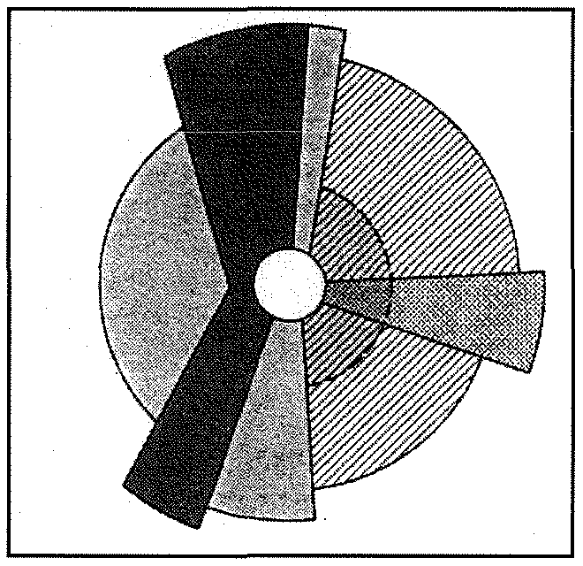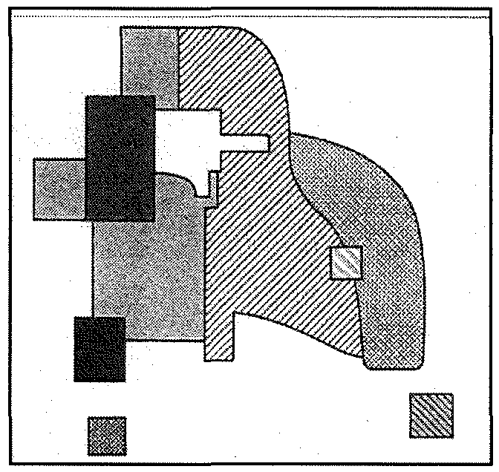

2a. What are census tracts?

2b. What types of data are reported by the US Census Bureau regarding the population of each census tract?

3. What is social area analysis?

**USE OF THE MODELS OUTSIDE NORTH AMERICA**

I European cities

4. In European cities, the wealthy tend to live in the inner-ring of cities and in a spine extending out from it.

(a) What are the advantages of the southwestern extending spine of Paris? (b) What are the advantages of living in the inner-ring, near the city center?

5. List three points about the conditions of European suburbs, where the poor live. (a)

(b)

(c)

Less Developed Countries

6. Cities in Africa, Asia, and Latin America resemble European cities in their structure. This is not a coincidence because ...

7. Draw and label a sketch of a "pre­ colonial city"

8. Colonial cities often contained a new "European sector" to the side of the pre-colonial city. Contrast their various elements in the table below.

|  |  |
| --- | --- |
| "Old Quarters" - the pre-colonial city | "European district" - the colonial addition |
|  |  |

9. Describe how the elite spine developed in modern Mexico City.

Squatter Settlements

10. What are the causes of squatter settlements?

11. Use the third paragraph in this section to make a simple flowchart which depicts stages in the development of a squatter settlement.

|  |  |  |  |  |
| --- | --- | --- | --- | --- |
|  |  |  |  |  |
|  |  |

12. Describe services and amenities in a typical squatter settlement.

Chapter 13: Urban Patterns

Key Issue 3: Why Do Inner Cities Have Distinctive Problems?

Rubenstein, pp. 454-459

1. Complete this statement regarding the basic problems of the inner city:

-------------------------------- -----------------------,

|  |  |  |
| --- | --- | --- |
| I Inner cities in the United States contain concentrations of | people | : |
| I |  | I |
| : with a variety of physical, and | problems very | : |
| I  : different from those faced by residents.  l |  | I  j1 |

**INNER CITY PHYSICAL PROBLEMS**

2. What is the majorproblem faced by inner-city residents?

3a. Describe the inner-city process known as filtering.

3b. What is the ultimate result of this process?

4. What is redlining and its result?

5. What is urban renewal?



PUBLIC HOUSING

A Who (primarily) builds and maintains public housing?

B. Percentages of public housing in the US ...

a. Public housing accounts for _% of all housing in the US.

b. Public housing accounts for % of all housing in the inner city.

C. Why are the high-rise public housing "projects" built during the 50's and 60's now considered unsatisfactory?

D. How are recent public housing projects and "scattered-site" public housing of today different?

7. Why has urban renewal been criticized?

Sa. Define gentrification:

8b. Who is attracted to move into gentrified areas? Why?

8c. Why has gentrification been criticized?

9. Complete the boxed statement regarding the population of the inner city.

Inner-city residents frequently are referred to as a permanent _ because they are an unending of economic and social ----------

**INNER-CITY SOCIAL PROBLEMS**

10. List and briefly describe four specific social problems of inner-city residents.

A.

B.

c.

D.

**INNER CITY ECONOMIC PROBLEMS**

11. What financial crisis does the high proportion of low-income residents in the inner city create?

12. What two choices does a city have to solve this problem? Which have most chosen?

13. Sketch a small graph to show (approximately) how federal aid to inner­ cities grew and shrank:



20%

15%

10%

5%

0%

FEDERAL AID TO INNER CITIES

14. Regarding ANNEXATION: (a) What is annexation?

(b) What is required before an area can be annexed by a city? (c) In the past, why did peripheral areas desire annexation? (d)Whathaschanged?

Chapter 13: Urban Patterns

Key Issue 4: Why Do Suburbs Have Distinctive Problems?

Rubenstein, pp. 459-467

**THE PERIPHERAL MODEL**

1. List the elements of an urban area according to the peripheral model.

2. Complete the table below.

|  |  |
| --- | --- |
| PERIPHERAL AREAS | |
| Problems that they LACK | Problems that they HAVE |
|  |  |

3. Describe the formation of an EDGE CITY in the flowchart below.

|  |  |  |  |  |
| --- | --- | --- | --- | --- |
|  |  |  |  |  |
|  |  |

4. Describe the density gradient of an urban area.

5. How has the density gradient changed in recent years? (2 ways.)

(a) (b)

6. Define sprawl:

7. What is meant by the statement that: the "periphery of US cities looks like Swiss cheese"?

8. What has prevented the peripheries of European cities from looking like "Swiss cheese"?

9. In what two ways are suburban areas "segregated"?

a

b

10. What is a zoning ordinance?

**CONTRIBUTION OF TRANSPORTATION TO SUBURBANIZATION**

11. Read "Contribution of Transportation to Suburbanization" and "Motor Vehicles" to fill in the flowchart describing how developments in transportation affected the residential pattern of A.c'llerican cities.

PEDESTRIAN PHASE STREETCAR PHASE AUTOMOBILE PHASE

--+

12. Identify 2 ways in which the US Government has encouraged the use of motor vehicles by its citizens?

13a. What percentage of a city is devoted to motor vehicles?

13b. Identify 2 ways in which motor vehicles use land in urban areas.

(i) (ii)

14. What is rush hour and how much of a city's traffic does it account for?

15. List four ways in which public transportation is better than the automobile.

a. b. c. d.

16. Briefly describe what has happened (or is currently happening) to each of the following modes of public transportation in US cities.

• Trolleys

• Buses

• Rapid transit (subway and fixed light rail)

17. How does the North American situation compare to that in Europe and Japan?

**LOCAL GOVERNMENT FRAGMENTATION**

18. What is the basic problem caused by the multiplicity of governments in US urban areas?

19. Briefly not how each of the following forms of local government attempts to solve this problem?

A. council of government

B. federations

C. consolidations

20. What is smart growth?

21. Describe how "smart growth'' laws have been designed in Maryland, Oregon, and Tennessee.

|  |  |  |
| --- | --- | --- |
| Maryland | Oregon | Tennessee |
|  |  |  |