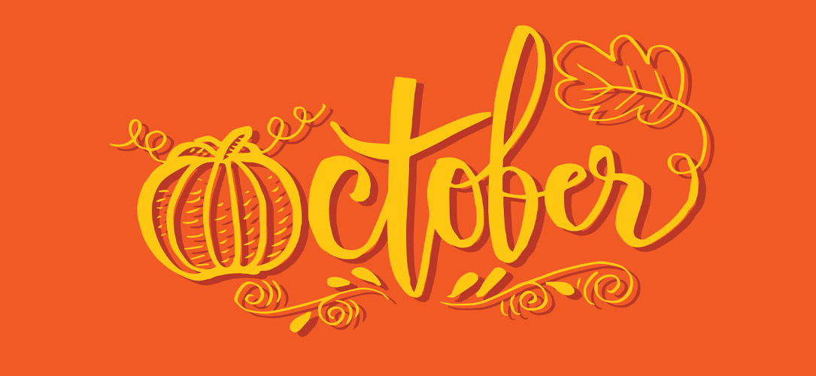  - October  This Week 10/12– 10/16  We are 26 chapters into “Death by Toilet Paper”. The vocabulary for this book is as follows: gruesome, slogan, grace period, confiscate, intercept, blissfully, eviction, enterprising, noxious, interior, seeps, practically, crafting, definitive, and indignant. In math we are working combining like terms. We will be adding the two concepts together so that we will combine like terms to solve 1 and 2 step equations. We will start coordinate plane this week as well. We are starting chemical and physical change in Science. In social studies we are working on government. We are learning about, what is government? Why do we need government? What are the types of government? We will get into amendments, laws, and types of judicial systems.  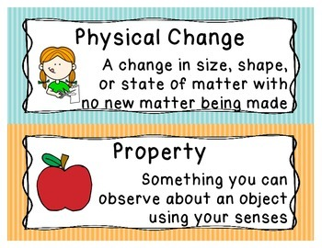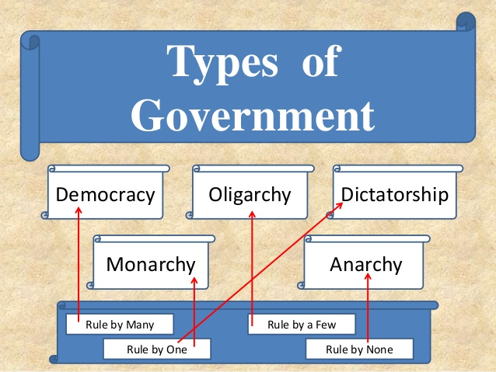  Email: knunn@paulding.k12.ga.us  Phone: 770-443-1449 |  |   Mrs. Nunn’s Class  Upcoming events  10/26 – 10/30  Red Ribbon week  11/03  Election Day (no school)  Questions to ask your child…  What type of government do we have in the United States?  Give an example of a chemical change.  Give an example of a physical change.  What is a coordinate plane? (Wednesday we will introduce this concept)  What does noxious mean?

