  - December  This Week 12/14– 12/18  We are working on reviewing our math skills. Combining like terms, integers, solving equations, and plotting points. We are reading Christmas stories and working on rewriting the stories. In Science we are going to be doing candy cane experiments. We are finishing Christmas around the world. We will read Georgia Night before Christmas and work on completing the, what does our Christmas look like? Have a safe and happy holiday!  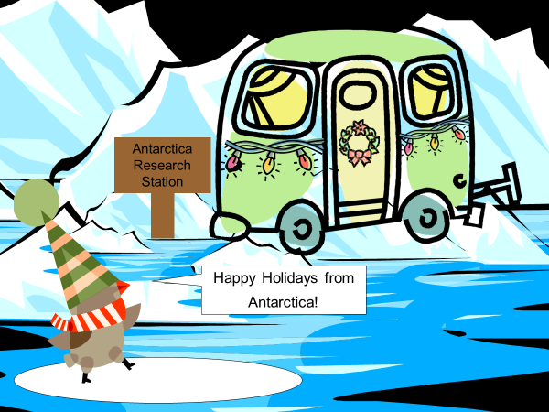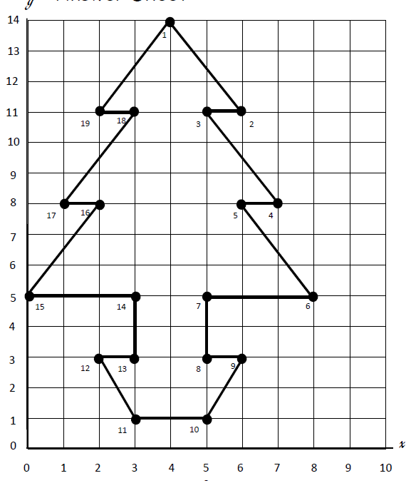  Email: knunn@paulding.k12.ga.us  Phone: 770-443-1449 |  |   Mrs. Nunn’s Class  Upcoming events  12/16  Ugly/Holiday Christmas sweater  12/18  Last day before Christmas Break (2-hour early release)  01/05  1st day of new semester (virtual learning day)  Questions to ask your child…  How long does Christmas last in Mexico?  What are the rules for integers?  What is the plot in “How the Grinch Stole Christmas?  What makes candy canes dissolve quickly?

