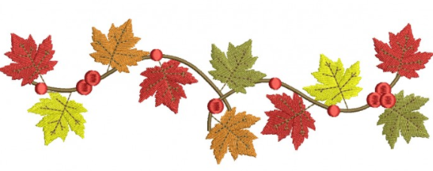**2nd Grade Wildcat Times**

**September 14-18**

We hope everyone has a safe and relaxing Fall Break next week.

Reminders

* Frozen Friday has begun. If you did not prepay for the semester or year, you can still purchase ice cream. Send $1 in on each Friday with your child.
* Your child can purchase ice cream from their lunch accounts Monday-Thursday.
* Please place all money in a Ziploc bag with your child’s name on it and what it is for.
* Please pack a snack for your child daily. We have a working snack, so it needs to be quick and simple (eaten one-handed).
* Please remember that water fountains are for water bottle refills only.

Look What We Are Learning

**Reading-** We are readingIvy and Bean together with discussions and activities.

**Writing-** We are writing a narrative while responding to the text.

**ELA-** We are working on simple and compound sentences, nouns, verbs, adjectives, and adverbs.

**Math-** We are representing number in standard form, word form, expanded form, and using pictures.

**Science/Social Studies-** We are readingWhere in The Wild and Camouflage: Changing to Hide together with discussions and activities.

**Spelling (practice nightly for Friday’s test):**

Pattern: or: horse sport

Pattern: ar: harm park

Pattern: ur: spurt hurt surface* plural* mural*

Pattern: er: perch fern merchant*

Pattern: ir: bird dirt

Important Dates

**September 14-18 – Virtual Fall Spirit Sale**

**September 21-25 – Fall Break No School**

Specials

|  |  |  |  |  |  |
| --- | --- | --- | --- | --- | --- |
|  | **M** | **T** | **W** | **Th** | **F** |
| **Bowling** | STEM | M | L | PE | STEM |
| **Davis** | PE | L | A | M | A |
| **Mills** | A | PE | M | A | PE |
| **Quinn** | M | A | PE | L | M |

Please wear sneakers for PE.

Homework

Please have your child complete their homework nightly and return it each day.

Reading With myon

1. To visit MyOn simply go to [www.clever.com/in/pcsd](http://www.clever.com/in/pcsd)
2. Enter their lunch number for the username and their initials+the first four digits of their birthday for the password
3. Click the MyOn icon

*You can also access MyOn through the county Student Dashboard at <https://www.paulding.k12.ga.us/site/default.aspx?PageID=38476>

Click the blue Clever icon.