GOLD 1 Matter Name______________ Period ____

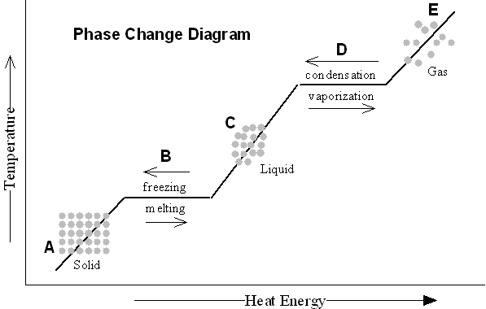

**Matter** – Everything that has mass and takes up space **Properties of matter** – Mass, volume, weight, density

**Phases of Matter:**

**Solid** - matter that has definite volume and shape.

The molecules are packed together tightly and move slowly.

**Liquid** - matter that has definite volume but not shape.

Since the molecules of a liquid are loosely packed and move with greater speed,

a liquid can flow and spread. (fluid)

**Gas** - matter that has no definite volume or shape. (Free molecules)

Molecules of a gas are so loosely arranged and move so rapidly that they will fill their container.

**Phase Change Descriptions:**

**Melting -** the change from solid to liquid.

**Freezing** -the change from liquid to solid.

**Vaporization**  - the change from liquid to gas.

**Evaporation**  - vaporization from the surface of a liquid.

**Boiling**  - vaporization from within as well as from the surface of a liquid.

**Condensation**  - the change from gas to liquid.

**Sublimation**  - the change from solid to gas.

**Deposition**  - the change from gas to solid.