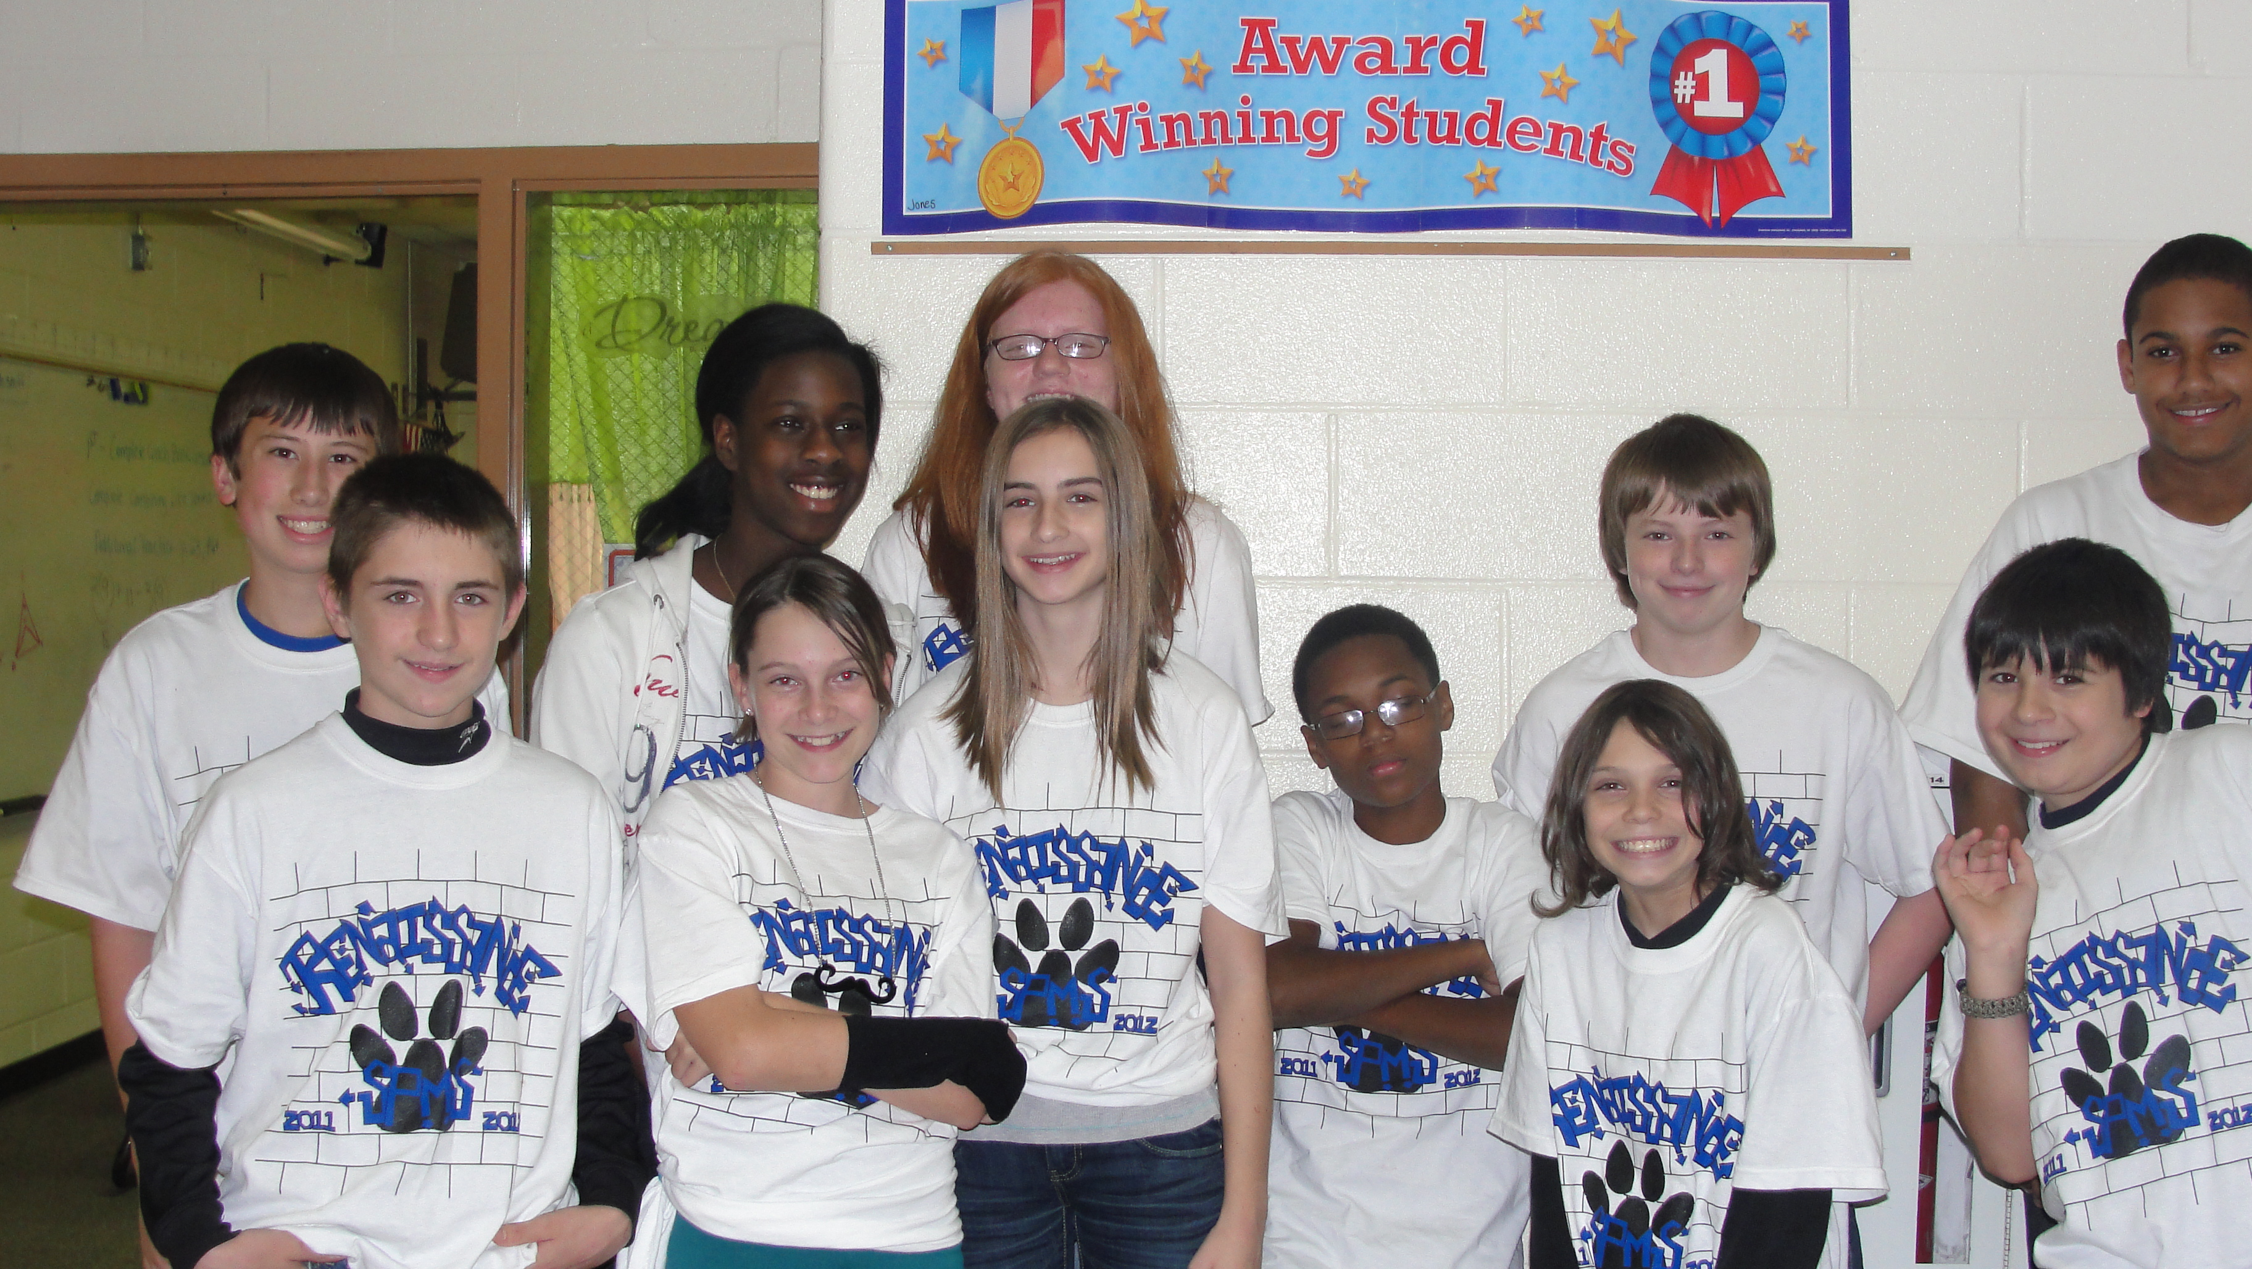

Partners in Education
2019-2020 SPMS Renaissance Program

Thank you in advance for contributing to this worthwhile program which enable struggling students to reach their full potential. We are looking forward to working together on this project which helps raise the student’s attendance, behavior and academic achievement.

SPMS currently serves over 500 students with approximately 50% receiving free or reduced lunch. As you know, students who are economically disadvantaged are often challenged in the areas of academics, attendance and behavior. The SPMS Renaissance Program reaches all students by offering positive incentives which help them fulfill the necessary goals to be successful in the future. We extend our sincere gratitude in your willingness to support the children of our community.

We say thank you by:

- Your business is listed on our school’s website
- Your business is posted on bulletin board in school hallway
- Your business name is on the back of t-shirts (approximately 500 t shirts worn throughout community by students to advertise for you)
- Your business is listed in local newspaper(s)
- Your business is listed on Sponsor list front entrance of school

Calendar of Events:

- First 9 week Renaissance Celebration
- Second Renaissance Celebration
- Third Renaissance Celebration
- End of Year Bash Celebration

How you can pledge:
- Check to SPMS
- Candy for School Store
- Display boards for science projects
- SPMS spirit wear
- Electronic game devices (hand held)
- Cameras
- Bicycles
- Kindles
- Movie Tickets
- Apple I tune cards
- Gift Certificates (Walmart, clothing stores, restaurants)
- Tickets to Stars and Strikes
- Tickets to Bowling
- Tickets to Movies

Other ways to help:
- Volunteer for a school beautification day
- Join us on any of our celebrations or Roar Fridays
- Be a Career Day speaker
- Read to kids
- Eat lunch with kids
- Be a Testing Proctor

I/we ______________________, pledge to contribute $1,000.00 ________
(Company Name)

I/we ______________________, pledge to contribute $750.00 _________
(Company Name)

I/we ______________________, pledge to contribute $500.00 _________
(Company Name)

I/we _______________________, pledge to contribute $250.00 ________
(Company Name)

Other Pledge: _________________________________________________

_____________________ Printed Name

______________________ Signature

______________________ Date

