- A group of similar organisms that can mate with each other and produce fertile offspring. ______________________
- What did Darwin infer from his observations of organisms in South America and the Galápagos Islands?

- Differences between members of the same species are called ______________________.
- What are genes and how are they involved in the process of evolution?

- What is the main way that a new species forms?

- What are fossils and what are the different kinds of fossil evidence?

- What parts of organisms are most likely to become preserved as a fossil?

- What parts of an organism can not be preserved as a fossil?

- Name the two methods of dating fossils and explain each.

- What 5 types of evidence do scientists use to prove that organisms evolved from a common ancestor?

- These structures are known as _____________ _____________
and are evidence of a _______________ _____________.
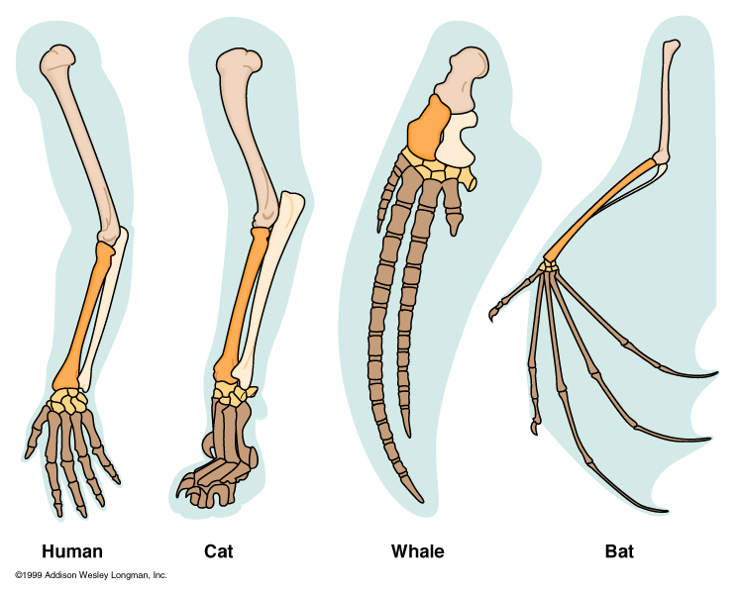

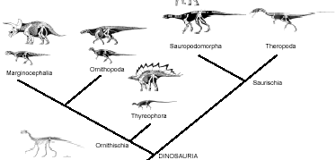

- Name the diagram to the right and
explain what it is used for.

- What did Darwin observe about the finches in the Galapagos Islands?

- What is an adaptation?

- What is natural selection?

- Name the three causes of natural selection and explain each.

- What evidence suggests that the ancestors of whales once walked on land?

- If the half-life of a radioactive element is 10 days, how long will it take for three fourths of a sample of the element to decay?

- Use the graph below to answer the following questions.
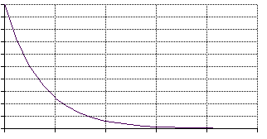
  - What is the half life of this element?
100

75

50

25

0

  - If you started with 8 grams of the element, how long would it take until there was only 1 gram left?

0 50 100 150 200

- What are mutations and how are they involved in natural selection?

- What is a scientific theory?

- What is evolution?

- Explain the two theories about the rate at which evolution happens.

- Which theory did Darwin’s ideas support?

- The only traits that can be acted upon by natural selection are those that are controlled by ____________________.

- How can species evolve different traits when they are separate from their group?

- How did studying selective breeding help Darwin develop his theory of evolution?

