Evolution Study Guide Answer Key

- A group of similar organisms that can mate with each other and produce fertile offspring. Species
- What did Darwin infer from his observations of organisms in South America and the Galápagos Islands?
A small number of different plant and animal species had come to the Galapagos Islands from the mainland.
- Differences between members of the same species are called Variation.
- What are genes and how are they involved in the process of evolution? Genes control traits and only those traits can be acted on by natural selection.
- What is the main way that a new species forms? A group is separated from the rest of the species.
- What are fossils and what are the different kinds of fossil evidence? Fossils are the preserved remains or traces of organisms that lived in the past. (1) Mold: a type of fossil formed when a shell or other hard part of an organisms dissolves, leaving an empty space in the shape of the part; (2) Cast- type of fossil formed when a mold becomes filled in with minerals that then harden; (3) Petrified fossil – a fossil formed when minerals replace all or part of an organism.
- What parts of organisms are most likely to become preserved as a fossil? Hard parts – shells, bones, teeth.
- What parts of an organism can not be preserved as a fossil? Cells, tissues etc.
- Name the two methods of dating fossils and explain each.
- Relative Dating - a method to compare the ages of two fossils based on the layer of rock in which it was found.
- Radioactive Dating- a technique used to determine the actual age of a fossil on the basis of the amount of a radioactive element it contains. Scientists compare the amount of the radioactive element left in the sample to the amount of the element that it breaks down into.
- What 5 types of evidence do scientists use to prove that organisms evolved from a common ancestor?
Fossils, Similarities in early development, similarities in body structure, DNA, and protein structure;
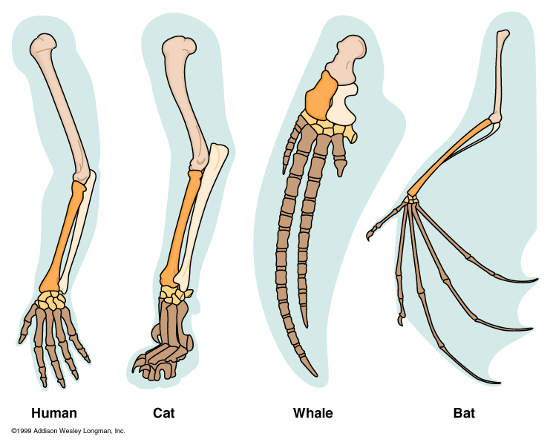
- These structures below are known as homologous structures and are evidence of a common ancestor.

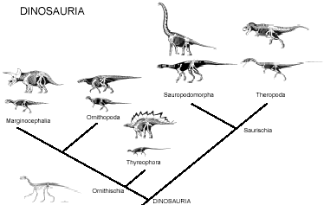
- Name the diagram to the right and explain what it is used for.
Branching tree – used to show how scientists think
different groups of organisms are related.
- What did Darwin observe about the finches in the Galapagos Islands?
Their beaks were adaptations related to the foods the finches eat.
- What is an adaptation? A trait that helps an organism survive and reproduce.
- What is natural selection?
The process by which individuals that are better adapted to their environment are more likely to survive and reproduce.
- Name the three causes of natural selection and explain each.
Overproduction – most species produce far more offspring than can possibly survive.
Variation – any difference between individuals of the same species.
Competition – members of the same species must compete for limited resources.
- What evidence suggests that the ancestors of whales once walked on land? Scientists have found fossils of Whale-like creatures that had legs.
- If the half-life of a radioactive element is 10 days, how long will it take for three fourths of a sample of the element to decay? 20 days
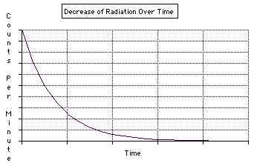
- Use the graph below to answer the following questions.
                - What is the half life of this element? 25 Years
                - If you started with 8 grams of the element, how long would it take until there was only 1 gram left? 75 Years

- What are mutations and how are they involved in natural selection?
Mutation – any change in a gene or chromosome that can either be helpful or harmful. They can affect the survival and reproduction of the organisms.
They are involved in natural selection as any variation within a population can be due to a mutation. This may make the organism better adapted to the environment which makes it more likely to survive and reproduce.
- What is a scientific theory? A well- tested concept that explains a wide range of observation.
- What is evolution? The gradual change in species over time.
- Explain the two theories about the rate at which evolution happens.
Gradualism- the theory that evolution occurs slowly but steadily. In this theory intermediate forms between a fossilizedorganism and its descendents is needed.
Punctuated equilibrium – species evolve quickly during relatively short periods or rapid change followed by long periods of little to no change. This theory accounts to gaps in the fossil record.
- Which theory did Darwin’s ideas support? Gradualism
- The only traits that can be acted upon by natural selection are those that are controlled by genes
- How can species evolve different traits when they are separate from their group? Isolation
- How did studying selective breeding help Darwin develop his theory of evolution?
Darwin observed that animals with a desired characteristic could be produced by allowing only those individuals with the characteristic to mate. He thought that a process similar to selective breeding might occur in nature.

