Arab

Refers to a mixed ethnic group made up of people who speak Arabic. Many practice Islam. Arabs live primarily in North Africa. The 2 groups that make up Arabs are the Bedouins (nomads) and the settled Arabs. Bedouins are mainly Sunni Muslim.
Arab people began to spread into North Africa in the late 600s AD, when the first Muslim armies arrived in Egypt. From there, Arab armies, traders, and scholars spread across northern Africa all the way to Morocco. Wherever the Arabs went, they took Islam and the Arabic language with them. Arabic was necessary if one was to be able to read the Quran, Islam’s holy book. From North Africa, Arab traders began to lead caravans south across the Sahara Desert in the gold and salt trade. This brought Islam and Arab culture to the Sahel region and beyond. Along the east coast of Africa, Arab traders traveled by land and by sea down to present day Kenya, Mozambique, Tanzania, and Zanzibar. They married local women and the process of blending cultures and religions began there as well. The Arabic language, the religion of Islam, and many other aspects of Muslim culture became part of Africa. Today Muslims are found throughout Africa. They make up a majority of the people living along the Mediterranean coast and in some countries along the Indian Ocean in the east.

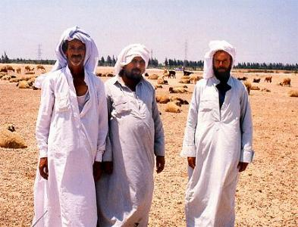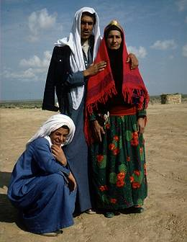

Ashanti

The Ashanti people are found in the modern country of Ghana. They have been a powerful group in this part of Africa for over three hundred years. Their culture has played a part in the countries around them, including Burkina Faso, Cote D’Ivoire, and Togo. The Ashanti believe that their kingdom was founded in 1701 with the help of a holy man who produced a Golden Stool from the heavens and gave it to the first Ashanti king. The Stool came to symbolize Ashanti power and the belief is that the kingdom will last as long as the golden stool remains in the hands of the Ashanti king. The traditional Ashanti religion is centered on the belief in a supreme god, or Nayme. His many children, the Abosom, represent all the natural powers and forces in the world. The traditional Ashanti believe that all living things have souls. They also believe that witches, demon spirits, and fairies have powers in the lives of men. Ancestors are given great respect, and there are a number of family rituals associated with birth, puberty, marriage, and death.
Other religions are also practiced by many of the Ashanti. Christianity has gained many followers in Ghana and along the west coast of Africa. It was introduced by European and American missionaries beginning in the 1800s. There are also a large number of Muslims. Like so many other places in Africa, movement of people through the centuries has resulted in a great deal of diversity in nearly all aspects of life among the Ashanti.

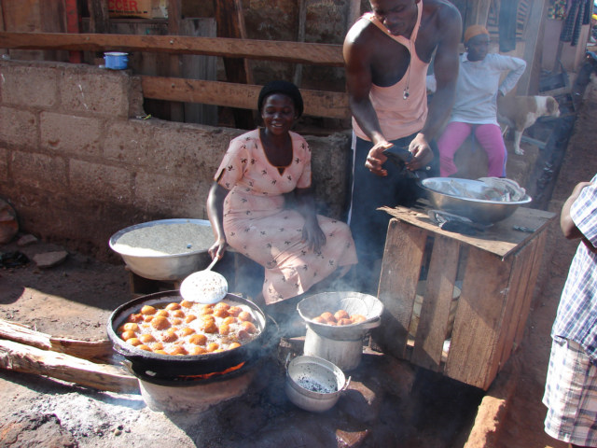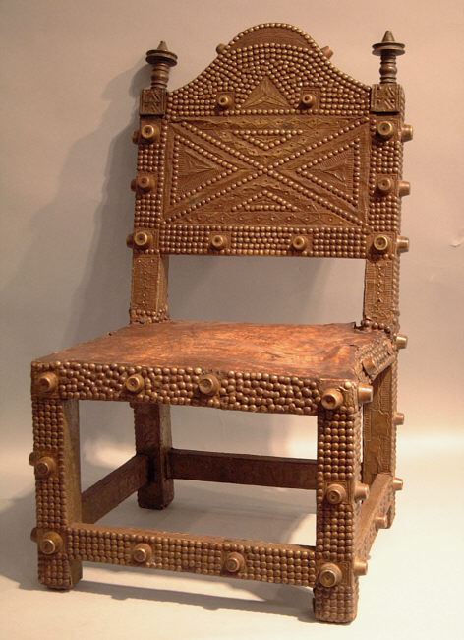

Live in central Ghana in western Africa. They are a major ethnic group of the Akans in Ghana. The Ashanti occupy the central part of the country. The government of Ashanti is shaped like a pyramid. There is one king and he heads the Ashanti Confederacy Council, a group made of paramount chiefs. A paramount chief presides over district chiefs. A district chief presides over a District Council of Elders, which is made up of subchiefs. Villages are brought together by a subchief. Within every village there is a village head council made up of all of the heads of households.
The Ashanti religion is a mixture of spiritual and supernatural powers. They believe that plants, animals, and trees have souls. They also believe in fairies, witches, and forest monsters. There are a variety of religious beliefs involving ancestors, higher gods (abosom) and Nyame, the Supreme Being of Ashanti. The Ashanti also practice many rites for marriage, death, puberty, and birth. The golden stool is sacred to the Ashanti. There is an elaborate legend surrounding it that is told by the old men of Ashanti. No one has ever sat on it and since its arrival, it has not touched the ground. As an Ashanti symbol, the golden stool represents the worship of ancestors, well-being, and the nation of the Ashanti.
The Ashanti (also known as Asante) people live in Southern Ghana. There are about 1.5 million people in the Ashanti nation. They speak a dialect of Twi, called Asante.
They are world famous goldsmiths and are best known in America for their Kente cloth, a fabric originally worn by the royalty of the Ashanti.
Historians can trace the beginnings of the Ashanti people to the thirteenth century, however, they did not hold great power until the end of the seventeenth. According to Ashanti legend, a golden stool descended from heaven and rested on the knees of the first Ashanti king called the Ashantehene.
Today the Ashantehene still rules the Ashanti people and the Golden Stool is still the most important icon in their culture. They believe that the golden stool contains the souls of all Ashanti people and embodies the strength in their nation.
In their early history, the Ashanti obtained most of their wealth through the slave trade. Many African Americans today believe themselves to be of Ashanti descent. Evidence of this exsists in Jamaica, where Ashanti mythology and folklore is considered Jamaican folklore and remains in tact. Also in the Southern United states, Ashanti folklore can be found as traditional African American folklore.
http://www.bsu.edu/classes/magrath/

Bantu

The Bantu-speaking people of Africa migrated in many different waves from the region just south of the Sahara Desert to the central and southern parts of the continent beginning over 2,000 years ago. Today the speakers of the hundreds of Bantu-related languages include many different ethnic groups, though they share a number of cultural characteristics. The Bantu refer to over 400 different ethnic groups. From their earliest days, the Bantu were known as farmers and animal herders, and they learned iron-making crafts as well. As they spread south and east across the continent, following rivers and streams, they met many new people and learned new skills, even as they shared their own. Bantu-speaking people settled as far south as the southern tip of Africa. They intermarried with the people they met accepting new traditions and blending them with Bantu culture. The Bantu migration was one of the largest movements of people in Africa’s history. Today over 60 million people in central and southern Africa speak Bantu-based languages and share some part of Bantu culture.
Many Bantu who settled in areas where there was a strong Arab presence are Muslim. Others living in parts of Africa influenced by missionary efforts are Christian. Still others follow tradition animist religions. Animists believe that spirits are found in natural objects and surroundings. They may feel a spiritual presence in rocks, trees, a waterfall or a particularly beautiful place in the forest.
The Bantu are a group of people who speak related languages and have similar social characteristics. They occupy a large part of Zaire and southern as well as eastern Africa. The Bantu are said to have originated from somewhere in the Congo region of central Africa and spread rapidly to the Southern and eastern Africa. (Today, more than one half of the population of Uganda is Bantu.). This migration brought new farming techniques, agricultural products (like bananas), and government structure to these areas. There are several groups speaking different Bantu Languages.
Though there are striking similarities in language and customs among the different Bantu groups, each group has its own peculiarities in customs and other social arrangements. The Bantu refer to over 400 different ethnic groups in Africa, from Cameroon to South Africa, unified by a common language family, the Bantu languages, and in many cases common customs. Today the Bantu are recognized more as a language group rather than a cultural group. The most widely spoken Bantu-derived language is Swahili, a lingua franca (a language used in common by different peoples to facilitate commerce and trade) used by up to 50 million speakers on the eastern coast of Africa. Traditional religion is common among the Bantu, with a strong belief in magic. Christianity and Islam are also practiced.

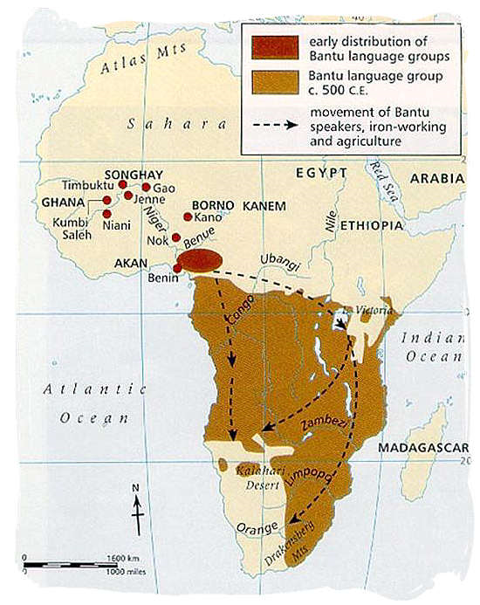
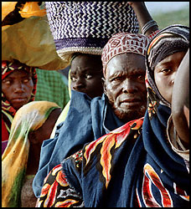
Swahili

The Swahili community developed along the coast of East Africa when Arab and Persian traders looking for profitable markets began to settle there and intermarry with the local Bantu-speaking population. The resulting Swahili culture is a mix of people who can claim ancestors in Africa, in Arabia, and even across the Indian Ocean. Many people in the countries of Kenya, Tanzania, and Mozambique share the Swahili culture, language, history, and traditions. While the Swahili language is considered a Bantu language, there are many Arabic words and phrases included as well. The word Swahili comes from the Arabic word “Swahili,” which means “one who lives on the coast.” Most Swahili today are city dwellers rather than traditional farmers and herdsmen. Many are engaged in fishing and trade, as their ancestors were.
Because contact with Arab traders was such a big part their history, most Swahili today are Muslims. Islam has been one of the factors that helped created a common identity for such a diverse group of people. It is not unusually for Swahili men to wear charms around their necks containing verses of the Quran to protect them from harm. The Quran is the holy book for Muslims. Many among the Swahili also follow local beliefs that have been part of the culture of eastern Africa since before Muslim traders arrived over a thousand years ago. These local beliefs are known as mila. One belief that is part of mila is that there are spirits that can possess a person. Many Swahili also see a close link between their religious beliefs and the practices of medicine and healing. Herbal medicines are often given along with prescribed prayers and rituals that are all thought to be part of the cure.

Muslims that live on the East African coast from southern Somalia to northern Mozambique. They also believe in spirits, which they call djinns. They may enter a trance to speak to these spirits. They often wear amulets with verses from the Koran to protect them from evil spirits.
The Swahili language is a mixture of Bantu (African) and other languages, principally Arabic. The formation of the Swahili culture and language is generally attributed to contact between African and Asiatic people on the coast of East Africa. The word “Swahili” was used by early Arab traders to this area and means “the coast’. Ultimately it came to apply to the people and the language.

