Third Grade Tasks (continued)

5. You are in charge of buying drinks for your team’s practice. Visit the Ingles aisle with sports drinks. You have twelve team members. Which sports drink would be the best deal for you? (The least amount for twelve drinks.)

6. Below describe why you think your team will like the sport’s drink you picked.

Hutchens Elementary School
586 Clonts Road, Douglasville, GA 30134
Principal: Stefanie Bowen
All families of Hutchens Elementary students have been invited to attend!
3rd
Grade
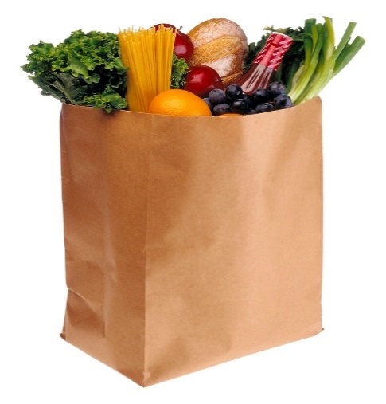

Welcome to Our Title I Family Night!
MAth and Reading Night AT INgles

Ingles - 1817 Dallas Nebo Rd, Douglasville, GA 30134

Here’s how it works:

- Sign in at the Café Title I Table for your grade level to receive your task packet.
- Students and their family members walk to the aisle that pertains to the word problem they are completing (an adult must accompany the child at all times).
- Use the information in the problem to find products and prices (if necessary), then solve the problem using math strategies the students are learning at school.
If help is needed for problem-solving, please ask a nearby teacher! We are excited to assist!
- Complete the problems for your grade level and bring the answer sheet back to the Café table to be reviewed.

Third Grade Tasks

- You and a friend go to Ingles and purchase frozen pizzas. Find two different types of pizzas that are the same size (label and draw them below).

If you eat ½ of your pizza and your friend eats ¼ of his/hers, who eats more pizza? Why?

- Compare and contrast the two types of frozen pizzas below. Would either one work for your family dinner? Think about what toppings your family likes.

Third Grade Tasks (continued)

- What do the pizza directions mean when it tells you to preheat the oven?

- A. Your family’s coffee pot stopped working this morning. How much would it cost for you to purchase a new one as well as another can of coffee? (You may use the dollar amount only – don’t worry about the cents.)

B. When you check out with your new coffee pot and coffee, you give the cashier a one-hundred dollar bill. If this is enough to cover your cost, how much change will you receive? (You may use the dollar amount only – don’t worry about the cents.)

