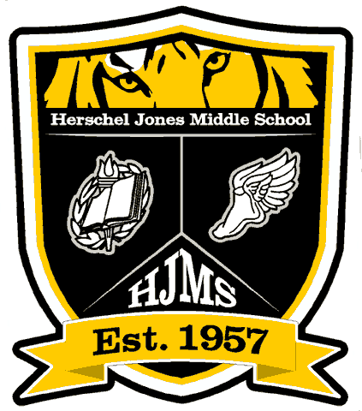
Engage ~ Inspire ~ Prepare

HJMS STUDENT DRESS CODE

APPROVED FOR SCHOOL WEAR

Pants and Shorts
- Pants and shorts must be sized appropriately and worn at the waist line.
- The length of shorts must be appropriate (5 inches from the top of the kneecap as measured by a ruler or a 3x5 index card).
- Holes, frays, rips, and/or tears may be present but must not extend above the 5-inch rule; holes, frays, rips, and/or tears above the 5 inch rule must be covered completely by a shirt.

Leggings
- Leggings may be worn provided the student’s top garment (shirt, blouse, or dress) meets the requirement of shorts (5 inches above the knee).
- Leggings must be sized appropriately; they should not fit in a manner that reveals a student’s undergarments or skin.

Skirts, Dresses, Jumpers, and Rompers
- Skirts must be sized appropriately and worn at the waist line.
- Shoulders must be covered and arm holes must be tight fitting.
- The length must be appropriate (3 in. from the top of the kneecap as measured by a ruler or 3x5 index card); slits in skirts/dresses must not extend above the 3-inch rule.

Shirts and Blouses
- Shirts and blouses must be sized appropriately.
- Long or short sleeved, dress shirts, polo type, and sleeveless with appropriate, tight-fitting arm holes may be worn.
- Tops and blouses must have straps that are at least 2 in. wide or the width of 3 fingers (no tank-tops, halter-tops, or spaghetti-strap tops).
- Top garments should not have writing, pictures, or graphics that unreasonably attract the attention of other students or cause disruptions or interference with the operation of the school (no vulgarity, sexual innuendo, drug, or alcohol promotion).
- Shirt-tails must fall below the belt line even with arms raised above the head or when the student is seated.

Shoes
- All students must wear appropriate shoes at all times (dress, tennis, flip-flops, clogs).

**Please read the next page for a list of unapproved items and additional notes**

Engage ~ Inspire ~ Prepare

HJMS STUDENT DRESS CODE

NOT APPROVED FOR SCHOOL WEAR

- Clothing items with holes, frays, rips, or tears which are too revealing or inappropriate
- See-through clothing
- Sleeveless shirts and/or blouses without appropriate (tight-fitting) arm holes
- Top garments with deep scooped necklines
- Clothing items that expose the bare midriff, bare back, or the bare shoulders
- Pajamas, bedroom slippers/shoes, or other sleepwear
- Clothing items that advertise, promote, or display the symbols or use of drugs, tobacco products, or alcoholic beverages
- Clothing items that may be considered racially insensitive or which displays or implies profane or obscene language or symbols
- Clothing items with emblems, insignias, badges, tattoos, or other symbols where the effect thereof is to unreasonably attract the attention of other students or cause disruption or interference with the operation of the school
- Headgear such as caps, hats, hoods, bandanas, wave caps, sweatbands, sunglasses, or any other head coverings. (Exceptions for religious or medical reasons may be granted by the principal.)
- Combs, rakes, curlers, or picks may not be worn in the hair
- Chains hanging from wallets or clothing
- Clothing items worn in a manner that exposes undergarments of any type
- Display or wearing of any gang articles, paraphernalia, or clothing that can be construed as being gang related (bandanas, sweat bands, head rags, etc.)
- Jewelry that is offensive, distracts, or is studded or pointed and heavy chains are not approved.

**The school administration reserves the right to alter the dress code for special occasions or extracurricular activities. Parents who require an exemption from the dress code for religious, cultural, or short-term medical reasons may make application to the principal.

RE: Paulding County School District
Student Dress Code Regulation
JCDB-R

