Name________________________________ Period ___________ Date ___________

- Measurement in the Laboratory. The most common system of measurement used by scientists is the metric system. The metric system is based on multiples of ten. Distance (length) is measured in units called meters (m); weight is measured in grams (g); and volume is measured in liters (L). Temperature is measured in Celsius or centigrade degrees (ºC).

  - The most common system of measurement used by scientists is called the __________________.
  - Meters are used to measure_______________________, weight is measured in units called _______________, and _________________ is measured in units called liters.
- Prefixes. Prefixes are words that are used with the basic units of the metric system. Prefixes are placed in front of the unit to show how large or small the unit is.
PREFIX | SIZE | EXAMPLE
centi (c) | 1/100 of the unit (0.01) | A centigram (cg) is 1/100 of a gram (g)
milli (m) | 1/1000 of the unit (0.001) | A millimeter (mm) is 1/1000 of a meter (m)
kilo (k) | 1000 of the unit | A kilometer (km) is 1000 meters (m)
1. ____________ are words that are placed in front of the basic units of the metric system.
2. Centi means _______ of the unit, milli means _________ of the unit, and 1000 of a unit has the prefix __________.
3. Complete the following equations.
a. 1 kilogram = ______ grams c. 1 milliliter = _______ liter
b. 1000 meters = _______ kilometer d. 1 gram = _________ kilogram

- Measuring Volume. The volume of a liquid is measured with a graduated cylinder. When liquid is poured into the cylinder, a curved surface called the meniscus is formed. Volume readings are made at the bottom of the meniscus.
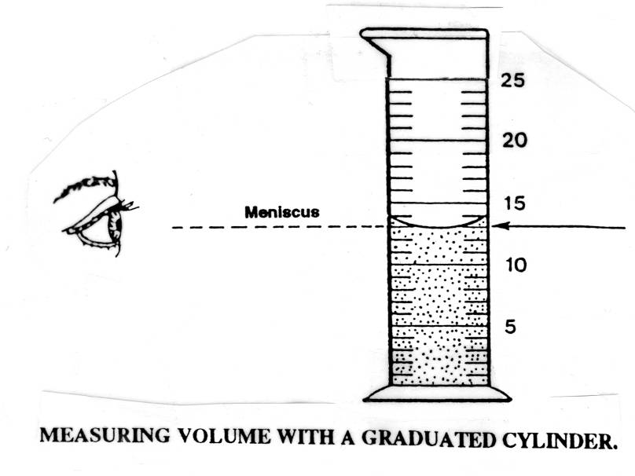
- In the diagram to the left, the volume of water is _________ Ml.
- A _________________________ is used to measure liquids in the laboratory.
- A meniscus is a _____________ surface.
- Volume readings are made at the _________________ of the meniscus.
2 Methods for Finding Volume:
1. L x W x H = cm3
2. (Water Displacement) Ending Volume - Starting Volume = Volume of object mL
Lab Application:
Measurable Item | Volume of Item
- MEASURING MASS. Materials are weighed in the laboratory by using a balance. The balance compares the mass of the object to be weighed with the weight of known objects called weights. Below is an example of one type of balance found in biology laboratories. Your school may have other types of balances.
- A balance is used in the laboratory to measure _______________________.
- A balance compares the weight (mass) of __________________ with the weight of ________________________.

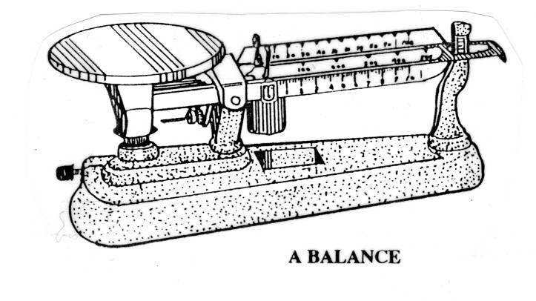
Lab Application:
Measurable Item | Mass of Item

E. Mass vs. Weight

Find out how much Uga weighs on each planet by multiplying Uga’s weight by the relative pull of gravity on each planet below.
Uga is 65 lbs.
Planet Name | Equation | Uga’s New Weight
Mercury | .38 x _____  (Uga the Bulldog 65lbs)
Venus | .9 x _____  (Uga the Bulldog 65lbs)
Moon | .17 x _____  (Uga the Bulldog 65lbs)
Mars | .38 x _____  (Uga the Bulldog 65lbs)
Jupiter | 2.36 x _____  (Uga the Bulldog 65lbs)
Saturn | .92 x _____  (Uga the Bulldog 65lbs)
Uranus | .89 x _____  (Uga the Bulldog 65lbs)
Neptune | 1.12 x _____  (Uga the Bulldog 65lbs)

IF WEIGHT CHANGES PLANET TO PLA\NET DOES Uga’s MASS? WHY OR WHY NOT?
________________________________________________________________________________________________________________________________________________________________________________________________________________________________________________________________________________________________________________________________________________________________________________________________________________________________________________________________________________________________

