To help continue your students’ social-emotional learning development, the PCSD SEL Team has organized the following ideas to assist you. Please modify these digital activities as you see fit.

**Zoom Conference Ideas**

1. Bingo
   1. Email your students their own Bingo Card
   2. Use an online Bingo number generator like the one below
      1. <https://appzaza.com/bingo-number-generator>
   3. Bingo Game Ideas
      1. Blackout – All numbers on the Bingo card must be completed
      2. Traditional – Get bingo vertically, horizontally, or diagonally
      3. Four Corners – Four numbers in the top left, top right, bottom left, or bottom right are completed.
      4. Additional ideas can be found online.
2. Show and Tell
   1. Students showcase a special item from their home.
3. Household Scavenger Hunt
   1. Teachers ask students to find objects in their home. The student who is first earns a point. The person with the most points wins the game.
   2. Ideas for the Scavenger Hunt
      1. A Book
      2. Something cold
      3. Something smelly
      4. Something soft
      5. Something small
      6. Something hard
      7. Something cute
      8. Something pretty
      9. Something you made
      10. Something you eat
      11. Something you play with
      12. Something that takes batteries
      13. Something you throw
      14. Something round
      15. Something that starts with the first letter of your name
      16. Something that smells good
      17. Something blue
      18. Something that has a number on it
      19. A hat that they are not wearing
      20. A crayon or marker
      21. A class artifact you made this school year
4. Pictionary
   1. A day before the Zoom meeting, teacher emails students their “Pictionary word.” Students are instructed to draw their image before the meeting.
   2. Teacher choses a student to hold up their picture, and students guess what they think the image is.
   3. Teacher continues the activity until everyone has had a chance to participate.
5. Good Things
   1. Teachers asks students to share good things with their peers
   2. Remember to celebrate after each student has shared something positive
6. Simon Says
   1. Play Simon Says with your students while you all are on Zoom!
7. Sink or Float
   1. Teacher gets a container of water (Careful! Watch your electronics!!!!!!)
   2. Then the teacher holds up an object and asks students if the object will sink or float
   3. Congratulate students for getting it right!
8. SEL Storytime
   1. Teacher reads a book to the class
   2. Teacher asks students to identify the emotions and feelings of the individuals in the story.
   3. Teacher asks follow up questions about the emotions in the book
      1. Example
         1. What makes you feel happy?
         2. What do you do when you are sad?
         3. Would you have done something different than the main character?
         4. What would you tell a friend that is worried?

**Ideas Using a Camera**

1. Pictures of Emotion
   1. Introduce Zones of Regulation

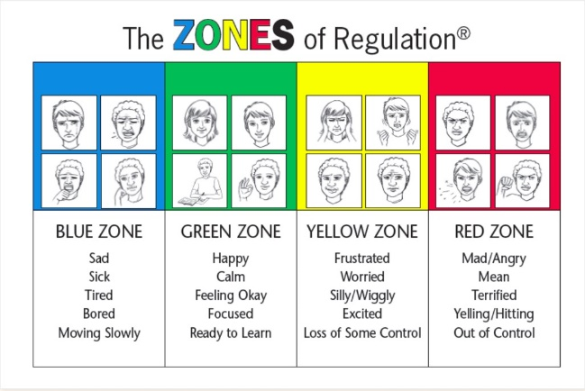

* 1. Students choose one word from each zone and take a picture of themselves showing a facial expression of each emotion. Students then upload the images to their teacher.
  2. Students then write a statement demonstrating their ability to manage their emotions.
     1. Example: When I am sad, I ask my mom for a hug.
     2. Example: When I am happy, I dance.
     3. Example: When I am frustrated, I count to five.
     4. Example: When I am mad, I go to my room to calm down.

1. Virtual Walk
   1. With your parents, walk around your house, yard, and neighborhood taking pictures to showcase your walk.
   2. Feel free to add captions explaining the pictures to the audience.
   3. Turn your pictures into a movie by adding audio descriptions
2. Video Collage
   1. Students take pictures of their favorite things and email them to the teacher.
   2. The teacher creates a virtual collage and shows it to the student. This can be done on PowerPoint, Video Editor, etc.
3. Daily Class Challenge
   1. Teacher gives students a challenge of the day, and the students take a picture of themselves completing the challenge.
      1. Example: Play outside
   2. Students can upload their pictures to Canvas
4. Try Not to Laugh Challenge (This could be done in a Zoom Meeting)
   1. Students record themselves telling their best joke.
   2. Students send their video attachment to their teacher.
   3. The teacher compiles the videos and sends them out to the class to view.
5. Cooking Show
   1. Record a video or take pictures of you cooking with your parents.
   2. Cooking Ideas
      1. Brownies
      2. Eggs (be careful of the stove)
      3. Decorating a Cake
      4. Coloring Easter Eggs
      5. Making Chocolate Milk
   3. Extension Idea – write a step by step process how to complete your task so others can learn to cook from you!

**SEL Reflections and Journal Prompts**

Students respond to daily SEL journal prompts.

Journal Prompts

1. What is your greatest strength?
2. Can you fix your own meal at the house? If so, what can you fix?
3. When are you the happiest?
4. How would you cheer up a friend who was sad?
5. What makes you feel powerful?
6. Who is your favorite fictional character? Why?
7. Who is your hero in real life? Why?
8. What are ten things you’re a grateful for?
9. What do you think school will be like when you are in middle school? What do you think school will be like when you are in high school? What do you think life will be like after high school? (Choose the one that is appropriate for your students)
10. List a goal for this week. How do you plan to meet this goal?
11. What makes YOU unique?
12. How do you feel today? How can you improve your mood?
13. What would make the world a better place?
14. What does growing older mean to you?
15. I feel amazing when…
16. If you had a theme song, what would it be?
17. If you could be in a TV show, which show would you be in? Why?
18. Which season fits your personality? Why?
19. I couldn’t live without…
20. Why is working hard important to you?
21. What is your favorite quote? Why do you like it?
22. What would you tell a friend who had a bad day?
23. What is a health tip you would like to share?
24. What does success mean to you?
25. List five things you love about your home.

SEL Bingo

Students are challenged to complete SEL tasks around their house. I have inserted a SEL Bingo Board I found on International SEL Day on March 27th. I have also created a blank bingo card for you to use if you decide to create your own game.

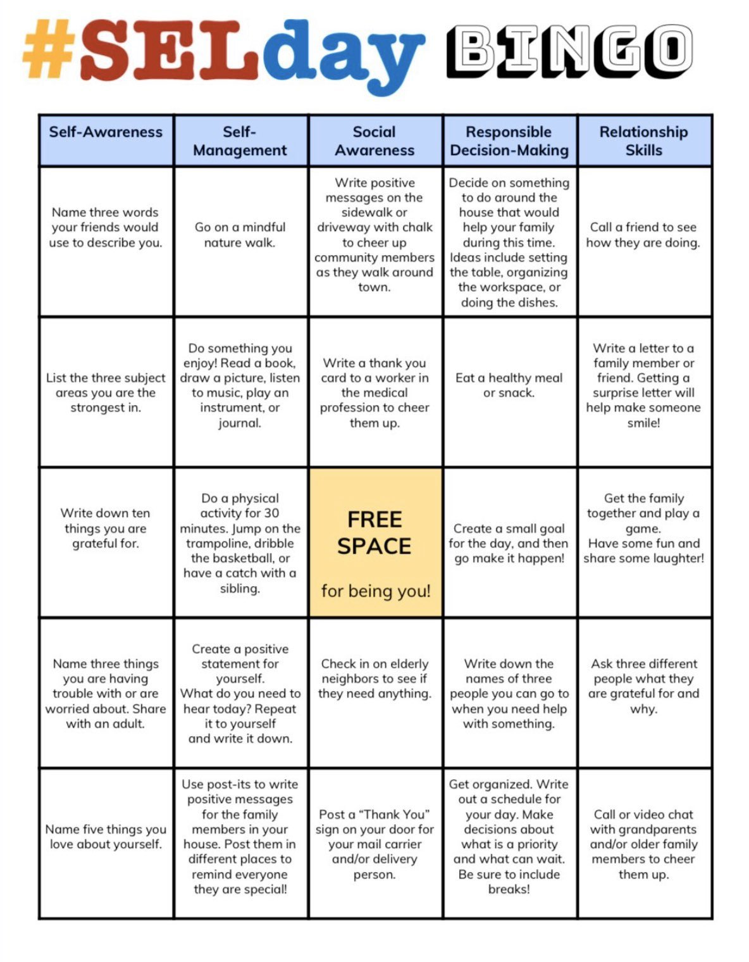

|  |  |  |  |  |
| --- | --- | --- | --- | --- |
| **B** | **I** | **N** | **G** | **O** |
|  |  |  |  |  |
|  |  |  |  |  |
|  |  |  |  |  |
|  |  |  |  |  |
|  |  |  |  |  |

**Spring Break Comic Book Activity**

Create a seven-page comic book telling the story of what you did each day during Spring Break. Discuss events that took place in the morning, afternoon, and evening. Remember to include images and words in your comic book.

**Goal Setter**

On a sheet of paper, write out a goal you want to accomplish before the end of the school year. On a separate sheet of paper, write out a plan of action to reach your goal. What steps do you need to take? What are some possible barriers? How will you overcome these barriers? Who can you seek for help while completing your goal? Once you have set your goal, share it with a trusted friend or family member.

**Letter Writing**

Write a physical letter to a friend or family member. Let them know that you are thinking about them and give them words of encouragement! Don’t forget to send the letter to them in the mail if that is possible.

**Personal Journal**

Purchase or create a journal. Begin making daily entries into your journal. You can put whatever you want inside your journal. You can talk about your day, talk about your feelings, list interesting things, list your thoughts, etc. If your journal entries bring up strong emotions, seek a trusted adult to discuss how you are feeling and seek advice on how to handle those feelings. Alternate Idea: Students can create a video journal instead of a paper and pencil journal.