**Air Masses & Weather Fronts**

**Air Masses:**

***Definition***: An air mass is a huge body of air that has similar characteristics, depending on where it forms:

* **Temperature**
* **Humidity** (Moisture Content)
* **Air Pressure** (Remember: cold air sinks & warm air rises. This is important when we talk about air masses & fronts moving)

**Temperature**: Affects Air Pressure

* **Tropical** – warm air masses form in the tropics (near the equator) with low air pressure
* **Polar** – cold air masses form north of 50° north latitude & south of 50° south latitude, with high pressure

**Moisture Content:**

* **Maritime** – form over oceans as water evaporates & the air becomes humid
* **Continental** – form over land so they are drier

**For each area where the air masses are forming, write the 1st letter for each description (Ex: Forms over water is Maritime, Forms in a cold place is Polar, so the letters would be mP for the air mass “bubble”)**

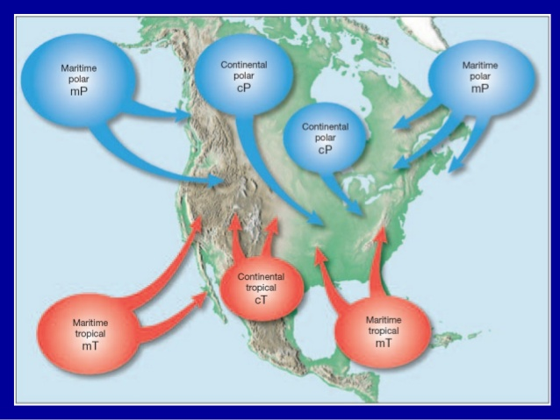

*The one Air Mass “bubble” that is missing near the bottom right should be mT because it is forming over warmer ocean water.

🡨

**Maritime Tropical:**

* **Warm, humid air masses form over tropical oceans**
* In summer, mT bring hot, humid weather, showers & thunderstorms (especially in GA)
* In winter, mT bring heavy rain or snow

**Continental Tropical:**

* **Hot, dry air masses form mostly in summer over dry areas**
* Cover a smaller area than other air masses
* In summer, cT bring hot, dry weather to southern Great Plains

**Maritime Polar:**

* **Cool, humid air masses form over the icy cold N. Pacific & N. Atlantic oceans**
* Affect the West Coast more than East Coast
* In summer, mP bring fog, rain & cold temps to West Coast

**Continental Polar:**

* **Large cP air masses form over central & northern Canada & Alaska**
* **Bring bitter cold with low humidity**
* In winter, cP cold, clear, dry air to North America
* If cP collide with mT, storms may happen (thunderstorms & tornados)

**How are air masses classified?**  By their temperature & moisture content (humidity) – see above for details

**Compare & Contrast Continental Tropical & Continental Polar:**

BOTH:

Dry air masses

Form over land

**How do air masses that form over land & ocean affect the weather in GA?**

* In GA, mT bring hot, humid weather, showers & thunderstorms
* If cP collide with mT, storms may happen (thunderstorms & tornados)
* cP bring cold temps

*Prevailing Westerlies & Jet Streams (winds) move weather across the US*

**What is the energy source that moves air masses around the Earth?**

**Sun** & Wind (caused by the sun heating Earth unevenly…more @ the equator, less at you go N & S, very little @ the poles)

**Weather Front Symbols:**

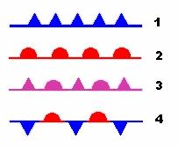

1. Cold Front (blue)

2. Warm Front (red)

3. Occluded Front (all purple)

4. Stationary Front (blue triangles & red semicircles)

**Cold Fronts**: Forms when a cold air mass pushes under a warm air mass, forcing the warm air to rise.

**Weather they bring**: Clouds called thunderheads can form as the moisture rises, cools & condenses. A brief thunderstorm may occur with heavy rain, gusty winds, thunder, lightning, hail followed by cool, fair weather.

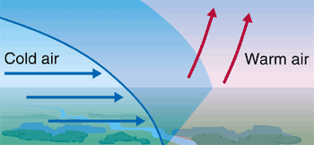

**Warm Fronts**: Forms when a moist, warm air mass slides up and over a cold air mass.

**Weather they bring**: Warm air rises & condenses into a broad area of clouds. A warm front brings gentle rain or light snow followed by warmer, milder weather.

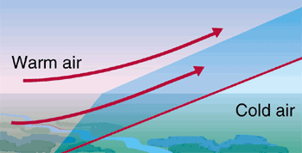

**Stationary Front**: Forms when warm & cold air meet & neither has the force to move the other. They stand still.

**Weather they bring**: Clouds and fog form. It might rain or snow. Clouds & precipitation last several days.

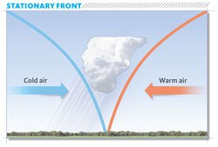

**Occluded Front:** Forms when a warm air mass gets trapped between two cold air masses. The warm air rises as the cold air masses push to meet in the middle.

**Weather they bring**: The temperature drops as the warm air mass is cut off from the ground & pushed upward. Can bring strong winds & heavy precipitation.

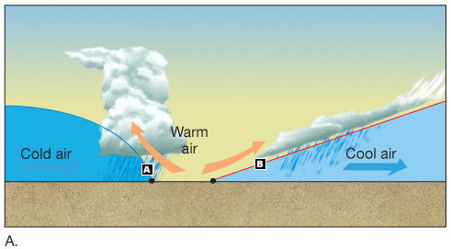

**What are fronts & how do they form?** (p 445) Fronts are the boundary where two air masses meet. Fronts form when two air masses that have different temperatures and humidities collide.

**How does density play a part in determining how opposite air masses react?** (p 446) Cold air masses are denser and sink, while warm air masses are less dense and rise.

**What is the difference between an occluded front and a stationary front?** (p 447) An occluded front happens when a warm air mass is trapped between two cooler air masses and the warm air is forced upward. In a stationary front, the warm air and cold air meet and neither moves the other.

**How do fronts cause weather changes?** (p 446-447) Fronts cause weather changes when air masses of different temperatures, densities, and speeds collide. When warm air rises, more clouds form, which brings precipitation. Temperature differences cause differences in density. Air masses will rise or sink according to the densities.