**McGarity Elementary School**



**School Improvement Plan**

**2024 -2025**

**Karla Dodgen, Principal**

PCSD VISION

PCSD MISSION

***The vision of the Paulding County School System is to prepare ALL students for success today and tomorrow.***

***Engage. Inspire. Prepare.***

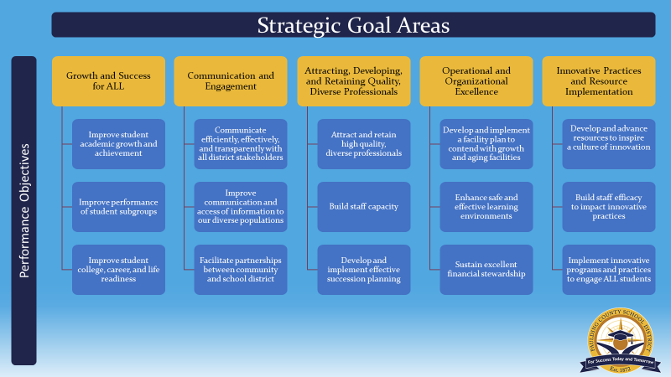

SCHOOL MISSION & VISION

Mission Statement:

At McGarity Elementary School we strive to:  
Master curriculum by  
Engaging students and  
Supporting all learners

Vision Statement:

McGarity Elementary’s vision is to maintain a progressive, highly qualified faculty, committed to education that delivers a national curriculum while embracing change and diversity. We will engage students with a variety of innovative experiences and opportunities that ignite the desire to continue learning. We will maximize every student’s strengths and talents by working collaboratively with all stakeholders to overcome their challenges.

|  |
| --- |
| ***McGarity’s School Improvement Action Plan***  ***SMART Goal 1: By the end of the academic year, the percentage of teachers demonstrating proficiency in analyzing and utilizing multiple measures of student data to inform ELA instructional practices to support student growth will increase from 40% to _80_% based on staff survey data.*** |

| **Strategic Goal Area** | **Action Steps** | **Process Goals**  **(Guide your Action Steps)** | **Person**  **Responsible** | **Monitoring** | |
| --- | --- | --- | --- | --- | --- |
| **Implementation** | **Effectiveness** |
| **Strategic Goals: Growth and success for all students, innovative practices and resources implementation, and developing, and retaining quality, diverse professionals**  **Data Folders: 43%**  **Set student goals 80%**  **ED students not making growth**  **29%**  **Conference with students bf and after 49%** | Intentionally use data to target students who have not made significant growth in ELA based on the previous year's Acadience and Growth Measure data. | The state of Georgia and Paulding County are providing district wide professional learning on the Science of Reading. Teachers will use this knowledge to inform instructional practices. Most teachers will participate in this PL at the school level monthly from August to April.  Using 23-24 reading data, all teachers will select 3 students that have not made significant growth. EAC will provide guidance on student selection. This will be done in early September.  Teachers will track their 3 case study students throughout the year. They will intentionally collect demographic data, perception data, student learning data, and processes data for these students. Each student will have a data folder and student goals. Initial data will be collected in August and then monthly after that. Student data and progress will be discussed at reading data days and bi-weekly check-ins.  These 3 case study students will have intentional interventions put in place using the knowledge from the Science of Reading professional learning to improve student achievement and growth. From August to May.  Teachers will have consistent communication with students about their data and will teach students how to set goals to improve academic outcomes, student accountability, and intrinsic motivation. This will be done monthly.  Administration will provide PL and coaching on using data. Some will include sharing data with parents, a good goal setting conference with a student, the 4 types of data, etc. Timeline will be August-May. | District Coach  ALL teachers- K-5th grade, support staff, ESEP staff, specials team  ALL teachers- K-5th grade, support staff, ESEP staff, specials team  ALL teachers- K-5th grade, support staff, ESEP staff, specials team  ALL teachers- K-5th grade, support staff, ESEP staff, specials team  Admin Team | Sign-in sheets will be used as evidence.  Teacher data spreadsheets and student selection protocol sheet.  Student data folder, data room student data cards  Teacher log of intentional instruction given to these students and consistent communication with parents.  Student data folders with log.  Coaching and PL log | Case study students will show growth in reading, measured by the reading screener and Acadience benchmarks and progress monitoring data.  Improve teacher capacity analyzing and using student data (survey data).  Teachers will start to use this data process with all students and across more content areas (survey data).  Students will be able articulate goals and data to parents during conferences (schedules/Zoom) and other adults within the building (observation data). |

|  |
| --- |
| ***McGarity’s School Improvement Action Plan***  ***SMART Goal 2: In*crease the percentage of students at target in the area of Numerical Reasoning on the Math Georgia Milestones Assessment by 10% in both 4th and 5th grade. Numerical Reasoning overarching domain: 4th grade goal of 37% (2024 was 27%), 5th grade goal of 25% (2024 was 15%).**  **\*\*This data will not be cohorts of students but done by grade level. The domain data from 3rd grade students is not comparable because of the drastic difference in the number of points given compared to 4th and 5th grade.** |

| **Strategic Goal Area** | **Action Steps** | **Process Goals**  **(Guide your Action Steps)** | **Person**  **Responsible** | **Monitoring** | |
| --- | --- | --- | --- | --- | --- |
| **Implementation** | **Effectiveness** |
| **Strategic Goals: Growth and success for all students, innovative practices and resources implementation, and developing, and retaining quality, diverse professionals** | K-5th grade teachers will build a deeper understanding of the math curriculum to enhance tier 1 instruction and use data cycles to build effective math NBI. | Using the data cycle achievement data, K-5th grade teachers will decide which centers to implement to support their tier 1 instruction and student growth when appropriate. They will preview the centers as a PLC. This will happen during pre and post assessment data cycle conversations.  K-5th grade teams will continue to use data cycles for each unit to drive Math NBI instruction. Teams will meet to design the data team cycle for the unit accessing the curriculum check points and common assessments. This will happen before, during, and after each unit of study.  2nd-3rd grade teachers will set student goals with students for Reflex math. They will check the class report weekly to check for progress and have conferences with students on progress. This will happen once a month starting in August with the initial goal setting.  EAC will conduct school-wide math sweeps to provide feedback and coaching with an intentional focus on facilitating lessons vs. leading them. This will start in September.  EAC will regularly attend grade level math plannings to ensure the use of data cycles and be part of the conversation on what the data is telling us and how we can move students using the materials we have been provided. This will start in August. | K-5th grade teachers  K-5th grade teachers  2nd- 3rd grade teachers .  EAC  EAC | As evidenced by lesson plans  As evidenced by data cycle spreadsheets.  As evidenced by student goal sheets.  As evidenced in coaching logs | Students will increase post test scores from pre-test scores. The data cycles sheet will be used to track this information.    Weekly checks of the My Class Report should show green checks and students moving through the program.  Improvement of lesson facilitation through observation data. |

***McGarity’s Professional Learning Plan***

| **Professional Learning Strategy/Support**  (Should be connected to effectiveness monitoring of action steps in the SIP) | **Audience** | **Presenter** | **Timeline** | **Monitoring** | | |
| --- | --- | --- | --- | --- | --- | --- |
| **Implementation** | **Effectiveness** | |
| Georgia Literacy Academy Professional Learning Modules 1-10. | K-5th grade teachers, support teachers, specials teachers, ESEP teachers | District  Coach, State of GA Modules | by the end of the April 2025 | Teachers will move through the modules and every month all staff will get together for an staff training to review content. | Case study students will show growth in reading, measured by the reading screener and Acadience benchmarks and progress monitoring data. | |
| Administration will provide PL and coaching on using data. Some will include sharing data with parents, a good goal setting conference with a student, the 4 types of data, etc. Timeline will be August-May. | ALL teachers- K-5th grade, support staff, ESEP staff, specials team | Admin | by the end of the April 2025 | Professional Learning day will be utilized for training, sign in sheets | Improve teacher capacity analyzing and using student data (survey data). | |
| Technology specialist will come four times during the year to provide PL on multiple technology pieces to support 1:1 technology during grade level planning. | All staff | District Technology Specialist | Monthly Sept-May | Sign in sheets | Effective implementation of 1:1 technology as noted in lesson plans |
| Mentors will meet with their mentees for at least 20 hours throughout the year to support new teachers to enhance their planning, instruction, and content knowledge. | Mentors and Mentees | EAC, mentors | As needed | Mentor paperwork | Increase in student achievement within supported classrooms |
| Paraprofessionals meet monthly as a PLC- teacher leaders will support PL during meetings. | Paraprofessionals | EAC, Lit Coach, teacher leaders | Monthly | Kick up attendance conformation | Increase in student achievement within supported classrooms |

Supports that may be included:

* PLC work
* Coaching sessions with Individual Teachers
* Mentors
* Online Professional Learning Opportunities
* Paraprofessional PL Opportunities
* Ongoing District or School provided PL