Name _______________________________________
Genetics Unit Study Guide
- What did Mendel DO to study the different characteristics in his genetic experiments? __________________
________________________________________________________________________________________
- Describe the results of Mendel’s experiments in the F1 and F2 generations. What were the percentages of genotypes of the offspring? Describe the phenotypes of the offspring in each generation._________________ ________________________________________________________________________________________
________________________________________________________________________________________
- Explain why Mendel’s cross of purebred tall and short pea plants resulted in only tall plants. _____________
________________________________________________________________________________________
________________________________________________________________________________________
- Create a punnett square showing the probability of producing a tall pea plant from two hybrid parents.

- If a homozygous brown rabbit (BB) is crossed with a homozygous white rabbit (bb), what is the probability that an offspring will have brown fur? ________________________________
- Define phenotype. __________________________________________________________________
- The chromosome theory of inheritance says that genes are carried from ___________ to offspring on __________________.
- _____________________ are factors that control traits.
- Geneticists use the notation GG to mean________________________________________.
- Geneticists use the notation Gg to mean ________________________________________.
- Describe the process of meiosis, and how it is beneficial to organisms. _______________________________ ________________________________________________________________________________________
- Genes that are carried on the X and Y chromosome are called ___________-_________________ genes.
- Sex cells contribute _______________ the number of chromosomes in body cells.
- Body cells have _________________ chromosomes, and sex cells have ______________ chromosomes.
- Males have _________________ sex chromosomes.
- What genetic disorder results in abnormally shaped blood cells? __________________________
- Define mutation. ___________________________________________________________________
- Mutations can be both ________________________ and ________________________.
- A mutation is harmful to an organism if it reduces an organism’s chances for ________________ and _________________.
- Physical characteristics called ____________________________ are studied in genetics.
- Cystic Fibrosis is a genetic disorder carried on a ________________________ allele that causes the body to produce thick mucus in the ____________________ and ___________________________.
- Define homozygous. _______________________________________________________________________
- Define heterozygous. ______________________________________________________________________
- Many genes joined together make up _______________________________________.
- Geneticists use _____________________________ to trace the inheritance of traits in humans.
- ___________________________ results in two organisms that are genetically identical.
- Describe the purpose of the Human Genome Project. _____________________________________________
________________________________________________________________________________________
- Define genetic engineering. _________________________________________________________________
________________________________________________________________________________________
- Give an example of selective breeding. ________________________________________________________
________________________________________________________________________________________
- A person who has one recessive allele and one dominant allele for a trait is called a ______________.
- Characteristics are affected by the interactions between genes and the _________________________.
- A ______________________ is the offspring of parents that have different alleles for a trait.
- A punnett square shows all the possible combinations of _________________ resulting from a cross.
- An organism’s _______________________________ is its allele combination.
- Chromosomes carry ___________________ from parents to offspring.
- If a _______________________ allele is present, this trait will always appear in the first generation offspring.
- In pea plants, the tall-stem allele and the short-stem allele are different forms of the same _________.
- An organism can be heterozygous for some traits and _____________________________ for others.
- Mutations or changes in DNA and chromosomes cause ______________ ______________________.
- A mutation in a ________ cell can be passed on to future generations. Mutations in a _________ cell only affect that one cell.
- Explain the difference between helpful and harmful mutations in DNA. ______________________________
________________________________________________________________________________________
Answer the questions below based upon the following punnett squares:
F1 Generation F2 Generation
B b

B

b
B B

b

b

B = Brown Fur b = White Fur
- Which trait-brown fur or white fur- is controlled by a dominant allele? ______________________________
- Which is controlled by a recessive allele? _____________________________________________________
- How do you know which allele is which? _____________________________________________________
- In the F2 generation, what percentage of the offspring have white fur? ______________________________
- What is the genotype of the offspring that have white fur? ________________________________________
- What percentage of the offspring in the F2 generation would have white fur if one of the parents had been homozygous recessive instead of heterozygous? ____________________ What percent would have brown fur? ____________________
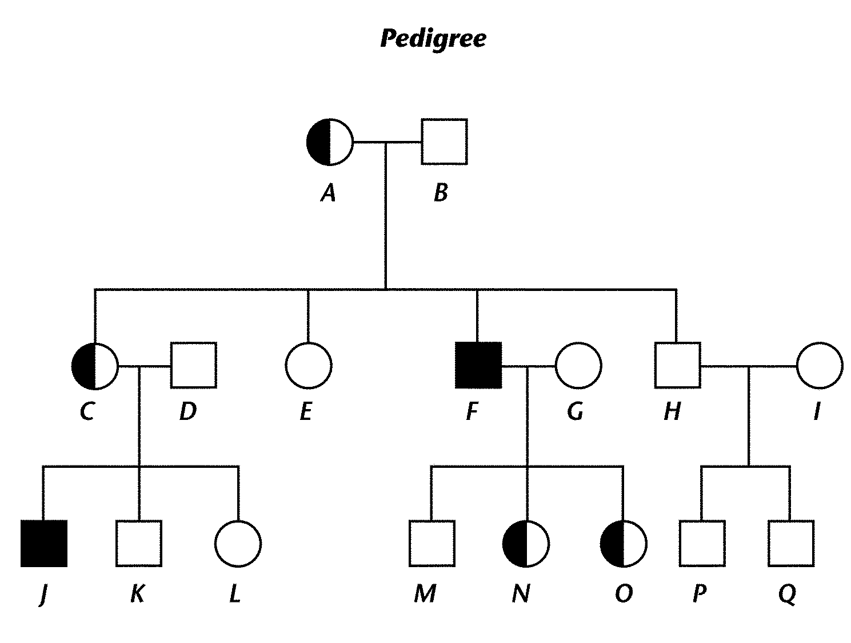
Use the diagram below to answer questions #48-50.
- In this pedigree, which individuals have the trait? _________________. How do you know? _________________________________________
- Which individuals are carriers of the trait? ___________________. How do you know? ______________________________________
- A male is represented by a ___________________ in a pedigree. A female is represented by a _______________________ in a pedigree.
- The genetic code is found in the order of nitrogen ______ along a gene.
- What is the complimentary strand for the following sequence: GATCGTAC - _________________________
- If a woman has two sons, what is the probability that her third child will be a son also? Explain your answer. ___________________

