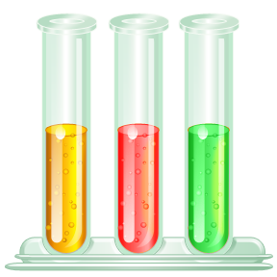
Macromolecule Virtual Lab
Standards Covered:
SCSh1. Students will evaluate the importance of curiosity, honesty, openness, and skepticism in science.
- Exhibit the above traits in their own scientific activities.
SCSh3. Students will identify and investigate problems scientifically.
- Collect, organize and record appropriate data.
SB1. Students will analyze the nature of the relationships between structures and functions in living cells.
- Identify the function of the four major macromolecules (i.e., carbohydrates, proteins, lipids, nucleic acids).

CARBOHYDRATES
- What do carbohydrates consist of?
- Plants store carbohydrates as___________________
- Insects store carbohydrates as __________________
- How do you test for sugars?
- How does it work?
- Which substances contain sugar?
Check the box under your predication if you think the substance contains sugar.
After the test, put a check in the box under result if the substance changed color.
Substance | Your predication | Result
Water
glucose
onion juice
lemon juice
diet sprite

- How do you test for starches?
- How does it work?
- Which substances contain starch?
Check the box under your predication if you think the substance contains starch.
After the test, put a check in the box under result if the substance changed color.
Substance | Your predication | Result
Water
glucose
onion juice
lemon juice
diet sprite

PROTEINS

- What are the chains that make up proteins?
- What test do we use to test for proteins?
- How does it work?
- Which substances contain protein?
Check the box under your predication if you think the substance contains protein.
After the test, put a check in the box under result if the substance changed color.
Substance | Your predication | Result
Water
egg white
chicken soup
diet sprite

LIPIDS

- What test is used for lipids?
- How does it work?
- What color do the solutions change if lipids are present?
- Which substances contain lipids?
Check the box under your predication if you think the substance contains lipids.
After the test, put a check in the box under result if the substance changed color.
Substance | Your predication | Result
Water
egg white
cream
coconut
margarine

EVERYDAY FOODS
We will now test everyday foods. In the table you will put a check if there is a color change for the test preformed.
Substance | Benedicts Test | Iodine Test | Biuret Test
Gelatin
Apple Juice
Ritz Cracker
Skim Milk

Analysis Questions:
- What is the purpose of this lab?
- How are the reagents useful in determining which macromolecules are present?
- What is one big thing you learned from performing this lab?

