

**Assessments**

Math: Rounding Decimals; Adding Decimals

Social Studies: Civil War Unit Test

Science: Classification

Reading: Theme Constructed Response & Vocabulary (Unit 5)

**Tumble Books**

[www.tumblebooklibrary.com](http://www.tumblebooklibrary.com)

Username – russom

Password – books

[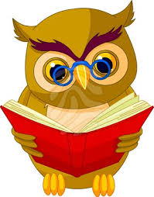](http://www.google.com/imgres?imgurl=https://erinzrockatorium.files.wordpress.com/2011/09/the-wise-old-owl-says-reading-is-fun.jpg&imgrefurl=https://erinzrockatorium.wordpress.com/2011/09/18/reading-is-fun/&h=400&w=313&tbnid=pez38b6fvXRQ9M:&docid=-USLG8Zk_MdJ_M&ei=PF0WVsO1GIegNszitqgC&tbm=isch&ved=0CCEQMygAMABqFQoTCMPDq4HsssgCFQeQDQodTLENJQ)

**Tech Connection**

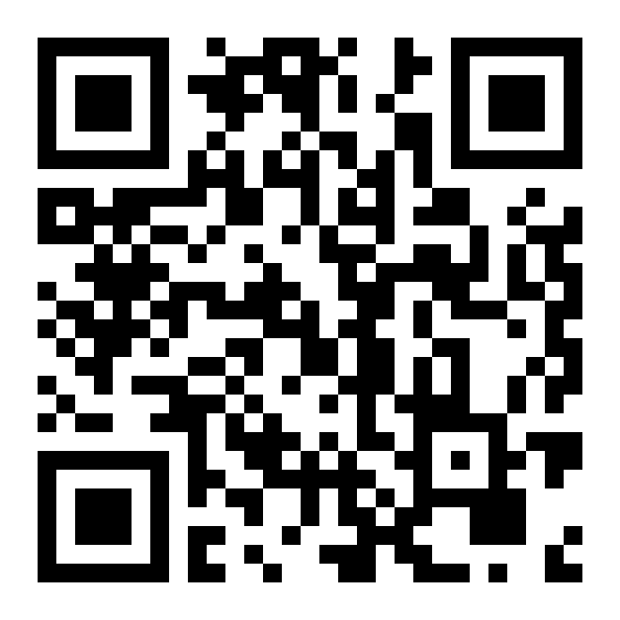

**Civil War/Reconstruction**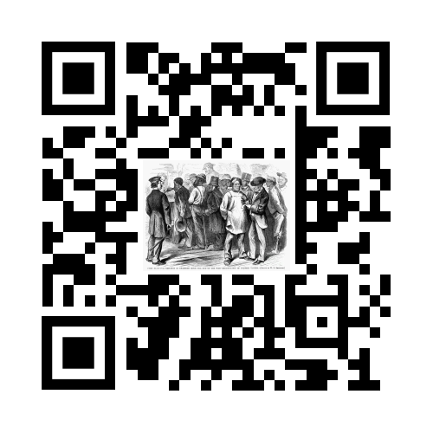

**October Upcoming Events**

October 27th-30th- Boo Grams for Sale Fifty Cents, Red Ribbon Week

October 27th - Kennesaw Mountain Field Trip

October 30th: Thank you letters to soldier for The Bert Show due

November 2-6: Pennies for Paulding

November 3: Election Day/No School

**Notes from the Teacher…**

***Volunteers…..***

Just a reminder that any parent or family member who plans to volunteer at Russom this year is required to watch the Mandatory Reporting video. Please sign off in the front office once you have viewed it.

***PTA Website***

<http://russomelementary.my-pta.org>

**Soldier Letters “The Big Thank You”**

[**www.bigthankyou2015.com**](http://www.bigthankyou2015.com)

Write a letter to a soldier for the holidays. If you wish to participate, please send in the letter by October 30th. Our office staff will postage them and mail them off for you!

**Yearbooks On Sale**

Yearbooks are now on sale at ybpay.lifetouch.com using ID code **10276016.**

Parents may also share photos with our yearbook staff at community.lifetouch.com using ID code **FIJPKO**.

**What Are We Working On…**

Reading: Citing Text Evidence to support Point of View & Theme, Poetry (Text Structure) (RL1-4, 6, 10)

Language Arts: Combining Sentences (L3)

Writing: Lucy Calkins Informational Writing (W5-7)

Math: Adding/Subtracting Decimals (NBT7) and Rounding Decimals (NBT4)

Science: Classification (S5L1)

Social Studies: Effects of the Civil War (SS5H1)