Relationships in Nature
Environmental Science Georgia Performance Standards:
SB4a. Investigate the relationships between organisms, populations, communities, ecosystems, and biomes.

Opening Activation
Essential Question: How might relationships in the environment affect living organisms? Are they positive or negative always? Explain your answer.

Before video: What is symbiosis? Explain your understanding.
This is what you think before the video, NO answer is wrong at this point.

After video: Revisit your answer, add any details you may have missed and predict what type of relationship you think the bird and the tree are illustrating.
Symbiosis is a partnership between two different species. This relationship may be beneficial to one or both species. Sometimes symbiosis might also mean that one species is harmed from the relationship.
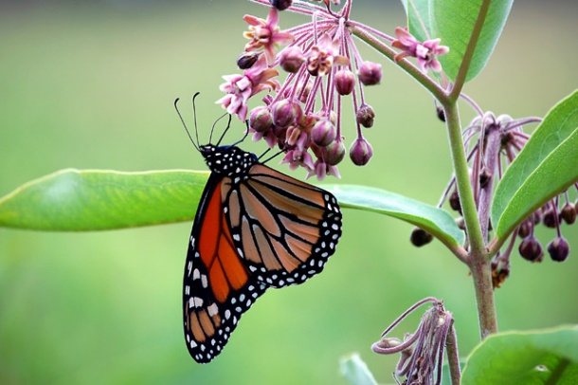
What are the main types of symbiosis?
Video: watch the clip and identify what type of symbiosis parasitism, mutualism, and commensalism are and give an example of each type.
Parasitism – involves one species benefiting from the relationship while the other is harmed. Example Fish and fish lice (the fish is harmed by the lice which feeds on its body fluids).
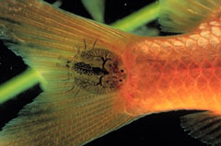
Mutualism – involves both species benefiting from the relationship. Example: Clownfish and anemone (Anemone tentacles sting is deadly to most fish, but not the clownfish) = the anemone provides protection for the clownfish to hide from predators while the anemone receives protection from polyp-eating fish, and are fertilized by the feces of clownfish).
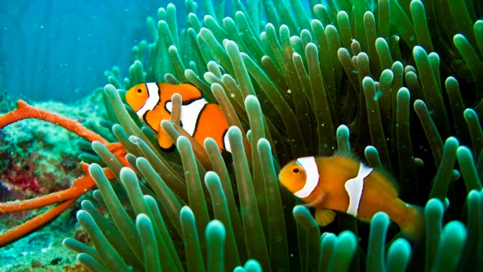
Commensalism – benefits one organism while the other is unharmed or unaffected. Example: Remora Shark and Sea Turtle (the shark hitches a ride by attaches via its sucker to the turtles back, and also obtains nutrients from the turtles back, while the turtle is neither harmed or affected by this event.
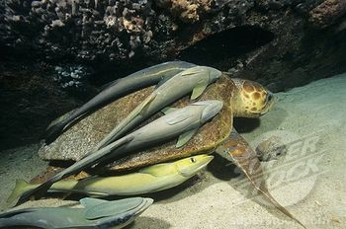

Zombie Caterpillars – Slave Bodyguards
Predict the symbiotic relationship.
This is your prediction and there is NO wrong answer here.

After the video: Explain the type of symbiosis.
This relationship is a parasitic one. The caterpillar is harmed while the wasp larvae benefit. The caterpillar ultimately dies.
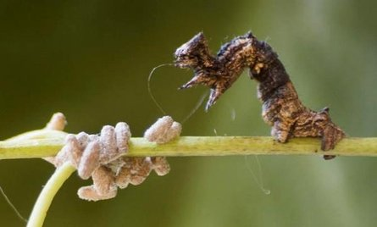

Cleaner Fish Carwash
Predict the symbiotic relationship.
You predict here, NO answer is wrong, this is simply your prediction.

After the video: Explain the type of symbiosis.
This relationship is mutualistic in nature. The cleaner fish benefit by obtaining nutrients from the parasites it cleans from the fish or other sea animal, and the sea organism benefits because the parasite is removed.
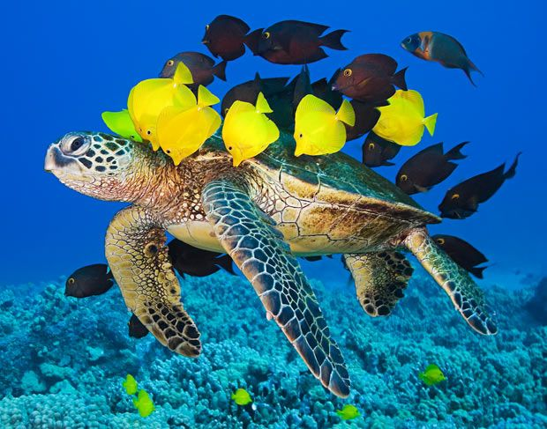

You like fries…Egrets like flies
Predict the symbiotic relationship.
You predict here, NO answer is wrong, this is simply your prediction.

After the video: Explain the type of symbiosis.
This relationship is an example of commensalism. The Egrets eat flies which annoy the cattle but do not harm them.
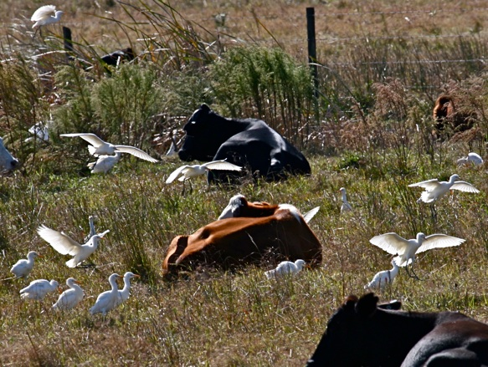

Predation: One Kills another
Give your own example and illustrate it. (be appropriate)

This can be any type as long as it is appropriate.
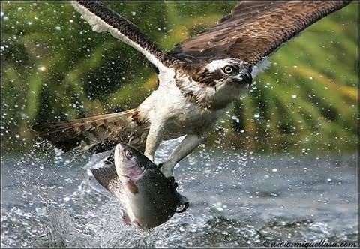

Competition: organisms both compete for limited resources
Give your own example and illustrate it.
This can be any type as long as it is appropriate.
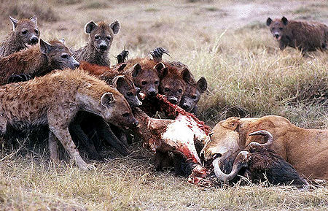
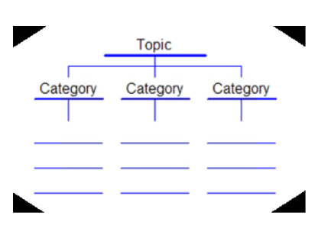
Summary: Symbiosis – Tree Map

Directions: Create a “symbiosis” tree map that contains the three main categories (parasitism, commensalism, and mutualism) for each you will give an explanation and a minimum of two examples. You may add the categories predation and competition for additional points.

