Name: __________________________________________________________ Date: ____________________________

Rate of Change Practice
- Below is the graph and table for 2 runners running the 400 meter hurdles race.
A
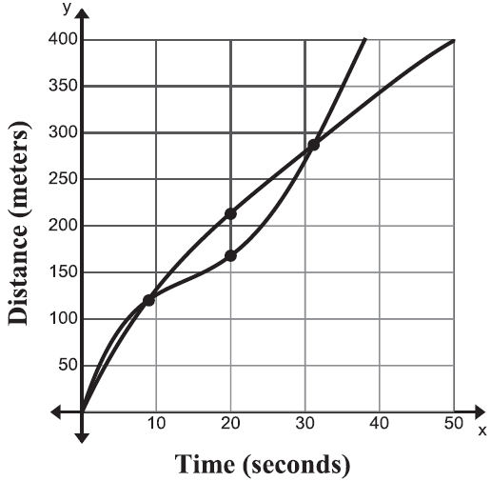
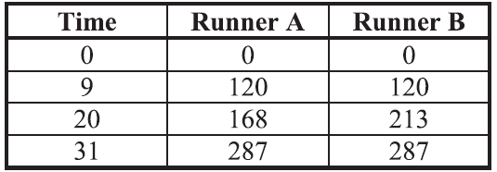
B
- Which runner has a faster average speed for the first 9 seconds?

- Which runner has a faster average speed from 9 to 20 seconds?

- Which runner has a faster average speed from 20 to 31 seconds?

- Which runner has a faster average speed from 9 to 31 seconds?

- Which runner wins the race? How do you know?

- The graph below shows the United States population from 1900 to 2010, as recorded by the U.S. Census Bureau.

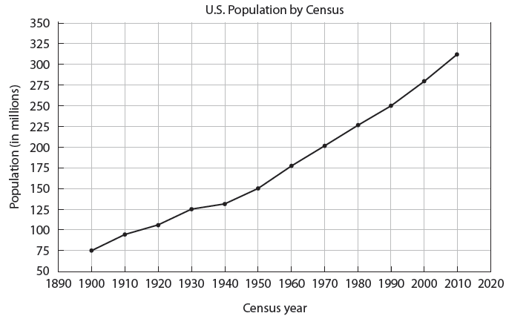
- What was the rate of change in the population from 1900 to 2000? Is this greater or less than the rate of change in the population from 2000 to 2010?

- Which 10-year time periods have the highest and the lowest rates of change? How did you find these?

- Find the rate of change of Pete’s height from 3 to 5 years.
Time (years) | 1 | 2 | 3 | 4 | 5 | 6
Height(in.) | 27 | 35 | 37 | 42 | 45 | 49

- For , find the rate of change on the interval [-2, 4].

- You and a friend are trying to decide which theater to go to for a Friday night movie. NCG charges $7 for the movie ticket and $3 per food item. Regal’s prices are represented by the table.
x | f(x)
0 | 4
1 | 8
2 | 12
3 | 16
4 | 20
Write an equation for NCG and Regal. Compare their rates of change and initial cost.

NCG: Regal:

Which theater is cheaper if you want to see the movie and also get a drink and popcorn?

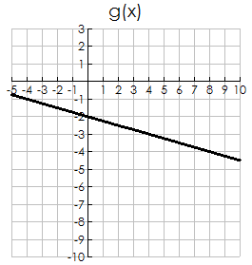
- For the following two functions, write the equations of each and complete the chart using <, >, or = to compare them.

x | f(x)
-3 | 11
-1 | 7
1 | 3
3 | -1
5 | -5

f(x) =

g(x) =

Characteristic of f(x) | <, >, or = | Characteristic of g(x)
y-intercept of f(x) = |  | y-intercept of g(x) =
f(4) = |  | g(4) =
Rate of Change of f(x) = |  | Rate of Change of g(x) =

