**[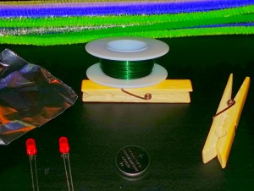](http://www.steampoweredfamily.com/wp-content/uploads/2015/08/cb-details4.jpg)CIRCUIT BUGS**  
 PIPE CLEANER BUGS OR ANIMALS (pg3)

**ALWAYS USE ADULT SUPERVISION**

**FOLLOW SAFETY PROCEDURES**

To make your own PIPE CLEANER Circuits you will need:

2 LED Lights

Insulated Copper Magnet Wire

Batteries – CR2032 3V

Electrical Tape

Clothespins

Pipecleaners

Popsicle Sticks (Optional depending on your design)

[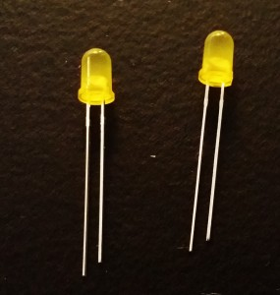](http://www.steampoweredfamily.com/wp-content/uploads/2015/08/cb-details2.jpg)

Circuit Bugs - A super cute circuit craft for kidsStart by setting out your LED lights.  
 You will notice one leg is longer than the other. The longer one is the positive pin.   
Before going any further test your LEDs by inserting the battery between the legs.  
 If it doesn’t work, try turning the battery around. If it still doesn’t work try a different  
 LED or battery. You want to make sure you have working parts right from the beginning  
 because the chance of circuits being interrupted is quite high as you work through this  
 project.

[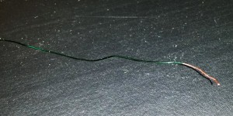](http://www.steampoweredfamily.com/wp-content/uploads/2015/08/cb-details.jpg)Circuit Bugs - A super cute circuit craft for kidsCut your wire. I recommend cutting it a bit long and trimming it later to the final length. We started by measuring the length of the clothespin twice (or in the case of our dragonfly we went really long and doubled his length which included a clothespin plus popsicle sticks). Strip both ends of your wire, about 2-3 cm in length. You want enough for a good connection but not too much that you raise your risk of circuit interruption. My wire was quite thin so I did this with a pair of scissors by scraping the wire along the scissors. If you have a thicker wire you can use wire strippers if you have them.

Circuit Bugs - A super cute circuit craft for kidsNow wrap the wire around the positive pin of each LED, then take the loose ends and twist them together. Repeat the process with the negative pin on both LEDs.

[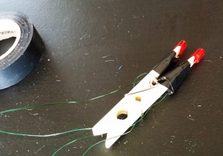](http://www.steampoweredfamily.com/wp-content/uploads/2015/08/cb-details3.jpg)

Take your two sets of twisted wires and test them on the battery. Throughout the construction I recommend you keep testing the circuits. It is very easy to interrupt the circuit. At times I even secured the wires to the battery with a clothespin so I could ensure the work I was doing wasn’t interrupting the circuit.

This project will require some patience and trial and error.

The next step can be done a few ways. You want to attach the LED’s to the legs of the clothespin or onto popsicle sticks by having each leg on either side of the wood. This will help prevent the wires touching and causing a short. You can simply set the LED’s there and snug them on but if you want them more secure I recommend wrapping the pins onto the wood with electrical tape. If you are going to get shorts in your circuit this is where they are most likely going to happen.

Circuit Bugs - A super cute circuit craft for kids. You may also want to tape the wires against the body, or if you have lots of extra you can wrap it around the clothespin. Make sure to leave the extra dangling from the end so you can attach the battery.

Start building your bug! You can do this however you wish. We simply wrapped the pipecleaners around the clothespin to create the look we wanted. By bending and twisting the pipecleaners we were able to secure them and make quite a stable design. We went with a Dragonfly, Beetle Bug and Bumblebee.

**PIPE CLEANER ANIMALS**

MATERIALS FOR EACH STUDENT:   
2 pipe cleaners with ends stripped of fuzz  
 five additional pipe cleaners, construction paper, tape, small rubber band, a disc battery ([from IKEA store](http://www.ikea.com/us/en/catalog/products/60207130/)), one LED light with anode and cathode legs curled.

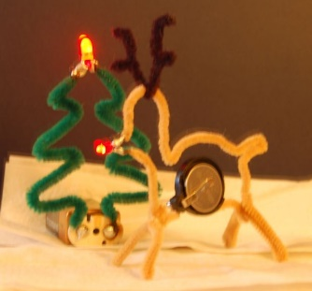[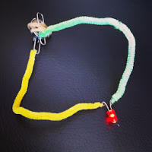](http://1.bp.blogspot.com/-5EWMPwqCSDQ/UoUQcdOF4fI/AAAAAAAAP5I/1wCO2tTXRkU/s1600/IMG_4432.JPG)

The simple circuit: two pipe cleaners (with ends stripped of fuzz), one LED light (with legs curled), two paper clips, rubber band and disc battery

1. Show samples of Alexander Calder's wire art for inspiration.
2. Students check that their light works with their battery by having it straddle the battery. Set the battery aside.
3. Students wrap a  raw wire end of a pipe cleaner to a paper clip. They take their second pipe cleaner and attach a paper clip in the same way. They should have two pipe cleaners, each with a paper clip foot. They should double check that they wrapped the wire tightly around the paper clips and that the wire of the pipe cleaner is touching the wire of the paper clip.
4. Now for the LED light attachment. The other end of each pipe cleaner is wrapped around one loop of the LED light (the anode and cathode legs need to be curled with pliers to create the loops). The LED light now looks like it has two pipe cleaner legs with paper clip feet.
5. Students test out the circuit by touching the paper clips at the same time to different sides of the battery.
6. At this point they have a working circuit. They attach one paper clip foot to the battery with a rubber band or tape. The other paper clip foot is the on/off switch that they tap against the battery to turn on.

|  |
| --- |
|  |