**Biome Unit Study Guide**

1. The climate of an area is typical weather pattern in an area over a long period of time and is determined Precipitation and temperature
2. Which biome is located between 15-25 degrees latitude has temperature ranges from -4 to 38 degrees Celsius, and receiving less than 25 centimeters of rainfall each year?

Desert

1. Which ecosystem is characterized as having a large diversity of plants and animals which are protected from pounding waves of the ocean, and is composed of almost equal amounts of fresh and salt water?

Estuary

1. Why do a large variety of plants grow in the tropical rain forest?

It is warm, humid, and rainy

1. Which biome includes ferns, large woody vines, monkeys, sloths, and boa constrictors?

Tropical rainforest

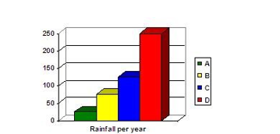

1. What biomes are shown in the graph, on the right? Label each bar.

A=Desert; B=Taiga; C=Deciduous Forest; D=Tropical Rainforest

1. In which biome would you expect to find the most nocturnal animals?

Desert

1. What major factor used to classify biomes?

The climate in the region

1. What could possibly cause a forest habitat to become a desert?

No rain, Drought

1. The kangaroo rat is able to get all the water it needs through its food and, therefore, never needs to drink liquids. This animal has adapted to survive in which biome?

Desert

Use the map below to answer questions 11-13

**A**

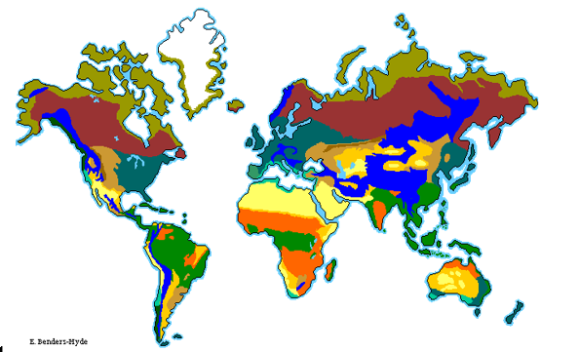

**B**

**C**

**D**

**A**

1. Which biome is represented by the letter A?

Tropical rain forest

1. Which biome is represented by the letter B?

Desert

1. Which biome is represented by the letter C?

Temperate deciduous forest

1. Lakes are characterized by:

Still, deep water

1. What is unique to the soil of the Tundra biome?

Permafrost



1. Crickets chirp to attract other crickets. The temperatures and rates of their chirping are graphed to the right. Which statements below is most likely true for the data represented in the graph?

The warmer the temperature, the more often crickets chirp

Traveling from the equator and going north, list the order you would reach each of these biomes, Desert, Taiga, Tropical Rain Forest (they are in alphabetical order here).

Tropical Rain Forest – Desert - Taiga

1. Use the following characteristics to determine this biome:

Found at the interior of continents, these large biomes are characterized by grasses that support large animals such as kangaroos, antelope, and bison which in turn support large predators such as wolves and lions.

Grassland

1. A scout troupe was planning a week-long camping trip. The Scout Master told the troupe that the camp was high in the Rocky Mountains and even though it was early summer in Southern Colorado they might find snow at the camp. He told them that the camp was built beneath large conifers such as spruce and hemlock. He stated they might expect to see elk, bighorn sheep, moose, and grizzly bears. In which biome is the camp located?

Taiga

1. Oak, Maple, and Beech trees, which lose their leaves each year, are typically found in which biome?

Deciduous forest

1. What is the major characteristic of abiotic features?

They are all non-living

1. Which two biomes have extremely limited precipitation?

Desert and taiga (tundra)

1. Which of the following correctly places the Earth’s terrestrial (land) biomes in order from the smallest amount of rainfall to the greatest amount of rainfall?

Deciduous forest – tropical rain forest – taiga – desert

Desert – taiga – deciduous forest – tropical rain forest

Taiga – desert – tropical rain forest – deciduous forest

Tropical rainforest – deciduous forest – taiga – desert

1. Lakes, rivers, streams, swamps, and marshlands are all an example of which type of biome/community?

Aquatic

1. What is the following biome: it has four distinct seasons and a moderate climate, includes squirrels, rabbits, skunks, and deer in the woods with maple, oak, and hickory trees?

Temperate deciduous forest

1. Which land biome is populated mostly by grasses and supports large animals such as bison, kangaroos, and antelopes?

Grassland

1. The _________ is located near the equator, has a warm temperature night and day, and is known as the most “biologically diverse place in the world”.

Tropical rain forest

1. A biome that is known as a cold desert because it has winter for six to nine months and gets less than 25 cm of precipitation per year is known as a _____________ biome.

Tundra

1. Ms. Jackson’s Science class has been studying the characteristics of water biomes. One student described a water biome with the following characteristics:

* Water contains more than 3 percent salt
* Contains coral reefs

Which water biome is the student describing? Marine

1. Which environmental change would most likely cause insect populations to increase quickly?

Extreme drought, Extended period of rain, Increase in bird population, Extremely cold temperatures

**SHORT ANSWER: Answer the following questions in several complete sentences.**

1. How does the variety of plants in a biome affect the variety of animals in a biome? Explain your answer.
2. If an ecosystem in a grassland biome started to receive less and less rainfall every year, what new biome would be established? Explain your answer.

**Essay Question: The question must be answered in a minimum of 5-8 complete sentences.**

1. Choose one of the following to answer:
2. Compare and contrast the temperature of the following biomes: tropical rain forest, deciduous forest, boreal forest.
3. Explain why most marine organisms live near the water surface of near the shore.
4. Explain why it is mostly location and climate in an area that determines its biome. Give specific examples to support your explanation.