SS8E3a Define profit and describe how profit is an incentive for entrepreneurs.
SS8E3b Explain how entrepreneurs take risks to develop new goods and services to start a
business.
SS8E3c Evaluate the importance of entrepreneurs in Georgia who developed such enterprises
as Coca-Cola, Delta Airlines, Georgia-Pacific, and Home Depot.

WHAT IS PROFIT?
Profit is the amount of money earned after subtracting all of your expenses.
The economic system of capitalism involves the production and consumption of goods and services. Making a profit is the ultimate incentive (or reason) for entrepreneurs and businesses. It is how they stay in ‘business’ and earn a living.


WHAT IS AN ENTREPRENEUR?
An entrepreneur is someone who opens their own company or business to provide a good and/or a service. The main risk is losing a lot of money if the business fails. Usually, an entrepreneur must get credit (borrow from a bank) just to start a business, but if you don’t earn a profit then your business goes bankrupt. This forces entrepreneurs to be creative and make smart decisions.

1886, Dr. John Pemberton invented the drink in Georgia and sold the rights to Asa Candler who marketed Coca-Cola to the world. Both men took a risk, but their efforts paid off and today Coca-Cola is the largest beverage company in the world.

1924, C.E. Woolman started a crop dusting business in Macon, GA. Eventually, he began delivering mail via airfreight for the US government. Relocated to Atlanta after the airport became popular and expanded Delta airlines to focus on passenger travel.

1927, Owen Cheatham turned a small lumber mill in Augusta, Georgia, into North America’s largest plywood and lumber company supplying paper products such as tissue paper, paper, packaging, and building materials.

1979, Arthur Blank and Bernie Marcus created the first home improvement center in Atlanta that combines a variety of products and building experts for both business contractors and the “Do-It-Your-Selfer”. Like the others, headquarters located in Atlanta.

SS8E5 The student will explain personal money management choices.

INCOME- money earned from a job or from selling something of value (personal items, property, stocks, etc)

SPENDING- using money to buy goods and services. These are things we both need and want. Also called expenses.

SAVING- not spending money in order to purchase goods or services later, or to have extra money in the future.

CREDIT- borrowing money (loan) and paying a fee (interest) to buy something you need / want now, and will pay for later.

INVESTING- letting the value of your money grow or earn interest through banks, stocks, bonds, mutual funds, certificates of deposit, and collectible items.






SS8G2a Explain how the four transportation systems interact to provide domestic and international goods to the people of Georgia.
SS8G2b Explain how the four transportation systems interact to provide producers and service providers in Georgia with national and international markets.
SS8G2c Explain how the four transportation systems provide jobs for Georgians.
INTERSTATE HIGHWAY SYSTEM
Interstates I-75, I-85, and I-20 intersect in the city of Atlanta and connect the state of Georgia to Alabama, Tennessee, South Carolina, and Florida. In addition, I-95 runs along Georgia’s coast from Florida to Maine. This highway system allows the citizens of Georgia to receive imported goods from other states and countries. At the same time, this system allows Georgia’s farmers and factories to transport goods to other states and countries. This helps the economy of Georgia by providing Georgians with products from abroad, and creates thousands of jobs in the transportation industry and related businesses.
HARTSFIELD-JACKSON INTERNATIONAL AIRPORT
Atlanta mayors William B. Hartsfield and Maynard Jackson built and expanded Atlanta’s airport to become the busiest in the world. Passenger travel and cargo shipments fly into and out of Atlanta every hour of every day. The airport interacts with the highway system to deliver imports and exports to different markets in Georgia, the United States, and throughout the world. Without the airport, many industries in the state would suffer and thousands of jobs would be lost, which would hurt the economy and government of Georgia.

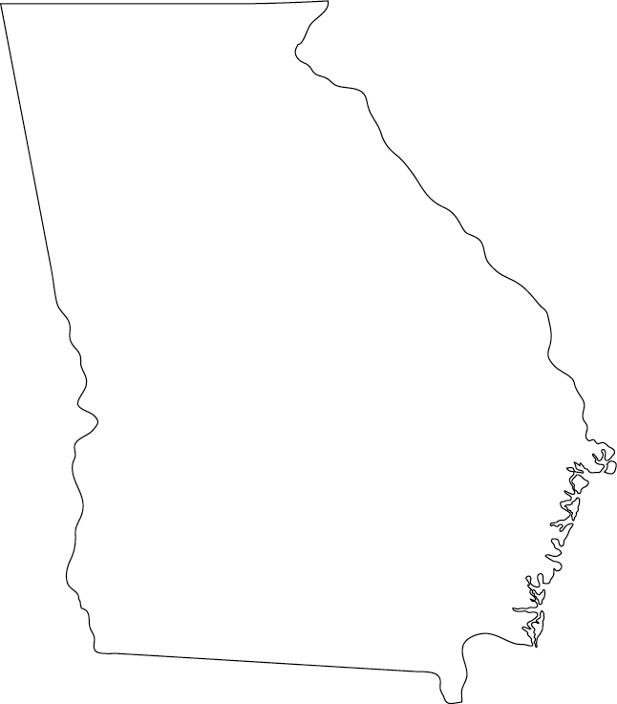

DEEP WATER PORTS
As Georgia’s first city, Savannah has always been a port city helping the citizens of Georgia to receive needed goods and ship products to other markets. During WWII, US Representative from Georgia Carl Vinson helped the coastal cities of Savannah and Brunswick receive government contracts to build navy ships, known as Liberty Ships. This greatly helped the local and state economies. Today, these two deep water ports are the busiest on the east coast and provide many jobs for Georgia workers and help Georgia play a major role in international trade.

RAILROAD
Prior to the Civil War the city of Atlanta became a railroad hub in order to export Georgia cotton to outside markets and to import agricultural products and manufactured goods from the Midwest and northern states. Today, the railroad continues to transport large quantities of goods in and out of the state with Atlanta being the hub of activity. The interstate and deep water ports are also connected to the railroad allowing raw materials and finished products to be transported to just about any location in Georgia, or the United States, or to another country overseas.

SS8E2a Describe how Georgians have engaged in trade in different historical time periods.
SS8E2b Explain how the four transportation systems contribute to Georgia’s role in trade.
TRANSPORTATION and TRADE THROUGHOUT GEORGIA’S HISTORY
Prehistoric Indian Period: Native cultures bartered from tribe to tribe (crops, tools, jewelry)
Colonial Period: System of mercantilism – colonies produced raw materials and shipped them to Europe in exchange for finished products that were manufactured in Europe.
Antebellum & Civil War Period: Georgia shipped cotton by boat and railroad to northern states and Europe in exchange for manufactured goods. The impact of the Naval Blockade on the South during the Civil War’s and the Atlanta Campaign / Sherman’s March was devastating.
Late 1800s and Early 20th century (1900s) Period: Georgia attracted industry and trade by hosting several International Cotton Expositions. Railroad and port cities continued to thrive.
World War II Period: Savannah and Brunswick deep water ports provided economic growth.
Post WWII Period: Atlanta becomes an aviation hub, and three major interstates intersect at the city of Atlanta which helped attract new industries, factories, and businesses to Georgia.
Modern Georgia Period: The four transportation systems interact together to help Georgia export its goods to outside markets while also importing goods from foreign markets.

SS8H12a Evaluate the consequences of the end of the county unit system and reapportionment.
END OF COUNTY UNIT SYSTEM
County Unit System became unconstitutional and was replaced by the “one person, one vote” popular vote concept. This decreased the voting power of rural areas that were often dominated by white supremacy views. Black and white candidates had a fair chance of winning elections.

REAPPORTIONMENT
District lines would be drawn based on more fair equal representation of the population.
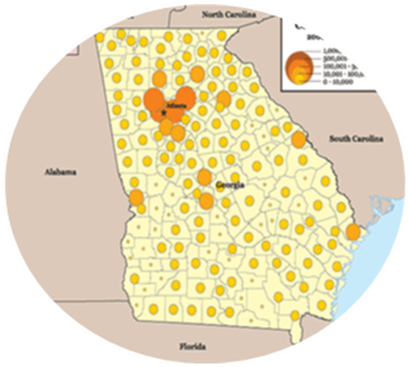

SS8H12c Analyze the impact of the rise of the two-party system in Georgia.
ONE PARTY SYSTEM 1877 – 1970
Conservative Democrats controlled Georgia politics
White supremacy, County Unit System, disenfranchisement
of blacks (white primaries, poll taxes, literacy tests, grandfather
clause, KKK intimidation), and Jim Crow laws once preserved
conservative Democrat rural power in state politics

TWO PARTY SYSTEM 1970 – PRESENT
Conservative Republicans and Liberal Democrats share power
White supremacy decreased, equal opportunity increased
Standard of living has increased for all Georgians



SS8H12b Describe the role of Jimmy Carter in Georgia as state senator, governor, president, and past president.

SS8H12d Evaluate the effect of the 1996 Olympic Games on Georgia.
1996 OLYMPIC GAMES
The city of Atlanta and the entire state of Georgia benefitted economically from hosting the Olympics. Many jobs and facilities were created before the Olympics Games began in 1996. Sporting arenas / stadiums, hotels, and other businesses were created to accommodate the many people who visited Georgia. The local and state government also increased their revenue through income, property, and sales taxes, which then was spent on providing programs and services for the citizens of Georgia. Since the Olympics, new businesses have relocated to Georgia to take advantage of Atlanta being an international city.

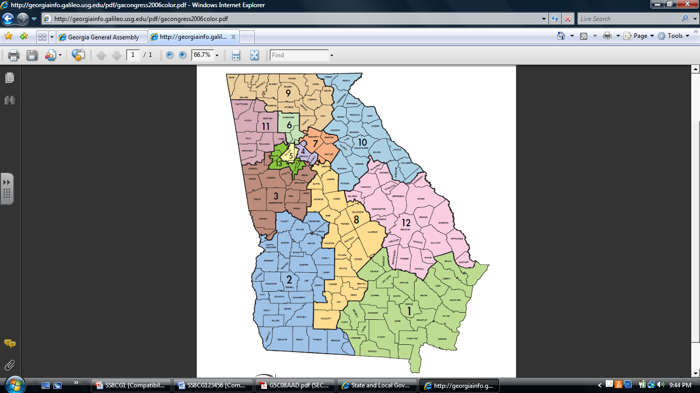

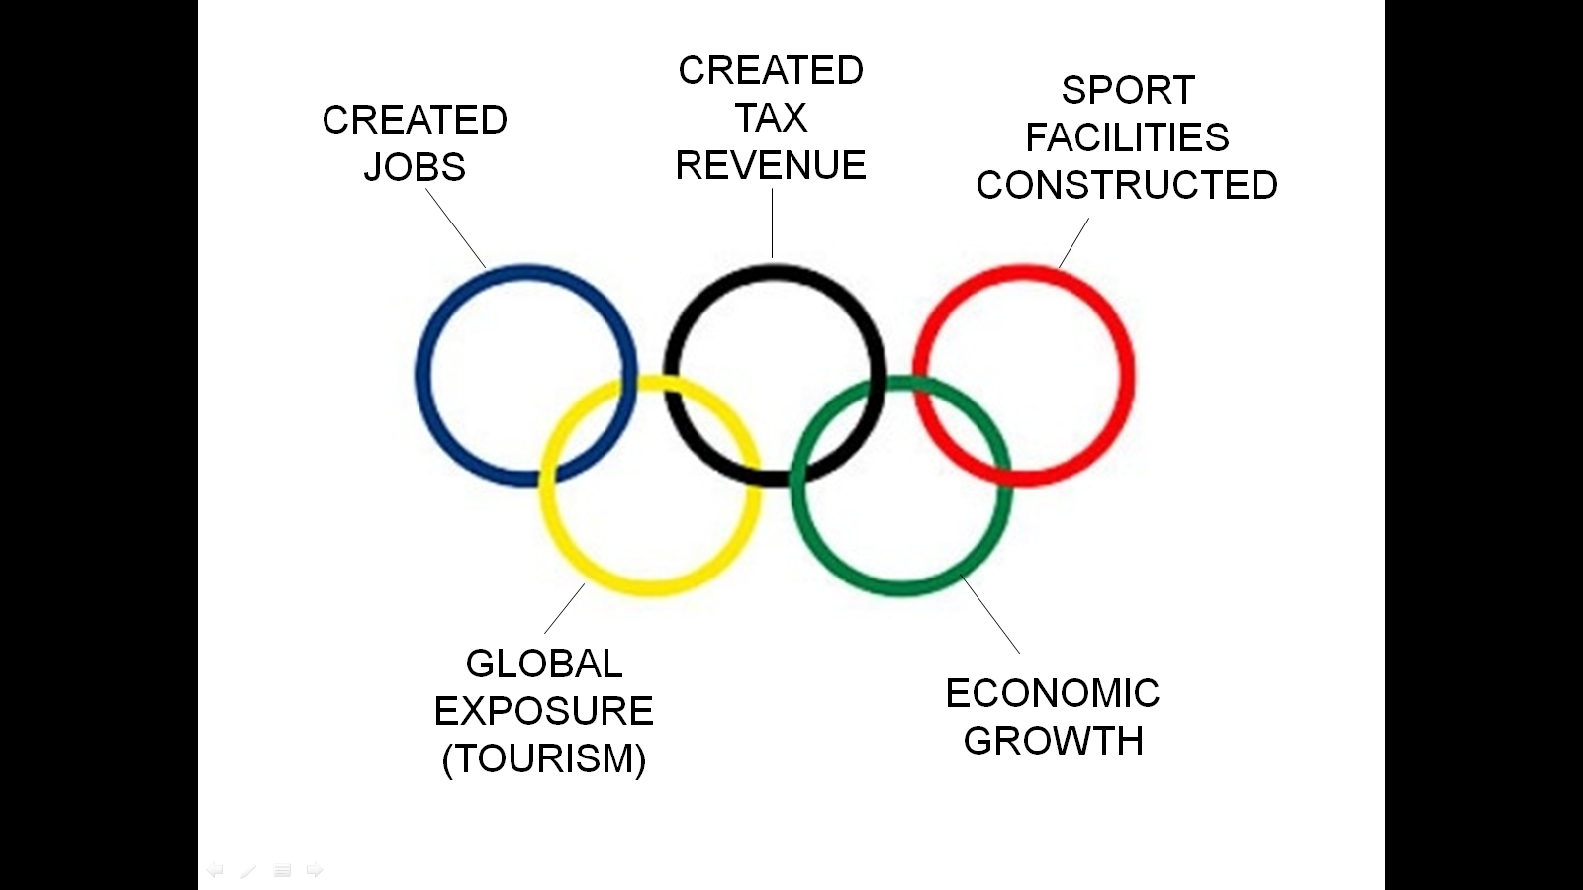

SS8H12e Evaluate the importance of new immigrant communities to the growth and
economy of Georgia
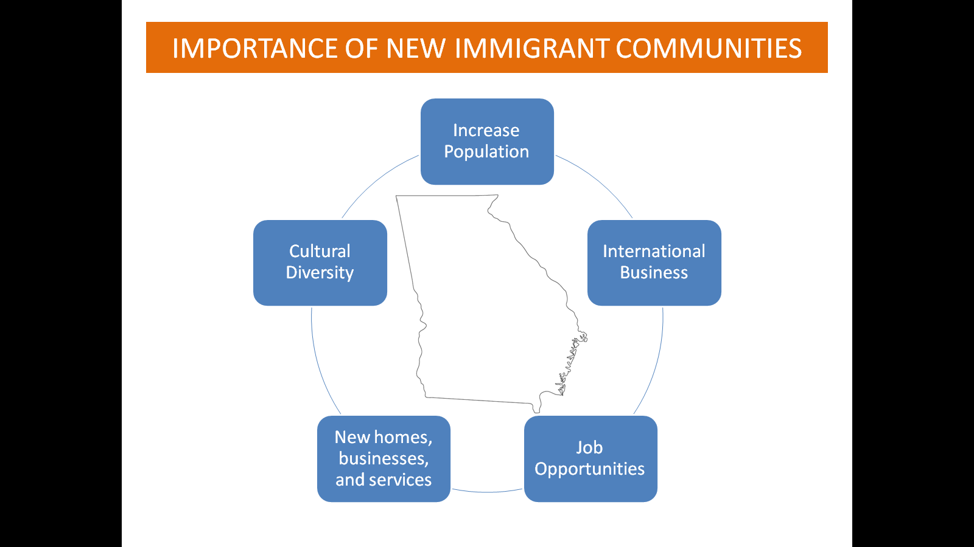
NEW IMMIGRANT COMMUNITIES
Some legal immigrant communities can provide low cost labor for many industries, which helps businesses grow while providing cheaper products and services for the general population. New populations also equal new markets for other Georgia businesses. Income and sales taxes provide the government more revenue, and new communities also increase the cultural diversity of an area. Georgia’s economy has grown since the mid-1990s partly due to new immigrant communities in the state.

